SELECT p.*,level,sys_connect_by_path(pa_name,'/'),sys_connect_by_path(pa_code,'/'), FROM pub_area_import_20150512 p start with p.pa_pcode = '0' CONNECT BY PRIOR pa_code ＝ p.pa_pcode

树查询

设置ajax为同步

$.ajaxSetup({

async: false

});

---换行符 (java表示 \n \r)会导致后台拼接的json到前台不可用

[解除数据库用户锁定]alter user hopemdm account unlock;

[测试环境重起等操作发邮件到psi.dsj@haier.com](mailto:测试环境重起等操作发邮件到psi.dsj@haier.com)

密码改成hrmdm,456

Oracle 查询中文 乱码

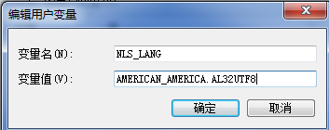

Hibernate 关联查询

Criteria criteria = session.createCriteria(Brother.class, "b");   
DetachedCriteria sisCri = DetachedCriteria.forClass(Sister.class, "s");  
sisCri.add(Property.forName("s.fName").eqProperty("b.fName"));  
criteria.add(Subqueries.exists(sisCri.setProjection(Projections.property("s. id "))));