1. a. log(5)

b. The default base is e^1. To use another base you do: log(5, base = exp(2))

c. The log of a negative number is undefined, so R returns NaN, which stands for Not a Number.

d. sqrt(9)

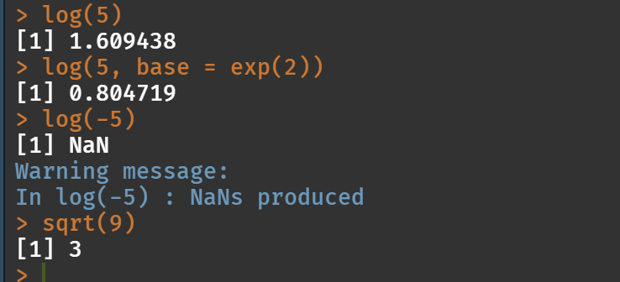

1. a. vec <- rnorm(15)

mean(vec)

sd(vec)

b. vec2 <- rnorm(15, mean = 10, sd = 2)

mean(vec2)

sed(vec2)

c. They’re not the same because of both rounding and because R could only approximate the mean and SD with 15 variables. The more variables, the closer the numbers would be.

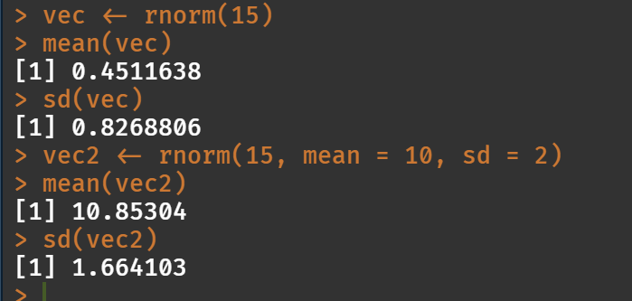

1. c. weight <- c(60, 72, 57, 90, 95, 72)

height <- c(1.80, 1.85, 1.72, 1.90, 1.74, 1.91)

d. plot(weight, height)

The scatterplot doesn’t show much correlation between the 2 values.

e. bmi <- weight/height^2

f. mean_w <- mean(weight)

g. weight2 <- weight – mean_w

f. sum(weight2)

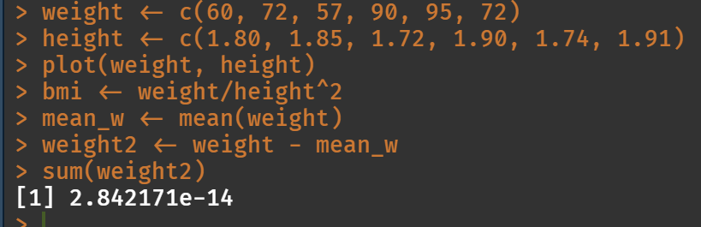

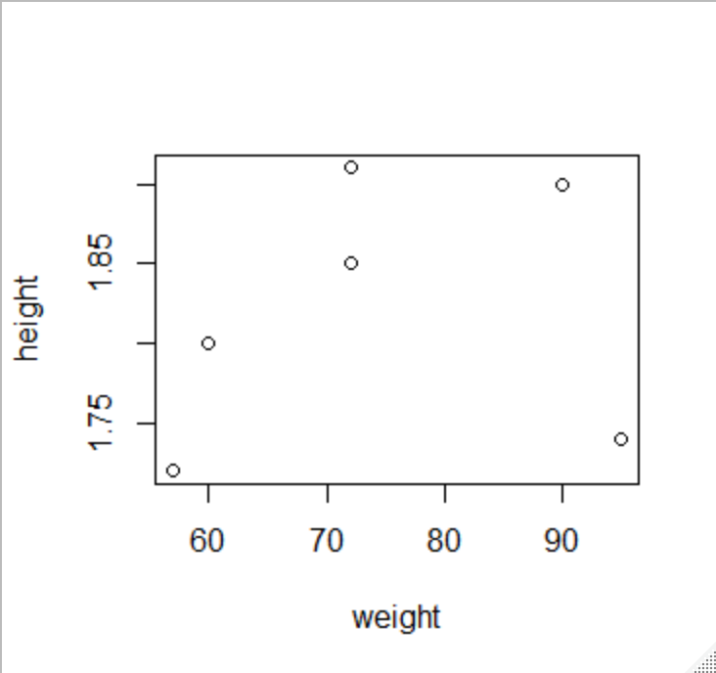

1. categories <- c('computer programming', 'math', 'statistics', 'machine learning', 'domain expertise', 'communication and presentation skills', 'data visualization')

ranking <- c(3, 4, 3, 2, 4, 5, 3)

rachel <- data.frame(categories, ranking)

names(rachel) <- c(“Categories”, “Ranking”)

barplot(rachel$Ranking, names.arg = rachel$Categories, las=2)



