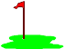
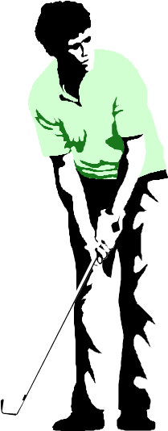
Longlevens Library Code Club

Anyone for Golf?

In this exercise you create a game of golf. You don’t have to produce any fancy 3D graphics, you can simply draw a side view of each hole on your course. Here’s an example hole prepared in Scratch:

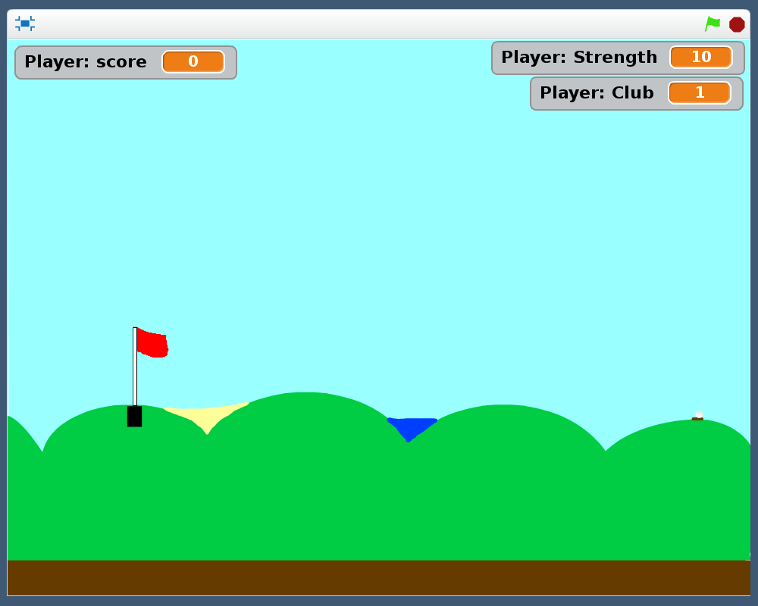

Each hole can have different features, bunkers, water hazards, long grass (rough) and bushes etc. Mix in level, uphill and downhill holes. Hitting the edge of the screen or landing the ball in water or in bushes will result in penalty shots. Once you have the game working make the game a 2 or even 4 player game so you can compete with your friends. Add in a low score table of the best rounds where you can put in the players name.
Requirements
- The course shall have 9 holes. Each hole shall be different in appearance including differences in gradients and distances between the tee off location and the green.
- The player shall be able to choose from the following clubs:
  - Drivers numbered between 1 and 9
  - Sand Wedge
  - Putter

The Putter shall hit the ball horizontally along the green. A Number 1 driver will hit the ball at 10 degrees above horizontal. The angle (known as the loft) shall increase by 4 degrees per club up to the 9 value club. For example a Number 2 driver shall loft the ball at 14 degrees, a Number 3 will hit the ball at 18 degrees, a Number 9 will loft the ball at 42 degrees. A Sand Wedge is a special club with a high loft typically used to get out of bunkers and very rough ground. Give it a loft angle of between 50 and 55 degrees. (These are fairly typical loft angles for golf clubs. Golf club manufacturers all have their own variations. We won’t complicate matters by including both wood and iron drivers which differ in the Numbers 1 to 4.)
- When putting, the ball shall roll along the ground and drop into the hole if it reaches it at no higher than a pre-determined speed. (Choose by experimenting.) When other clubs are used, end the movement where the ball hits the ground or obstacle.
- Enable the player to adjust how hard they want to strike the ball. When the player has chosen their club and strength, start the ball moving at the loft angle of the club and then gradually reduce the angle as the ball moves through the air to simulate gravity. You don’t have to get into clever mathematics to calculate how the ball moves, unless you really want to. Experiment with the speed, but remember vertical speed increases once the ball has reached its maximum height. Balls hit with high numbered clubs will go high and short, whereas low lofted clubs shall cause the ball to go far but low.
- A ball that lands in the hole completes the player’s turn. Keep a score of how many times the ball is struck before it goes into the hole and a running total for how many strokes it takes to complete the full course.
- Landing the ball out of bounds, in water hazards and in bushes shall incur a penalty shot in addition to the shot taken. For hazards, return the ball to its previous position from where it was hit. For balls that go out of bounds let the ball drop to the ground at the edge of the screen.
Hints & Tips
- In Scratch when a sprite is moved in the direction of zero degrees, it moves upwards. To work out the direction required for the club convert the club’s loft angle to the angle from vertical. If the flag is on the left, you then need to switch the direction to the other way. You can do this simply by multiplying by -1. See the figures below for hitting the ball to the right and left.
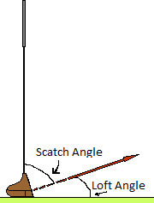
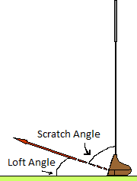
Scratch direction = 90 – Loft Angle
Scratch direction = -1 x (90 – Loft Angle)
or Scratch direction = Loft Angle - 90

You can work out whether a left or right shot should be taken by finding the direction to the hole from the ball using a particular element in the ‘Motion’ category providing you make either the hole or flag a sprite.
- Don’t worry about animating the player hitting the ball. Just making the ball move according to the club and strength settings is sufficient.
- When the player reaches the green, zoom in to make the putting easier. Switch automatically to the putter and you may find it easier to have special strength settings for putting.
Additional
- Make the game a multiplayer game for up to 4 people. Create a Low Score table of best rounds.
- Golf scores are normally quoted as a number above or below par. Decide how many strokes it should take a golfer to pot the ball for each hole. Note most 9 hole golf courses have a total par score of 36. Quote the par score for each hole to the players during their round and change your scoring system to use above or below par numbers.

Report the player’s score for the hole when he has potted the ball using the following golf naming convention:
    - Player matches the par score for the hole, this is simply “Par”.
    - 1 below par, is known as a “Birdie”.
    - 2 below par is an “Eagle”
    - 3 below is an “Albatross”.
    - A hole-in-one is known as an “Ace” whatever the par is for the hole.
    - 1 above par is known as “Bogey”,
    - 2 above par is a “Double Bogey”,
    - 3 above par is a “Triple Bogey” etc.

- Make the ball bounce when it hits the fairway or green and adjust the distance it continues if the ball lands on an uphill or downhill slope accordingly.
- Add wind speed to the game. Show the direction of the wind by which way the flag is flying and state the wind speed as a new variable. Each time a hole is played the wind strength shall be randomised, but make it the same for each player in a multiplayer game. Use the speed and direction to affect how the ball flies through the air by adding or decreasing the speed calculated from the player’s strength input.
Optional
- When your player reaches the green, zooming in to the green using a 3D depiction of the green. When the ball is hit and moves towards the hole away from the player make it shrink in size. If you find this easy maybe have a go at a complete hole in 3D graphics.

