Longlevens Library Code Club

International Space Station Coding Challenge
February - March 2019

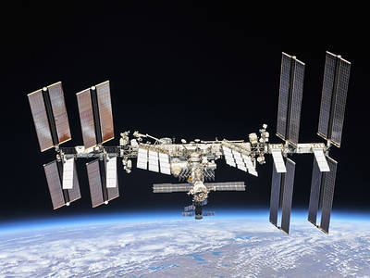
This is a chance to create a short computer program that will be run in space on a special Raspberry Pi computer known as an Astro Pi, on board the International Space Station. The Astro Pi will be used to tell the astronauts what the temperature is inside the space station using a sensor on the Astro Pi’s “Sensor Hat”, which is an additional electronic circuit board that fits on Raspberry Pi computers. You will indicate the temperature in a short message and possibly a simple graphical image using the Sensor Hat’s LED matrix screen.
You need to complete and submit your code no later than the last Code Club before the official closing date of 20 March 2019. (Please note this Code Club may be the one scheduled for 9 March 2019.)

Instructions
- Please read through the “Astro Pi: Mission Zero” instructions:
https://projects.raspberrypi.org/en/projects/astro-pi-mission-zero
- Form teams of 2, 3 or 4 and decide on a team name.
- In your teams start writing and testing your code using the “Trinket” at:
https://trinket.io/mission-zero
- Under the 3 given lines of code please put your team name followed by your names on a line starting with the Python comment marker which is the ‘#’ character.
- Make sure you achieve 3 ticks in the list of things you need to include in your program under the Trinket. You also need to make sure your program runs for no more than 30 seconds and that your code is no more than 1000 characters in length. (Ask a Code Club volunteer to check.)
- Once you are satisfied with your code, demonstrate it to one of the Code Club volunteers. If they agree it is ready to be submitted, the volunteer will insert the codeword needed and click on “Continue To Form”. Please complete all the details requested. These details will be used to produce the certificates for the entries that are run on the ISS, so please make sure everything is spelt correctly. Please note you are only allowed to enter once.
What happens Next?
All submissions that are correctly submitted will be uploaded and run on an Astro Pi computer on board the International Space Station in May. Certificates will be issued to all those whose code was run and these will be emailed to one of the Code Club volunteers. The volunteers will arrange for you to collect your certificate once it has been received.

08/02/2019

