Longlevens Library Code Club

European Space Agency and Raspberry Pi Foundation’s
International Space Station Coding Challenge 2020
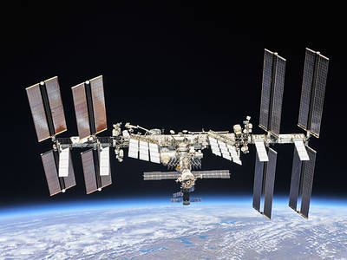
This is a chance to create a short computer program that will be run in space on a special Raspberry Pi computer known as an Astro Pi on board the International Space Station. The Astro Pi will be used to tell the astronauts what the temperature is inside the space station using a sensor on the Astro Pi’s “Sense HAT”, which is an additional electronic circuit board that fits onto Raspberry Pi computers. You need to indicate the temperature in a short message and optionally add a simple graphical image using the Sense Hat’s LED matrix screen.
You need to complete and submit your code in teams of between 2 and 4 children (age limit 14 years old) no later than the last Code Club before the official closing date of 20 March 2020. This is expected to be Saturday 14 March 2020.

Instructions
- Please read through the “Astro Pi: Mission Zero” instructions:
https://projects.raspberrypi.org/en/projects/astro-pi-mission-zero
- Form a team with 1, 2 or 3 other children and decide on a team name.
- In your teams start creating and testing your code using the “Trinket” at:
https://trinket.io/mission-zero
- Under the 3 given lines of code given please put your team name followed by your names on a line starting with the Python comment marker which is the ‘#’ character.
- Make sure you achieve 3 ticks in the list of things you need to include in your program under the Trinket. You also need to make sure your program runs for no more than 30 seconds and that your code is no more than 1000 characters in length. (Ask a Code Club volunteer to check.)
- Once you are satisfied with your code, demonstrate it to one of the Code Club volunteers. They will check it using the club’s own “Sense HAT” equipped Raspberry Pi computer. If they agree it is ready to be submitted, the volunteer will insert the codeword needed on the Trinket page and click on “Continue To Form”. Please complete all the details requested on the form. These details will be used to produce the certificates for the entries that are run on the ISS, so please make sure everything is spelt correctly. Please note you are only allowed to enter once.
What happens Next?
All submissions that are correctly submitted will be uploaded and run on an Astro Pi computer on board the International Space Station in May. Certificates will be issued a few weeks later to all those whose code was successfully run.
06/01/2020

