Longlevens Library Code Club
Scratch - Milk Bottle Factory

Description
This is a Scratch program that shows how a control system operates. Empty bottles are fed along a conveyor belt, they fill up as they pass under the milk filler. Bottles are checked that they have been filled with milk. If they are not full, they are removed from the production line otherwise they continue to be sealed with tops and labelled before reaching the end of the line. The conveyor belt speed and milk flow rate can be altered by the player.

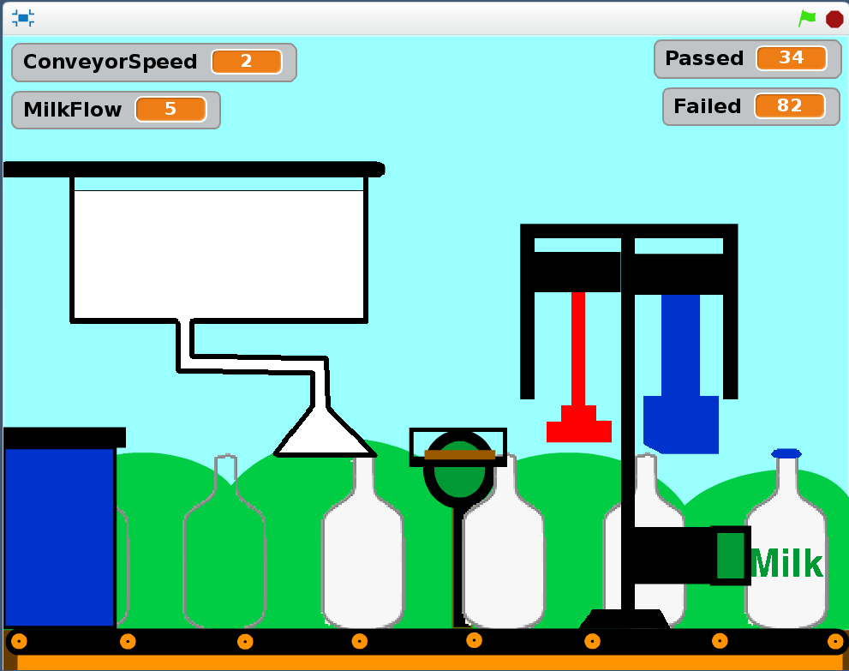
Load and Save the Resources
Open Scratch and load the “MilkBottleFactoryResources.sb2” file. Then save the project as a new project in your own “Coders” folder. This project only has the sprites that we will be using for the placing the bottles on the conveyor belt, filling the bottles, checking the bottles are full, rejecting if not full or topping and labelling them if they are full.
The Conveyor Belt
The speed of the conveyor belt determines how fast the milk bottles are processed. They will start on the left and progress to the right through the factory on the belt.
In the Conveyor Belt Sprite select the “Data” category and “Make a variable”. Call the variable “ConveyorSpeed” and leave the variable set for all sprites.
We need to control the speed, so go to the “Control” category and drag into the Scripts area the following elements:
“When <Green Flag> clicked”
“When <space> key pressed” - change the key to “<left arrow>”
“When <space> key pressed” - change the key to “<right arrow>”
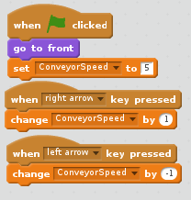
Under “When <Green Flag> clicked” add from the “Looks” category; “go to front”. This ensures the sprite is not hidden behind any other sprites. Then using the “Data” category set the initial “ConveyorSpeed” to “5” underneath “go to front”.
Also from the “Data” category, choose the “Change <ConveyorSpeed> by <value>” element and use it change the “ConveyorSpeed” by “1” when the “<right arrow>” key is pressed and “-1” when the “<left arrow>” is pressed.

The Bottle Placer
The Bottle Placer’s function is to put a new empty bottle on the conveyor belt when the previous bottle is sufficiently clear. Select the Placer sprite then from the “Control” category drag “When <Green Flag> clicked” into the scripts area. To make sure the illusion isn’t spoilt add a “go to front” elements from the “Looks” category so that bottles will appear behind it. Drag the “forever” loop element from the “Control” category and snap it under the “go to front” element. From the same category drag into the loop a “create clone of <sprite>” element and set the type of sprite to “Bottle”.
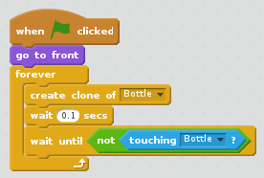
Before the Placer creates another bottle it needs to wait until the new bottle has left the Placer. Insert into the loop a “wait until <condition>” element from the “Control” category. From the “Operators” category, place a “not <condition>” into the “wait until” element. Then from the “Sensing” category, drag over a “touching <what>?” element into the “not” element.
We need to make sure the loop doesn’t run too fast, so put a “wait <seconds>” element from the “Control” category into the loop between the “create clone of Bottle” and the “wait until” elements. As the bottle clone takes time to create, without that pause, the test for the latest bottle touching the Placer may return the wrong value and a second or even third bottle may appear on the conveyor belt before the first bottle leaves the Placer. Set the time to wait to “0.1” seconds.
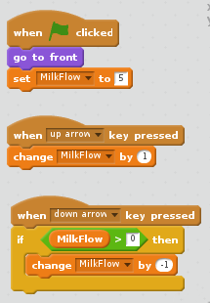
The Milk Filler
This is a large vat of milk that fills up each bottle as it passes underneath the Filler’s nozzle. Select the Filler sprite, then from the “Data” category create the variable “MilkFlow” (for all sprites). This represents how fast the milk is flowing out of the filler.
Repeat the instructions for the Conveyor Belt but use the <up arrow> and <down arrow> keys to increase and decrease the flow of milk. Set the “MilkFlow” variable to “5” when the Green Flag is clicked. Add an “if” element from the “Control” category to prevent the value of MilkFlow being less than zero. You might want to go back and add a similar “if ConveyorSpeed > 0 then” element to the Conveyor Belt to stop it from going backwards.
The Monitor
The Monitor sprite indicates if the bottle passing it are full of milk or not. Select the sprite and then from the “Data” category create the following variables:
“Passed” (for all sprites) - This will count how many bottles are correctly filled.
“Failed” (for all sprites) - This will count how many bottles are under filled.
“bottleChecked” (for this sprite only) – Indicates if the current bottle has been checked.
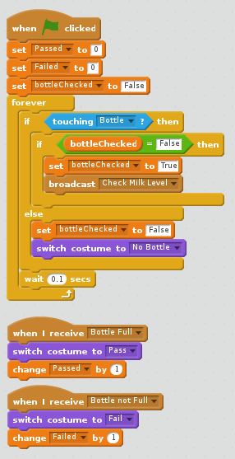
Set the “Passed” and “Failed” variables to zero and “bottleChecked” to “False” when the Green Flag is clicked. The “bottleChecked” variable is a special Boolean variable which we will use to stop a bottle from being checked and counted more than once.
The Monitor has three different appearances:
1) No bottle touching – “No Bottle” costume
2) Full bottle – “Pass” costume
3) Partially full bottle – “Fail” costume
Add a “forever” loop from the “Control” category and add into it an “if <condition> then <script> else <script>” element. Insert into the <condition> a “touching <what>?” element from the “Sensing” category. Select “Bottle” as the item that is being sensed. This will continuously check if a bottle is in front of the Monitor. Insert into the “if” element an “if <condition> then” element. Add an “ = ” element from “Operators” into the <condition> and use it to check if “bottleChecked” is “false”. If it is we need the “Sensor” sprite to check if there is milk in the bottle right up to the top. Change the “bottleChecked” variable to “True” and then from “Events”, drag over a “broadcast <message>” element and set the message to “Check Milk Level”.
If there is no bottle touching the Monitor it shall return to its “No Bottle” costume. In the “else” scripts for “touching Bottle?” reset the “bottleChecked” variable to “False” and then insert a “switch costume to <No Bottle>” from the “Looks” category. To reduce the number of times the loop runs per second, add a “wait 0.1 secs” element.
When the Sensor sprite checks if there is milk at the top of a bottle and broadcasts either the message “Bottle Full” or “Bottle not Full”. From the “Events” category, drag over the “When I receive <message>” element twice. In the first one select the message “Bottle Full”. In the second one select the message “Bottle not Full”. Under each add a “switch costume to <costume name>” element. For “Bottle Full” set the costume to “Pass” and add underneath a “change <Passed> by 1” element. Repeat for “Bottle Not Full” but the costume is “Fail” and change the “Failed” variable by 1.
The Sensor
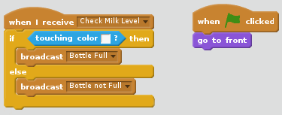
The Sensor sprite determines if there is milk right up to the top of the bottle currently passing between it and the Monitor Sprite. We set up the Monitor to broadcast a “Check Milk Level” message whenever there is a bottle in front of it. We therefore need to trigger a script starting with “when I receive <Check Milk Level>” element from “Events”. Under it add an “if <condition> then <script1> else <script2>” element. The condition is whether the sensor is touching the white colour of the milk in the bottle so insert in a “touching color?” element and change the colour to the same colour as used for milk in the bottle costumes. In <script1> insert a “broadcast <Bottle Full”> element. In <script2> insert a “broadcast not Full”.
We want the Sensor to be positioned in front of the bottles so add in a “when <green flag> clicked” element with “got to front” snapped under it.
The Finisher
After the bottle has been checked it needs to be removed if it is not full or labelled and sealed if it is full. The Finisher sprite is simply a framework for three other sprites, the “Knocker”, the “Topper” and the “Printer”. The only purpose of the Finisher sprite itself is to be used to sense when a bottle is touching it. There is no code to write on the scripts tab.
The Knocker
The knocker will knock off from the conveyor belt any bottle that is not full. It activates when a bottle that is not full is touching the Finisher. It needs to be in the up position when the Green Flag is clicked and in front of the bottels. Choose the “When <green flag> is clicked” element and snap underneath a “go to front” element followed by a “go to x: <value> y: <value>” element from the “Motion” category. Set the values to be 85 and 50 respectively so that it fits into the front part of the finisher.
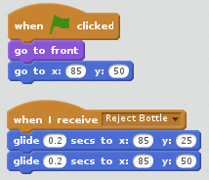
It is summoned into action by the message “Reject Bottle” being broadcast. Select “When I receive <message>” element from the “Events” category and add underneath two “Glide <0.2> seconds to x <value> y <value>” elements from the “Motion” category. Set the “x” value to “85” in both and then set the “y” value to “25” in the first one and “50” in the second.

The Topper
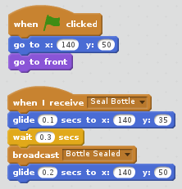
The Topper will add a top to seal the bottles as they pass underneath. It moves in the same way as the knocker. Copy the code from the Knocker and change all the x values to “140”, the y value that is “25” to “35” and the message in the “when I receive <message>” to “Seal Bottle”. When the Topper is in the down position, add in a “broadcast <Bottle Sealed> element. This will trigger the bottle to change to the “Bottle Sealed” costume. Change the glide time to “0.1” seconds for the initial “glide” element as we want the pressing down action to be quick.
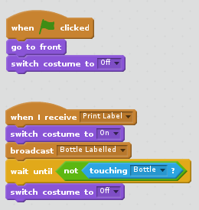
The Printer
The printer adds the label “Milk” to the bottles as they pass. The operation is triggered when a bottle touches the Printer and broadcasts the message “Print Label”.
Use a “When <Green Flag> clicked” script to bring the Printer to the front and initialise the costume to “Off”.
Then drag over from “Events” a “when I receive <message>” element and change the message to “Print Label”. Switch the Printer’s costume to “On”, broadcast a message “Bottle Labelled” then insert a “wait until <condition> element”. We are going to turn the Printer back to the “Off” costume when the bottle has passed the Printer. Insert a “not <condition> and into that insert a “touching <Printer>?” element. After that add on a “switch costume to <Off>” element.
Bottles
The Bottle sprite is going to control how the bottles are processed. As the bottles move along the conveyor belt different actions will be triggered as the bottles come into contact with other sprites. To keep control we need to know what is happening with each cloned bottle as it passes along the conveyor belt.
Cloned Bottle Initialisation
Select the Bottle sprite and create the following variables using the “Data” category:
“myBottleStatus” (for this sprite only) - This indicates the stage the bottle has reached.
“myAmountOfMilk” (for this sprite only) - The quantity of milk in each bottle.
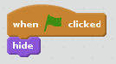
We only want to move the clones of the Bottle sprite created by the Placer sprite. The main Bottle sprite won’t be used and needs to be hidden from view. From the “Events” category drag a “when <Flag> clicked“ element to the script area. Then from the “Looks” category, drag a “hide” element and lock it below the “when <Flag> clicked”.
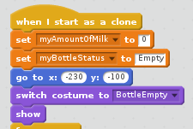
To initialise cloned bottles, drag over into the scripts tab a “when I start as a clone” element from the “Events” category. Set the “myAmountOfMilk” variable to zero and “myBottleStatus” to “Empty” using “set <variable> to <value>” elements.
The bottle needs to start at the left hand side of the conveyor belt. Use a “go to x: <value> y: <value>” element from the “Motion” category and set the value of x to “-230” and y to “-100”.
Switch the costume to “BottleEmpty” and add a “show” element using the “Looks” category.
Moving the Bottles
To move each bottle on the conveyor belt we need to add a forever loop that increases the “x position” by the speed of the belt. From the “Control” category lock a “forever” loop under the “show” element and lock into the loop a “change x by <value>.” element from the “Motion” category. Set the value of the element to be the conveyor belt speed by dragging the “ConveyorSpeed” data value from the “Data” category. To stop the loop running too fast, snap a “wait <value> secs” element from the “Control” category under the if statement and set the value “0.1” seconds.
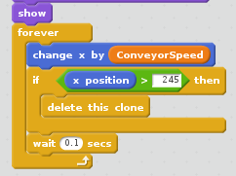
When the bottle gets to the end of the conveyor belt and is complete we need to delete it. From the “Control” category, choose the “if <condition> then” element and drag that so it locks under the “change x by ConveyorSpeed” element. From the “Operators” category, choose the “ > ” operator and drag it into the <condition> part of the “if” element. In the left hand side of the greater than operator, drag and lock in the “x position” element from the “Motion” category and put “245” in the right hand side. From the “Control” category, drag “Delete this clone” into the body of the “if” statement.
Now test your script and check that empty milk bottles appear behind the “Placer” sprite and disappear after they have reached the end of the conveyor belt.
Filling the Bottles
As each bottle passes under the Filler it will come into contact with the Filler’s nozzle. The bottle touching the nozzle will trigger the filling of the bottle with milk. Milk flow needs to cease once the bottle is full or when it has been moved too far by the conveyor belt to remain in contact with the nozzle.
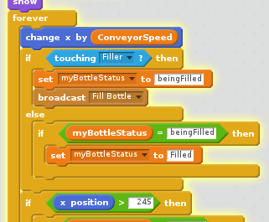
Insert an “if <condition> then <script> else <script>” element into the loop after the “change x by ConveyorSpeed” element. Insert into the conditoin part of the “if” element a “touching <what>?” element from the “Sensing” category. Set the value in this element to “Filler”. Change the “mybottleStatus” to “beingFilled” as the only bottle we want to fill is the one touching the Filler. Filling needs to be performed separately from the motion loop, so the event of touching the Filler requires a message to be broadcasted to activate the filling operation. From the “Events” category, drag “broadcast <message>” into the first script choice of the “if touching Filler then <script> else <script>” element. Set the message to be “Fill Bottle”. Once the bottle is no longer in contact with the Filler, we need to move the status on from “beingFilled” to “Filled. Insert into the “else” part of the “if” element an “if <condition> then” element. Use the “if” element to check that the myBottleStatus is “beingFilled” and in the then script., set it to “Filled”
To fill the bottle, start a new script with the “when I receive <message>” element from the “Events” category. Set the message to be “Fill Bottle”. We need to check that the bottle is the one being filled. Add an “if <condition> then” element and check “myBottleStatus” is “beingFilled. In the “if” element, add from the “Data” category a “change <myAmountOfMilk> by <MilkFlow>” element.
As the milk enters the bottle we need to animate the level of milk in the bottle rising. The Bottle sprite comes with 14 costumes in rising order of milk levels from empty to full. When the amount of milk in the bottle reaches “8”, the next costume in the sequence shall be chosen. To know when the next costume needs to be chosen, reduce the “myAmountOfMilk” variable by “8”. We could use an “if” statement to check the value of the “myAmountOfMilk” variable, but if the “MilkFlow” is greater than 8 we may need to change up two or more costumes at once. It is therefore better to use a “repeat until <condition>” loop from the “Control” category. The loop runs if the level of milk is greater than 8 and the bottle is not full.
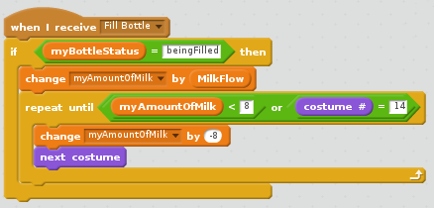
To perform the costume changes, lock a “repeat until” from the “Control” category element under the “change <myAmountOfMilk> by <MilkFlow>” element. Then lock an “ or ” operator into the condition of the “repeat until” element. We need another operator in the left hand side of the “or” operator. Choose a “ < ” element and snap that into the left hand side of the “or” operator. Insert the “myAmountOfMilk” variable on the left and “8” on the right. On the right hand side of the “ or ” operator we need to check the bottle costume is not already full. From the “Operators” category insert the “ = ” operator and on the left hand side put “costume #” from the “Looks” category. On the right hand side insert “14”. Within the loop, put in a “change <myAmountOfMilk> by <-8>” element and add the “next costume” element from the “Looks” category.
Checking the Amount of Milk
The Monitor and Sensor sprites are used to report whether the bottles are full or not full of milk. When a bottle passes the Monitor we trigger the checking by broadcasting a “Check Milk Level” message.
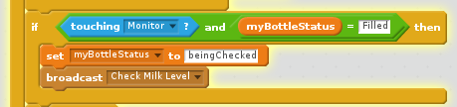
Add into the main “Forever” loop an“if <condition> then” and insert in an “ and “ operator I the <condition>. Set the left hand condition in the “ and “ operator to “touching <Monitor>?” and on the right hand side add a check for “myBottleStatus” equals “Filled”. In the script area for the “if” element set the “myBottleStatus” to be “beingChecked” and add a “broadcast <message>” element changing the message to “Check Milk Level”.
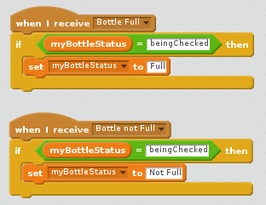
We already set up the Monitor and Sensor sprites earlier with the scripts they need when the message goes out to “Check Milk Level”. The Sensor broadcasts either “Bottle Full” or “Bottle not Full” which we used in the Monitor scripts but we can also use for the Bottle. Use a “when I receive <message>” element from Events and add in an “if <condition> then” element. Set the condition to and “ = “ operator and use it to check that the bottle is the one being checked. If it is the bottle and the message is “Bottle Full”, we want to set “myBottleStatus” to “Full”. Copy the script and change the message to “Bottle not Full” and set the new “myBottleStatus” to “Not Full”.
Rejecting Bottles
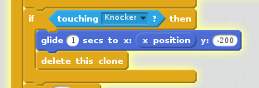
The Knocker sprite shall knock off the conveyor belt any bottles that are not full. The action is triggered when a bottle touches the Finisher and has the “myBottleStatus” set to “Not full”. All the bottle has to do is sense when it comes into contact with the Knocker and fall off the conveyor belt.
Add another “if <condition> then” element to the Bottle sprite’s forever loop. Set the condition in the “if” element to “touching Knocker?”. Add a “glide <1> secs to x:<value> y: <-200>” element. We won’t complicate the “x:” value, we’ll just keep it the same as it was when the Knocker makes contact. Drag over from “Motion” the “”x position” value. After it has moved down behind the conveyor belt we need to delete it. Add a “delete this clone” element.
Sealing the Bottles
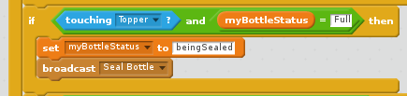
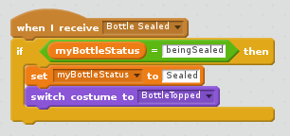
When a bottle passes the Topper sprite the top shall just touch triggering the broadcast to the Topper sprite to seal the bottle. The bottle’s “myBottleStatus” must be “Full” and set to “beingSealed” as soon as it touches the Topper to stop repeat broadcasts.
When the “Topper” broadcasts “Bottle Sealed” we want to swap the costume to a new sealed costume. Duplicate the full bottle costume and draw a top on the bottle and give it a suitable name. Start a new script in the Bottle sprite with “when I receive “Bottle Sealed”, check the status of the bottle is “being Sealed” and then set the status to “Sealed” and switch the costume to the new costume.
Labelling the Bottles
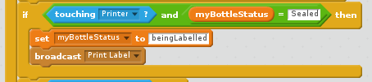
Sealed bottles shall be labelled with “Milk” when they come into contact with the Printer. Inset another “if” statement into the “forever” loop and check if the bottle is touching the Printer and has the status “Sealed”. Change the status to “beingLabelled” and broadcast “Print Label” so that the Printer reacts.
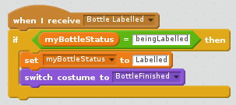
In the costumes, duplicate the bottle with the top and add the word “Milk” in roughly the centre of the bottle and call it “BottleFinished”. When the Printer sends back the message “Bottle Labelled” we want to switch to this new costume and set the status of the bottle to “Labelled”. The switch takes place behind the bracket holding the Printer so the transformation from unlabelled to labelled is hidden from view.
Completion
The bottle’s production line is now complete. Click the Green Flag and increase the conveyor belt speed and milk flow and see if the sprites keep up. At some point an uncompleted bottle will reach the end of the conveyor belt. This is a very messy situation. Insert an action with the loop to stop in this situation.

Additional Challenges
Convert into a Game
Add a timer to make the factory into a game to see who can achieve the most full bottles. Incur a time penalty when bottles are knocked off the conveyor belt for not being full. The game should end if a unfinished bottle gets to the end of the conveyor belt due to running the conveyor belt too fast.
Improve the animations
1. Make the quantity of milk in the Filler’s vat decrease as bottles are filled. Refill it from a tanker lorry when it gets too low. Decrease the maximum value of “MilkFlow” when the level of milk in the vat is running low.
2. The current nozzle would spill lots of milk. Make a nozzle that moves with the bottle or stop the bottle by lifting it off the conveyor belt temporarily while filling it, fitting it snugly into the nozzle to stop leaks. Make sure if you stop the bottle to fill it, the next bottle on the conveyor belt doesn’t hit it.
3. Rather than the rejected bottles falling off the conveyor belt, add another conveyor belt to take them back to the beginning to be filled up properly on a second attempt.

