You are going to make the classic asteroids game in python.

Before you start, you need to have completed the beginners guide to turtle graphics.

You will make this game in several stages so that you can learn to program in python quickly and easily.

During the project you will see the code you have already typed and keeping in blue.

So lets begin.

1. Create a new file and call it asteroids.py

First we are going to set up the window and the turtle in just the same way we did in the beginners lessons.

from turtle import Turtle
t=Turtle()
t.screen.exitonclick()

Save and run to check you get a window.
2. Now we are going to separate to Screen from the turtle so we can control the screen independently.
from turtle import *
t=Turtle()

screen = Screen()

# Setup screen so that position (0,0) is the centre of the window

screenMinX = -screen.window_width()/2
screenMinY = -screen.window_height()/2
screenMaxX = screen.window_width()/2
screenMaxY = screen.window_height()/2
screen.setworldcoordinates(screenMinX,screenMinY,screenMaxX,screenMaxY)

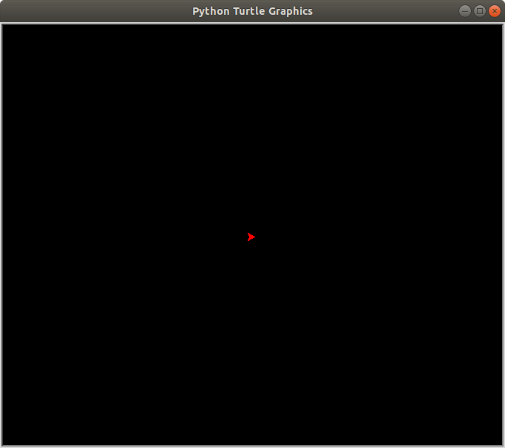
screen.bgcolor("black")
t.color(‘red’)
screen.exitonclick()

Save and run your program.
It should like this →

Looks very familiar

3. Next we are going to add code to listen and respond to the keyboard.

Insert after t.color(‘red’)
screen.onkey(doLeft, 'Left')
screen.listen()

This code tells the program to doLeft when the ‘Left’ arrow key is pressed and then to ‘listen’ to the computer for you to press a key.
Save and run the program. Press the left key
Either you will get an error ornothing happens. Don’t worry. You’ve not done anything wrong. You just haven’t created the doLeft code yet.
We’ll do this now.
We’re going to use a function. This is a block of code you only have to type once and can re-use throughout you program.
To create a function called doLeft you type:
def doLeft():
print(“left pressed”)

Put these two lines before the previous 2 llines
Save and Run
Can you create a doRight function that responds to the right arrow key being pressed.
Now we need to get the turtle to change direction when the keys are being pressed. You’ve already done this earlier. Remember t.left() and t.right()
Replace the print lines with either t.left or t.right. Set the rotate angle to 10.

Save and Run.
The program now looks like:

from turtle import *
t=Turtle()
screen = Screen()

screenMinX = -screen.window_width() / 2
screenMinY = -screen.window_height() / 2
screenMaxX = screen.window_width() / 2
screenMaxY = screen.window_height() / 2
screen.setworldcoordinates(screenMinX,screenMinY,screenMaxX,screenMaxY)

screen.bgcolor("black")
t.color('red')

def doLeft():
t.left(10)

def doRight():
t.right(10)

screen.onkey(doLeft, 'Left')
screen.onkey(doRight, 'Right')

screen.listen()

screen.exitonclick()

Can you see the problem with the spaceship.
Let’s fix that.
Add the following after you made the screen black.
screen.register_shape("ship",((-10,-10),(0,-5),(10,-10),(0,10)))
t.shape("ship")

Save and Run.
Next we are going to explore Objects and Classes

