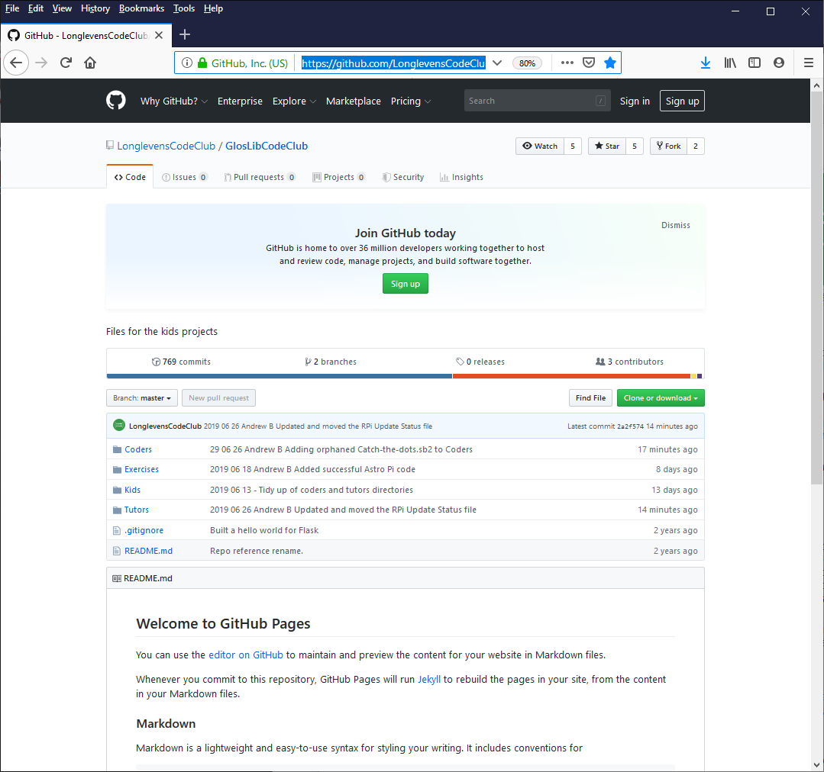
Depending on your child’s experience and interest, he/she will be coding in a number of ways. The club has a wide variety of projects available for children to choose with easy to follow step by step guides that allow them to create games, animations and websites in various computer languages including Scratch, HTML, JavaScript and Python.

After each session, all the work is uploaded to the ‘cloud'. This means that outside of the club sessions, both you and your children can continue to work with their projects to help embed the knowledge and techniques required to develop competent coding skills.

This sheet has been created to provide parents/guardians/siblings the necessary information to access your child’s work and allow you to engage with them in a fun and encouraging manner.
Where are the children's projects stored?

All projects ( and all the exercises and documents ) are stored in a website called a repository specially designed to store computer programs. Longlevens Code Club uses a repository called Github.

Simply point your Internet browser to: https://github.com/LonglevensCodeClub/GlosLibCodeClub
And you will see:

All the children’s work is stored in the ‘Coders’ link. Just follow the links to your child’s folder.

The files can be then copied and pasted to your home computer and edited and run at home.

All the files are read only, so you can’t break or overwrite anything. So feel free to download everything and explore to see what some of the other children are doing too.

Please turn over to see how to run these programs at home.

Thank you.

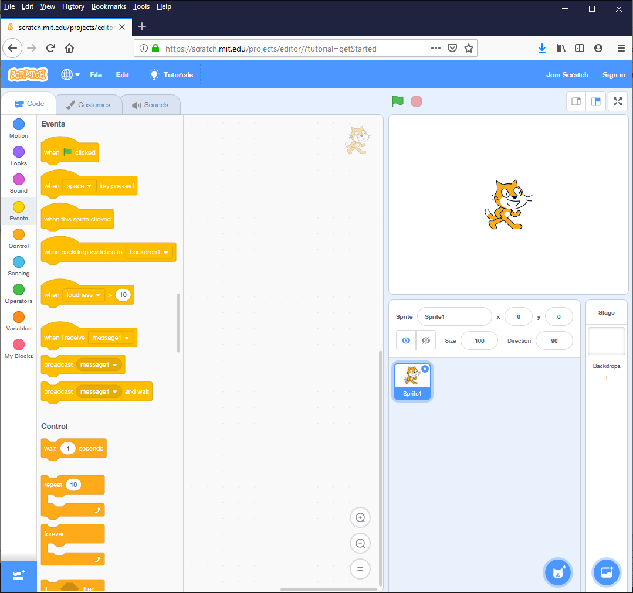
SCRATCH

Scratch is a visual programming language specially designed for children and is often used in schools. It enables computer programs to be created with minimal typing and without any previous programming experience.

There is an online version that you can use to explore and develop the programs your children have created.

Just visit:
https://scratch.mit.edu/

There are some great tutorials and examples there too!

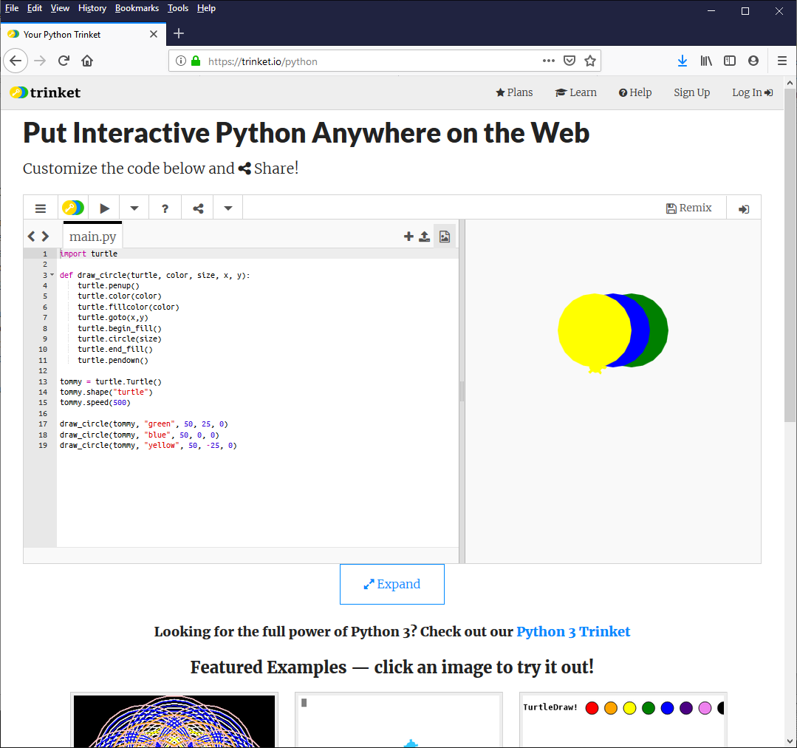
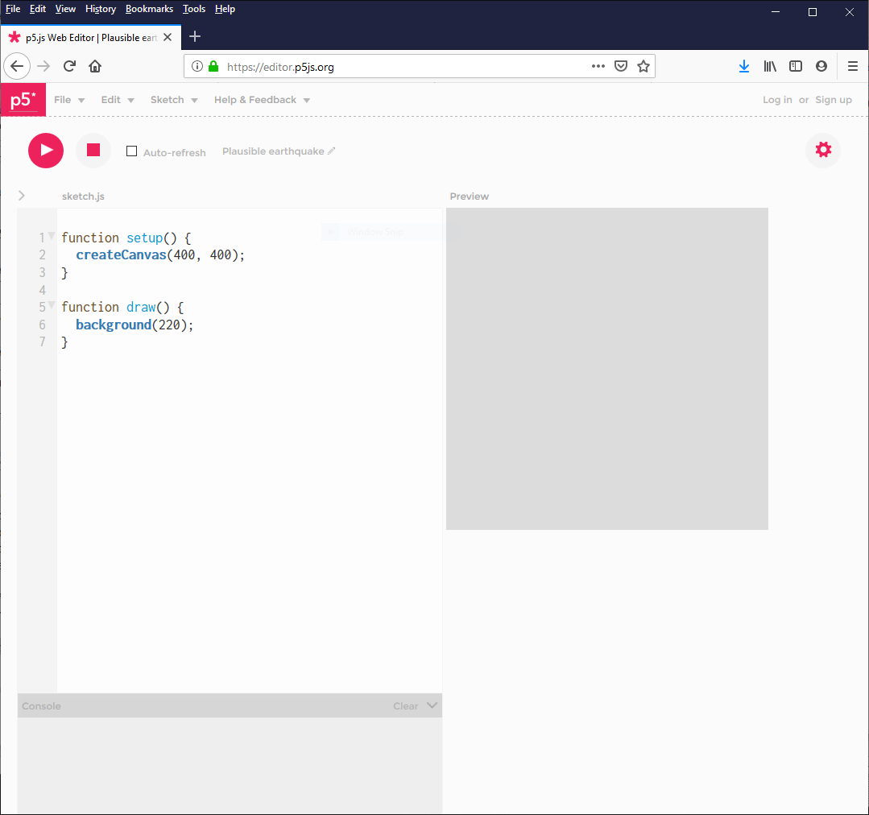
PYTHON

Python is a programming language used in engineering, universities and many businesses worldwide. Because of this there are many additional extras available online to make learning to program fun and exciting.

Python is perfect for creating games, analysing data from the internet or talking to real world devices such as a smart-home. Home Assistant is written in python.

An online python editor can be found at:
https://trinket.io/python

HTML & JAVASCRIPT

HTML & JavaScript are the languages of the internet. Your internet browser is able to display some amazing content thanks to these technologies ( Netflix, Spotify and many others use this technology). So it’s perfect for developing apps that run in the cloud.

Whilst there are many online editors available here’s a couple of our favourites:
https://trinkit.io
https://editor.p5js.org

There are some great YouTube tutorials to help inspire you and your children.

