You are going to make the classic asteroids game in python.

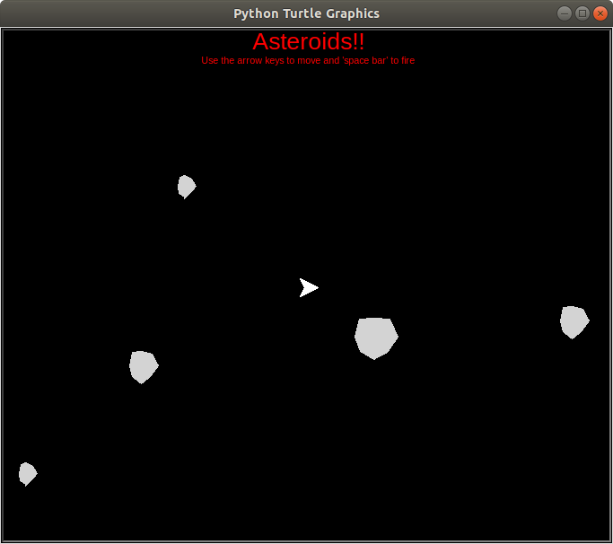

Before you start, you need to have completed the beginners guide to turtle graphics.

You will make this game in several stages so that you can learn to program in python quickly and easily.

During the project you will see the code you have already typed and keeping in blue.

So lets begin.

Create a new file and call it asteroids.py

First we are going to set up the window and the turtle in just the same way we did in the beginners lessons.

from turtle import *
ship=Turtle()

Save and run to check you get a window.
Now we are going to separate to Screen from the turtle so we can control the screen independently.

from turtle import *
ship=Turtle()

screen = Screen()

# Setup screen so that position (0,0) is the centre of the window

screenMinX = -screen.window_width()/2
screenMinY = -screen.window_height()/2
screenMaxX = screen.window_width()/2
screenMaxY = screen.window_height()/2
screen.setworldcoordinates(screenMinX,screenMinY,screenMaxX,screenMaxY)

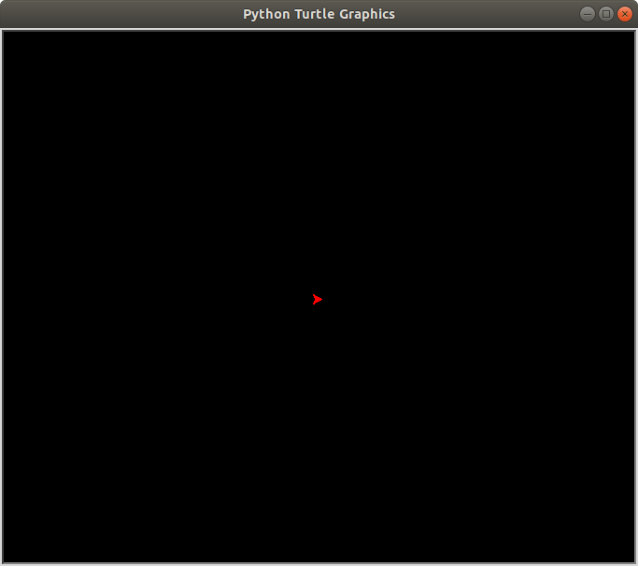
screen.bgcolor("black")
ship.color(‘red’)

Save and run your program.
It should like this →

Looks very familiar doesn’t it.

We want our program to rotate the ship if you press the left or right keys. So we need to add 2 functions that do this.

To create a function called doLeft you type:
def doLeft():
print(“left pressed”)

def doRight():
print(“right pressed”)

Next we are going to add code to listen and respond to the keyboard.

screen.onkey(doLeft, 'Left')
screen.onkey(doRight,’Right’)
screen.listen()

Save and run the program. Press the left and right keys
Now we need to get the turtle to change direction when the keys are being pressed. You’ve already done this earlier. Remember t.left() and t.right()
Replace the print lines with either t.left or t.right. Set the rotate angle to 10.

Save and Run.
The program now looks like:
from turtle import *

ship=Turtle()
screen = Screen()

screenMinX = -screen.window_width()/2
screenMinY = -screen.window_height()/2

screenMaxX = screen.window_width()/2
screenMaxY = screen.window_height()/2

screen.setworldcoordinates(screenMinX,screenMinY,screenMaxX,screenMaxY)

screen.bgcolor('black')
ship.color('red')

def doLeft():
ship.left(10)

def doRight():
ship.right(10)

screen.onkey(doLeft,'Left')
screen.onkey(doRight,'Right')
screen.listen()

Can you see the problem with the spaceship?
We need to create a sapce ship shape that rotates around the centre of the ship and not the front.
Let’s fix that.
Add the following after you made the screen black.
screen.register_shape("ship",((-10,-10),(0,-5),(10,-10),(0,10)))
t.shape("ship")

Save and Run.

from turtle import *

ship=Turtle()
screen = Screen()

screenMinX = -screen.window_width()/2
screenMinY = -screen.window_height()/2

screenMaxX = screen.window_width()/2
screenMaxY = screen.window_height()/2

screen.setworldcoordinates(screenMinX,screenMinY,screenMaxX,screenMaxY)

screen.bgcolor('black')
screen.register_shape("myship",((-10,-10),(0,-5),(10,-10),(0,10)))
ship.shape("myship")

ship.color('red')

def doLeft():
ship.left(10)

def doRight():
ship.right(10)

screen.onkey(doLeft,'Left')
screen.onkey(doRight,'Right')
screen.listen()

Ok. So now we want to add a few capabilities to our ship. It needs to move forward, shoot bullets and eventually collide with asteroids. To do this we need to turn our ship into and object.

Objects are blocks of code that contain both functions and variables. This is called a class

Let’s recreate our spaceship code as a class.
class SpaceShip(Turtle):
def __init__(self): # create spaeceship
Turtle.__init__(self) # create spaceship using Turtle
self.color("red")
self.shape("ship")

def doLeft(self):
self.left(10)

def doRight(self):
self.right(10)

- The code in red is the code for the class which defines the spaceship
- See if you can follow the code where the spaceship is created. Try and guess what the ‘self’ parts of the code mean. Ask a volunteer if you are correct or not.

So the program now looks like:

from turtle import *

screen = Screen()
screenMinX = -screen.window_width()/2
screenMinY = -screen.window_height()/2
screenMaxX = screen.window_width()/2
screenMaxY = screen.window_height()/2
screen.setworldcoordinates(screenMinX,screenMinY,screenMaxX,screenMaxY)
screen.bgcolor('black')
screen.register_shape("myship",((-10,-10),(0,-5),(10,-10),(0,10)))

#define the spaceship class of type Turtle
class SpaceShip(Turtle):
def __init__(self):
Turtle.__init__(self) # same as ship=Turtle()
self.color('red')
self.shape('myship')

def doLeft(self):
self.left(10)

def doRight(self):
self.right(10)

ship = SpaceShip()

screen.onkey(ship.doLeft,'Left')
screen.onkey(ship.doRight,'Right')
screen.listen()

We changed the code to create an object called SpaceShip. The __init__ function creates the object and we use the self keyword to specify THIS CURRENT object.

Next, we are going to add more capabilities to our spaceship.

Firstly, we want our spaceship to know where it is on the screen. Give it a starting position.
We do this by changing the code that creates the spaceship
ship = SpaceShip(Screen, x, y).
and the class code too.
class SpaceShip(Turtle):
def __init__(self, x, y):
Turtle.__init__(self) #same as ship=Turtle()
self.color('red')
self.shape('myship')
self.goto(x, y)

from turtle import *

screen = Screen()
screenMinX = -screen.window_width()/2
screenMinY = -screen.window_height()/2
screenMaxX = screen.window_width()/2
screenMaxY = screen.window_height()/2

screen.setworldcoordinates(screenMinX,screenMinY,screenMaxX,screenMaxY)
screen.bgcolor('black')
screen.register_shape("myship",((-10,-10),(0,-5),(10,-10),(0,10)))

class SpaceShip(Turtle):
def __init__(self, screen, x, y):
Turtle.__init__(self)
self.speed(0)
self.up()
self.color('red')
self.shape('myship')
self.goto(x, y)

def doLeft(self):
self.left(10)

def doRight(self):
self.right(10)

ship = SpaceShip(screen,50,-50)

screen.onkey(ship.doLeft,'Left')
screen.onkey(ship.doRight,'Right')
screen.listen()

Save and Run
Now we need to add an engine to our spaceship. We’ll use the up arrow to add ‘Acceleration’ to our space ship. To start off well use a simple burst of acceleration for each keypress.

add screen.onkey(ship.fireEngine, ‘Up’) into your program.

We also need to add the fireEngine function to our class. To begin with, we’ll create a dummy function that just prints out some text.

def fireEngine():
print(“Engine fired”)
Can you think where these two pieces of code go?

from turtle import *

screen = Screen()
screenMinX = -screen.window_width()/2
screenMinY = -screen.window_height()/2

screenMaxX = screen.window_width()/2
screenMaxY = screen.window_height()/2

screen.setworldcoordinates(screenMinX,screenMinY,screenMaxX,screenMaxY)
screen.bgcolor('black')
screen.register_shape("myship",((-10,-10),(0,-5),(10,-10),(0,10)))

class SpaceShip(Turtle):
def __init__(self, screen, x, y):
Turtle.__init__(self)
self.speed(0)
self.up()
self.color('red')
self.shape('myship')
self.goto(x, y)
self.acceleration = 0

def fireEngine(self):
print("Engine fired :")
self.acceleration = self.acceleration + 1
print(self.acceleration)

def doLeft(self):
self.left(10)

def doRight(self):
self.right(10)

ship = SpaceShip(screen,50,-50)

screen.onkey(ship.doLeft,'Left')
screen.onkey(ship.doRight,'Right')
screen.onkey(ship.fireEngine,'Up')
screen.listen()

We’re nearly there. We are adding acceleration to the ship, but we are not using it up.
We now need a game loop to take that energy and move the ship.

Let’s create a function call gameLoop() to do this

