Longlevens Library Code Club

Graphs in Maths

When you learn mathematics at school, you will encounter all sorts of equations for lines and geometrical shapes such as circles, ellipses and tangents. Before you say “No, not maths in Code Club!”, how good would it be to be able to check your homework before you hand it in? Even if you don’t need to provide a graph with your answer, drawing a graph of an equation could help you verify your worked out result(s). If you don’t yet know about equations for circles and tangents or anything about solving quadratic equations, here’s a chance to get ahead of the class.
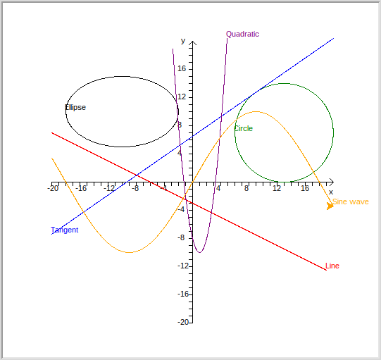
Requirements

Create a program that can produce graphs containing each of the following:
- Straight lines. Formula: where m is the gradient and c is the y value at x = 0.
- Circles. Formula:where point (h, k) is the centre point and r is the radius
- Ellipses. Formula:
where twice a is the width of the ellipse along the x axis and twice b is the width of the ellipse along the y axis. Note, if a = b you have a special ellipse called a circle!
- Tangent on a circle. A tangent is a line that touches a circle or ellipse at just one point. The equation to use is:where point (a, b) is on the circle or ellipse and m_{t} is the gradient at that point.
You will need to find a point on the circle (use the circle formula itself to find one) and work out the gradient at that point. You calculate the gradient of the radius to the chosen point using the formula:where the centre of the circle is at point (h, k). The tangent has to be at 90 degrees to this gradient for which you use the inverse formula:
- Quadratic equations. Formula: where a, b, and c are constants.
- Simple sine waves. Formula: where A is the amplitude.

Hints & Tips
- This exercise is much easier than it may first look. The letters indicating gradients and constants are inputs to be given by the user. For the y values, generate them using the equations for a range of x values. Draw a line from the first point to the next, then the next and you will end up with a straight line, a curve, a circle/ellipse on your graph providing the x and y values are within the limits of the axes.
- Start with a graphic screen area 400 pixels wide and 400 pixels high. The x and y axes will then range from -200 to +200 pixels. The centre point is (0, 0). You need to scale the pixels to the units used in your equations. For a start make the x and y maximum values 20 and the minimum values -20, then all you have to do is scale your answers by a factor of 10.
- When you loop through the x values when drawing curves, make sure your loop increments the x values equivalent to a pixel or two so that your curve is smooth and circles don’t look more like hexagons. You may have to scale your answer prior to running the loop to get the y values in pixels.
- In the case of circles and ellipses, you will get two values of y for each value of x except at the minimum and maximum values of x. If you are really clever you can draw two or even 4 lines for each value of x and reduce the overall drawing time.

Additional Exercise 1 – Draw a two dimensional sine wave

Can you plot a sine wave at multiple points from your initial sine wave? You should get an interesting shape.
Additional Exercise 2 – Make your code more efficient

Just by using the equations as given in your loops should give you the correct results, but not necessarily as fast as the resulting lines could be drawn. For instance:
- Can you draw a line between two points on the boundary of the graph and not calculate y values for values of x in between?
- Do you need to calculate r² each time when drawing circles? Calculate it only once before the loop starts and see how much quicker your circle draws. Are there other calculations that are repeated inside loops that give the same answer every time?
- Are you drawing beyond the edge of the graph? Drawing beyond what is visible takes processing time and large values of y can seriously affect processing speed. Check before you draw if the point you are going to is greater than the maximum value of y or less than the minimum value of y. Do you need to rescale your graph to be able to see the results?
Additional Exercise 3 – Add extra shapes and lines

Make you graph draw parabolas, hyperbolae, cosine waves and any other mathematical shapes and lines for which you can find a formula.

Can you find out how to modify the equations to draw a tangent on a circle so that you can draw one on an ellipse?

