Longlevens Library Code Club

Sudoku Solver

Sudoku puzzles usually consist of a grid of 9 x 9 squares, split up into 9 groups of 3 x 3 squares. Upon completion each digit from 1 to 9, must appear only once in each row, column and 3 x 3 group. Below is a sample completed Sudoku puzzle.
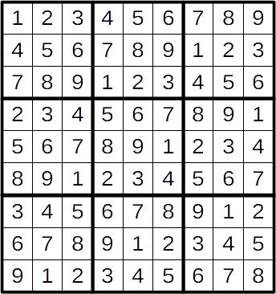

A Sudoku puzzle will usually start with just a few digits in place. To complete the puzzle you have to find squares where only one of the nine digits will fit within the rules. When you put digits in, more squares will be reduced to just one possible digit. However, make a mistake and it can all go wrong and be very hard to go back and fix the error.

Once you have created a Sudoku solving algorithm, it should work for puzzles of any difficulty. You can even try reversing it to create new puzzles for your friends and family to solve!
Hints & Tips
- The algorithm will need to check each square one by one. When it finds a square where only one digit will fit, assign that number in the square. Then restart the algorithm, maybe from the next square or back at the beginning. Keep the algorithm scanning the grid until:
  - It completes all the digits.
  - Finds squares where no digits will fit without breaking the rules.
  - There are only squares where two or more digits will fit. At this point, completion may still be possible. Find a square with the least number of possible digits. Assign one of the possible digits temporarily and restart the algorithm. If it can’t complete the puzzle, go back and switch the temporary digit to the next possible digit and so on until all alternatives are used up or the puzzle is solved.
- If you can’t get your program to solve a puzzle, work through the puzzle yourself with a pen and paper, noting down the thought processes you follow. Convert your written process into code and add it into your algorithm.
- It may sound obvious, but do start with puzzles rated as easy. Maybe use the sample on this page first, removing only a few numbers at first. Continue to remove them and see how much harder it is for the computer to solve it. There will become a point where the puzzle will have more than one solution. Can you make your algorithm check for multiple solutions? Newspapers and magazines have to make sure there only ever is one solution for their puzzles before being published otherwise they would be inundated with complaints! On the following page there is an example of how a puzzle can have more than one solution.
- Be aware that there are many more ways of inserting 1 to 9 in the grid than there are Sudoku solutions. Just putting a few digits into the grid and setting off your algorithm will result in failure more often than not. Use puzzles published in newspapers, magazines and books to test your program.

Additional Exercise 1 – Sudoku X

Make a copy of your Sudoku solver and change it to work with a smaller 6 x 6 grid of squares split into 6 groups of 3 x 2 squares, inserting the digits 1 to 6 only. Then add in to your algorithm this additional rule:

The diagonals shall each have the digits 1 to 6 in them once.

Here’s an example completed puzzle:
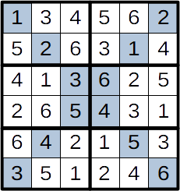
Additional Exercise 2 – Sudoku Puzzle Creator

Once you have a working program, reverse the algorithm to come up with easy, hard and difficult puzzles to solve without using the computer. Use published solutions and remove digits but check the puzzle remains solvable before giving it to your friends or family to complete.

In the Sudoku X sample above, can you spot a group of 4 squares that could lead to two solutions? You must leave one digit in place in the 4 squares at the start to ensure only one solution is possible. Do make sure your puzzles don’t have more than one solution.

