**Lưu đồ (FLOWCHART):**

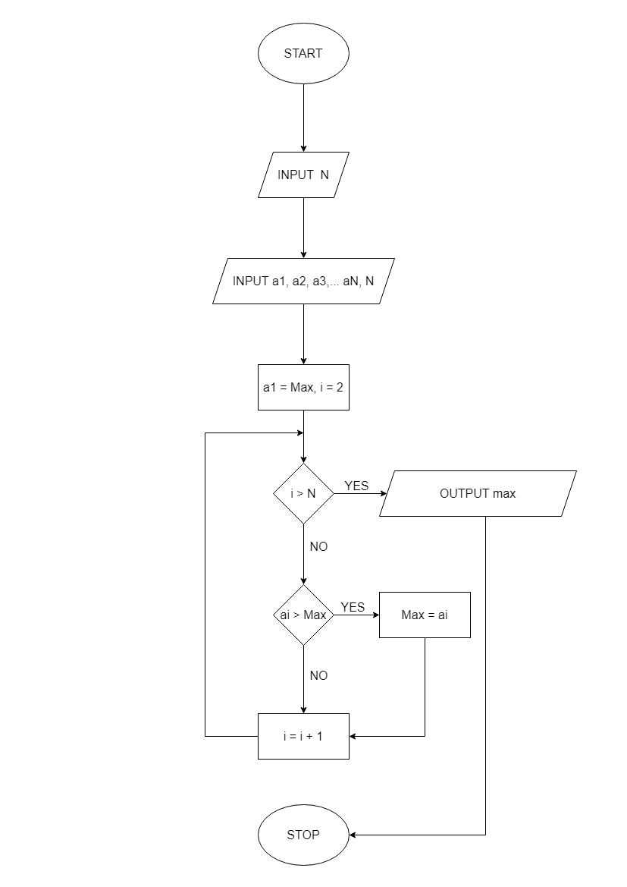

**Mã giã (PSEUDO-CODE)**

BEGIN

INPUT a1, a2, a3,…ai,N.

max = a1 , i = 2

WHILE i <= n

DO

IF max < ai THEN

max = ai

AND IF

i = i+1

END DO

OUTPUT max

END