**Elevate Your Garden with Autumn Colour**

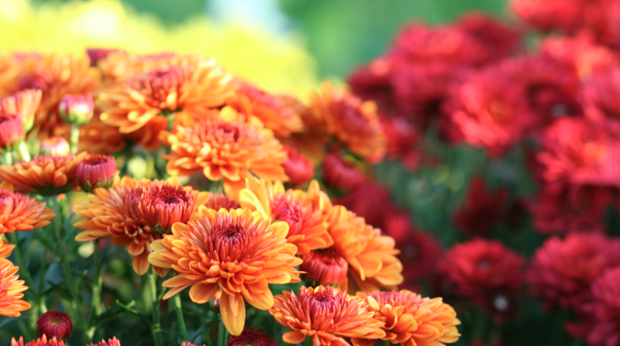

Autumn is a season of transition, where the garden shifts from the lush greens of summer to warmer hues. Enjoy the last of the warmer weather, and fill your garden with vibrant colour that will thrive in the cooler months ahead.

Autumn is nature’s planting time. Planting now gives your plants a chance to get established before winter arrives, and brings vibrant colour to your garden through those cooler months. Here are some of our top tips for creating a stunning autumn garden.

Create Depth

To make your garden feel lush and dynamic, incorporate plants at different heights. Start with taller feature trees like maples, renowned for their fiery red and orange foliage. Add mid-sized shrubs like camellias or azaleas to bring seasonal blooms, and finish with groundcovers such as alyssum or pansies to fill in the gaps.

Plant Odd Numbers

Odd numbers of plants create a natural look in your garden. Start by placing the largest structural plants before working your way down to the smallest ones. To maximise impact, try pairing complementary plants such as colourful cyclamen with soft green ferns, or soft alyssum planted beneath maple trees.

Preparation is Key

Great gardens start with great soil. Before planting, enrich your soil with compost and sheep pellets. For heavier clay soils, add a sprinkle of ClayBreaker Gypsum to improve its structure. These simple steps set the foundation for thriving plants year-round.

Maintenance

Maintaining a thriving garden takes a little care. While the cooler months bring more rain, it’s important to ensure your garden gets a good soaking at least once a week. Feed your plants every three to four weeks with Kings General Garden Fast Food, or for an organic option, try Aquaticus Organic Garden Booster.

To keep your garden vibrant for longer, choose plants with staggered bloom time. Pair early autumn favourites with late-season stars like nandina for a display that lasts well into winter!