**It's Time To Plant Spring Bulbs**

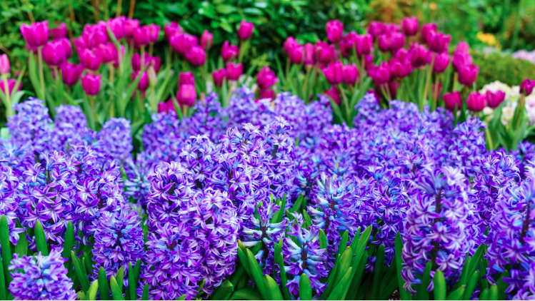

Spectacular spring bulbs will brighten up your garden with their vibrant colour and delightful fragrance. Plant now in autumn to enjoy beautiful blooms once spring arrives. With a huge range of bulbs to choose from, you can create stunning displays in garden beds, borders, or pots.

**Planting**

The best time to plant spring bulbs is in autumn, but specific planting times vary depending on the variety. Check out our top varieties below for detailed tips, or ask a friendly team member instore if you’re unsure. Spring bulbs grow well in both garden beds and pots. When planting in the ground, ensure the soil is well-draining and nutrient rich. Mix in Kings Compost and pumice sand at planting time, or use a specialised mix like [Tui Bulb Mix](https://www.kings.co.nz/tui-bulb-mix-10l-715510) for best results. If your garden beds tend to get soggy during wetter months, plant your bulbs into a slight mound to improve drainage. For pots, choose a container large enough for the bulbs to grow into, and ensure it has adequate drainage holes. Plant directly into Tui Bulb Mix for the best results