1. General description

After you load the webpage, it should display as the following figure. The design of the webpage assumes the monitor has a higher length resolution of 1440 pixels. So if the resolution is under that, it may have some problem of displaying appropriately. So you need to have the webpage displayed in the “Maximize” mode. Besides, the recommended web browser is Fire Fox, but other web browsers should also work well.

As shown in the figure, the left side is a sidebar, allowing you to choose from a set of functionalities. The center part displays the network. The default one is Buffalo network. The right part is the output of some information. By hovering over any node, its node information is displayed. By hovering over any link, its link information is displayed. Note that hovering over one link is a little hard, we need to exactly hover over the link.

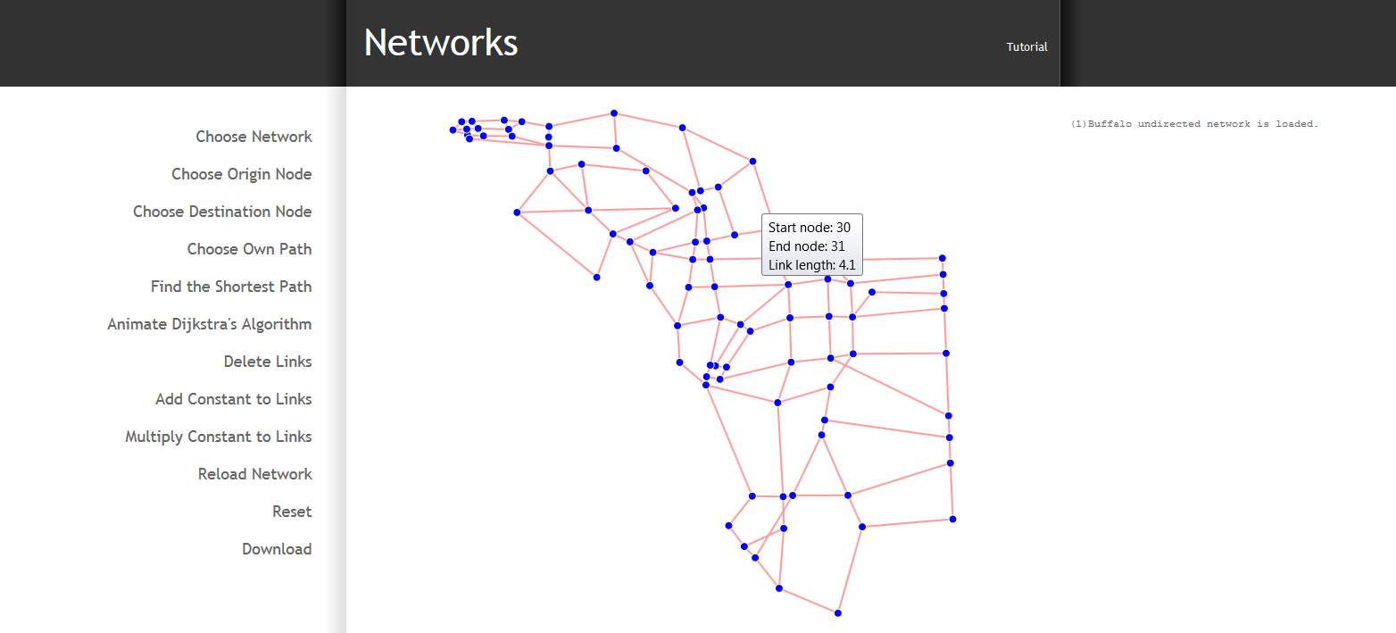

2. Choose Network

By hovering over the “Choose Network” sidebar menu, a second level menu will show up and you are able to choose any network listed (Buffalo, Ravenna and an illustrating example). Besides, log information will be displayed on the right to shown what network you have chosen.

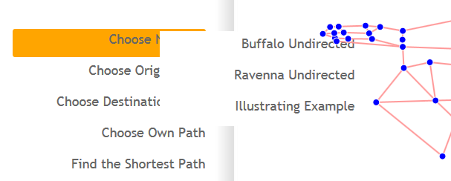

3. Choose Origin Node and Destination Node then to Find the Shortest Path

* Click the “Choose Origin Node” in the sidebar menu, and then click on any node of the network you have chosen to be the original node. Once the node is chosen as original node, it will be shown as red instead of blue.
* Click the “Choose Destination Node” in the sidebar menu, and then click on any node of the network to be the destination node. Once the node is chosen as the destination node, it will be shown as red instead of blue.
* Click the “Find the shortest Path” in the sidebar menu, it will find the shortest path with your chosen origin and destination. A window will pop up to tell you the length of shortest path. Click “OK” on the pop up window. Then you will see the shortest path shown in green on the network. The shortest path distance will be shown in the right output part as well.
* The shortest path algorithm is implemented using Dijkstra’s algorithm. If you want to see the search process, you can click on “Animate Dijkstra’s Algorithm”. It will show you the labeling process. Once a node is shown bigger red circle, it means it is labeled (the minimum distance to the origin node for the remaining nodes). The algorithm stops when the destination node is found.

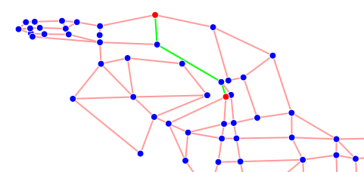

4. Choose Own Path and Compare with Shortest Path

* Click “Choose Own Path”, and then go to the network to choose your own path. You can choose the path by choosing nodes along the path, which means that we can choose the link by choosing its initial and termination nodes. The process goes in this way: You first choose the origin node by clicking on any node, and then choose one of its adjacent nodes. Now you can see one link is displayed with a deeper color which means it is selected. You can continue do so until you reach your ideal destination nod. During the process, you can also un-choose your current link by clicking on the current destination node again.
* Then you click “Find the shortest path”, it will give you the length of your chosen path, and the length of the shortest path. Also, two paths are displayed on the networks if your chosen path is different with the shortest path.

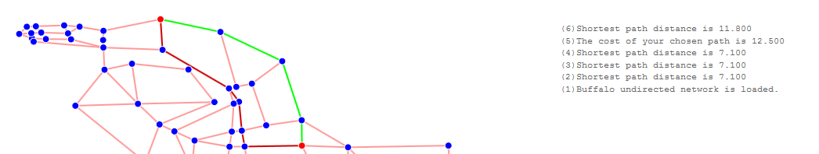

4. Delete Links and See how Shortest Path change

Click on “Delete Links” on the sidebar, you are able to delete any link. Once a link is deleted, it will become dashed line instead of solid line. You may also notice that the “Delete Links” turns to “Stop Deleting Links”. So you can click on “Stop Deleting Links” when you are done.

If you have your chosen origin and destination nodes on the network, after deleting some links, the shortest path can change automatically. You can experiment with this a bit.

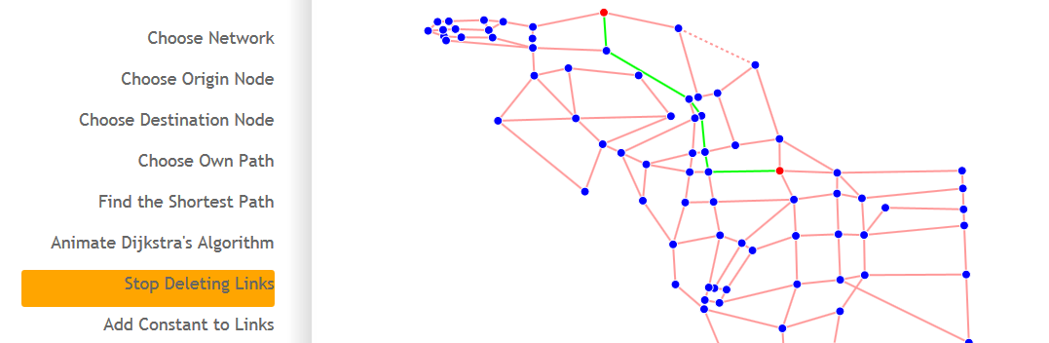

5. Add a Constant to all the Links

By hovering over “Add Constant to Links”, a second menu will show up and let you to choose how much you want to add up to all the links. In order to have appropriate values, we list “5% of the median” and “10% of the median” under this menu.

By clicking “5% of the median” or “10% of the median”, the network link length will increase by certain constant (which value is displayed on the right of the output part). Additionally, if you have chosen your origin and destination nodes, it will give you the shortest path before and after adding the constant. If you did not choose, the default origin node is 1 and the default destination node is the last node.

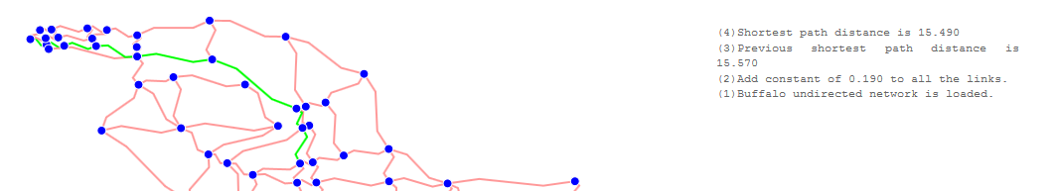

6. Multiply Constant to all Links

By hovering over “Multiply Constant to Links”, a submenu will show up and will let you choose to multiply 1.1 or 1.5 to all the links. By clicking “Multiply 1.1” or “Multiply 1.5”, the network link length will become 1.1 or 1.5 of its original length. Additionally, if you have chosen your origin and destination nodes, it will give you the shortest path before and after adding the constant. If you did not choose, the default origin node is 1 and the default destination node is the last node.

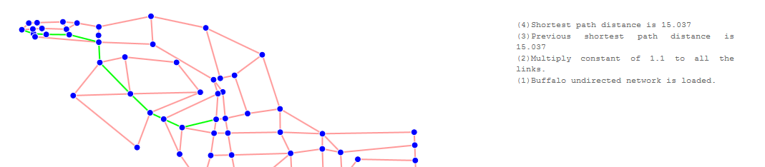

7. Reload Network

By clicking on “Reload Network”, the network you have chosen will be displayed in the original format.

8. Rest

By clicking on “Reset”, it will allow you reset. But the network is the same with the one before reset.

9. Download

By clicking “Download”, it will allow to save the current network data to an “.csv” file.