Unit 3 - Lesson 3 - Part 3: Operational Phase
Lesson 3 of 5

Lesson Objectives
In this lesson we aim to:
Understand ISO 19650 part 3, and the operational phase of an asset.
Audio transcript (00:22)
Organization and digitization of information about buildings and civil engineering works, including Building Information Modeling, BIM, Information Management using Building Information Modeling Part 3. Operational Phase of the assets. The meaning of an operational phase is the period of time that the building or asset is in operation after construction and commissioning is complete.

Operational Phase
As you can see, a huge portion of information management in relation to an asset, and also the bulk of an assets life is during the operational phase.
Audio transcript (00:23)
As you can see, a huge portion of information management in relation to an asset and also the bulk of an assetls life is during the operational phase. This management process has been specifically addressed with ISO 19650 Part three relating to the operational phase of assets. ISO 19650 part three is designed to be a companion to ISO 19650 Part two.

Asset Data
ISO 19650-3 replaced PAS 1192-3 in the UK which was published in 2014 and applicable until part 3 release in 2020.
Audio transcript (00:22)
ISO 19650 Part 3 replaced Paz 1192 Part Three in the UK which was published in 2014 and applicable until Part three release in 2020. For building operators and facility managers, the data embedded in BIM models relating to assets is extremely valuable and must be managed effectively. Data is considered as the new gold.
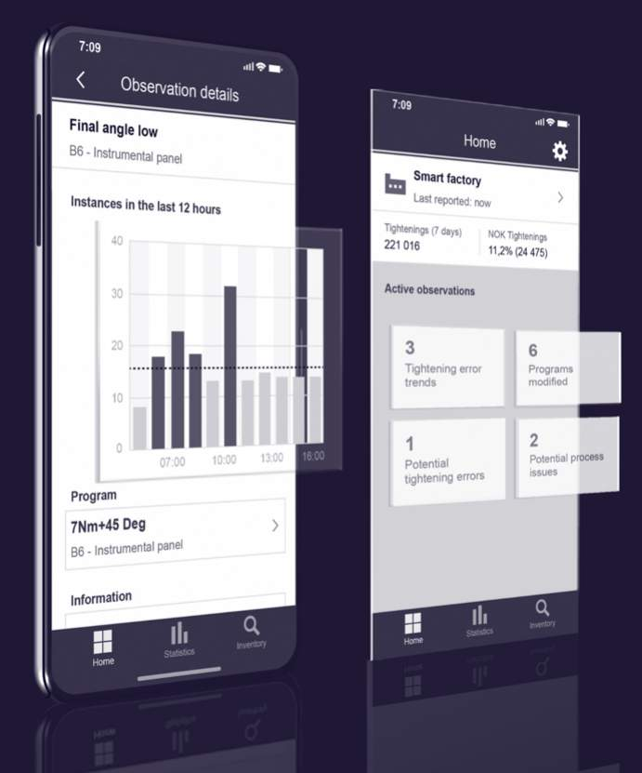
Data is considered the new gold!

Principles
ISO 19650-3 is designed to sit alongside and compliment part 2 and as such you will see many similar processes . This is so they can be utilised over the delivery and operational phase of an assets life.
There are however four key principles that are different:
Trigger Events:
Trigger events have carried over from the PAS standards. Those that can be foreseen and planned for, and those that cannot. an example of planned may be yearly maintenance.

Information Management Flow Chart
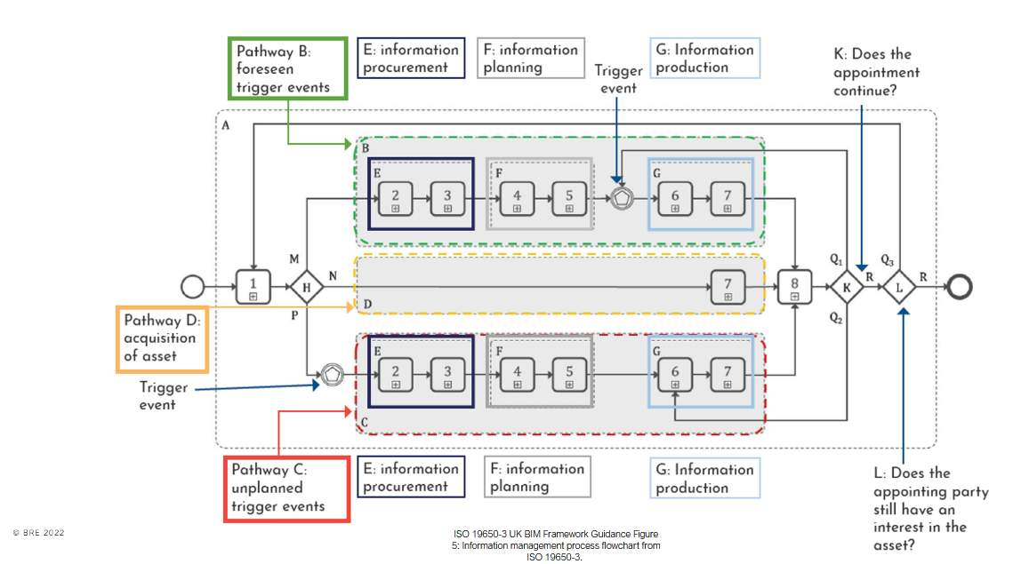
Click on the image to expand.

Activity groupingsA – encompasses all activities during operational phase B – activities per each appointment (before a trigger event)C - activities per each appointment (AFTER a trigger event)
Step 1 leads to three different pathways, shown as shaded boxes labelled B, C and D depending o the trigger eventWithin the pathways B and C, the process isbroken into 3 sub-groups labelled E, F and G.Sub-group E is about procurement – of a tier 1 contractor or an in-house teamSub-group E is about procurement – of a tier 1 contractor or an in-house teamSub-group G is about production – when information is produced by appointed parties, reviewed by a lead appointed party and ultimately accepted by the asset owner/operatorThe process has feedback loops at points K and L.

Lesson Summary
Lesson complete! You are now able to:
Understand ISO 19650 part 3, and the operational phase of an asset.
[CONTINUE]

