Unit 3 - Lesson 5 - Part 5: Security Minded Approach
Lesson 5 of 5

Lesson Objectives
At the end of this lesson, you will be able to:
Understand ISO 19650 part 5 and information security requirements.

Information Security
ISO 19650-5 is a specification for security-minded sensitive information management concerning information received, created or processed in relation to an asset, project, product or service.
The safety and security of information is paramount, and the release, loss or exploitation of that information must be considered through transparent, collaborative production of information.
Audio transcript (00:51)
With the rapid evolution of technology and the need for transparency between design, construction, manufacture, operation and management teams, the way in which we collaborate, share information and open ways of working, we need to address vulnerability issues and therefore security implications such arise whether for built environments, assets, products, services, individuals or communities, as well as any associated information. ISO 19650 Part 5 provides a framework to assist organizations key vulnerability issues and the nature of the controls required to manage security risks to a level that is tolerable to the relevant parties. A security minded approach should be applied throughout the life cycle of an initiative, project, asset, product or service, whether planned or existing, where sensitive information is obtained, created, processed and or stored.
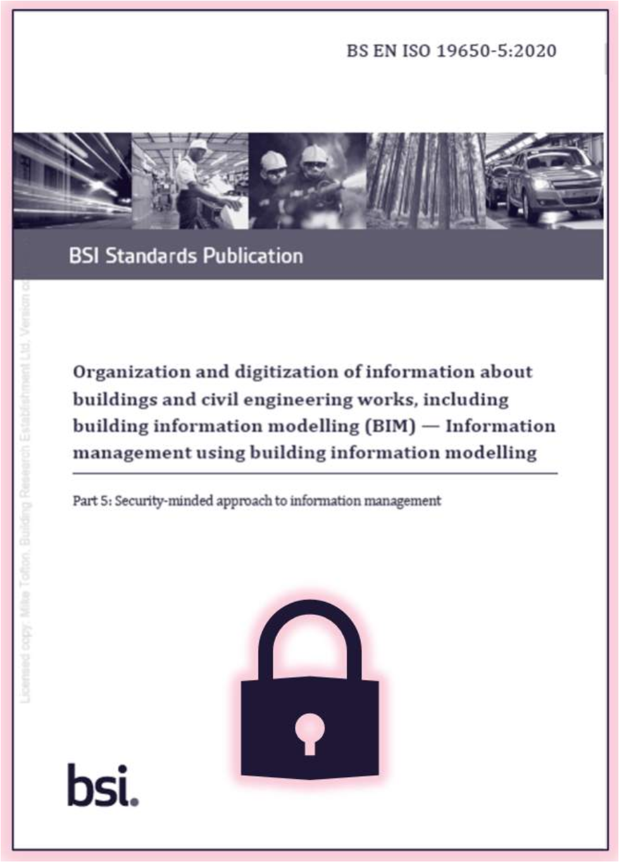
Part 5: Security-minded approach to information management
Refer to ISO 19650-1 and ISO 19650-2 for further understanding of security-mindedness within the context of the ISO 19650 series and the whole life cycle considerations.
The secure management of information is important to maintain the safety and security of:
- Individuals, occupants or users
- Asset Information
- The actual asset
Audio transcript (00:34)
This is important to maintain the safety and security of personnel and other occupants or users of the asset and its services, the asset itself, asset information and or the benefits that asset exists who deliver. Such processes can also be applied to protect against the loss, corruption or disclosure of valuable commercial information and intellectual property. Understanding the security framework is a fundamental aspect of establishing who can access what information and what they can do with it is therefore at the heart of how common data environments are configured and managed.
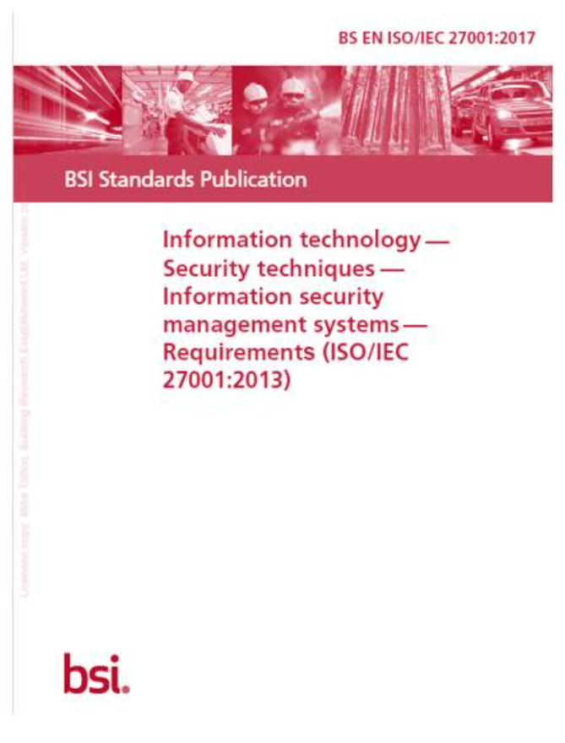
There is a need to adopt information security management systems (ISO 27001) and a security-minded approach (ISO 19650-5).
This is due to the aggregation of information as well as evolving techniques of:
- Hostile reconnaissance
- Malicious acts
- Disclosure of sensitive information
Audio transcript (00:23)
Sensitive information includes intellectual property, commercially sensitive and personally identifiable information. There may be sensitive information that the employer does not want out in the public domain for security issues. For example the CCTV system. That is where the cameras are, where the power is, where they are dealt with internally. Most of the other information was open to everybody, but these would not be.

IT Data Security
Data security is becoming increasingly more important every day.
There are many standards that relate to data security, such as:
GDPR - General Data Protection Regulation

Security Triage
‘The organization(s) shall apply the security triage process outlined in Figure 3 to determine whether a security-minded approach is required in relation to the initiative, project, asset, product or service’
⧉ Missing image (source: https://elearning.bre.ac/pluginfile.php/191403/mod_resource/content/8/content/assets/R3DzXC0Zi4hpYoEk_wPdoiwTV-Z0qVdNm.png)
⧉ Missing image (source: https://elearning.bre.ac/pluginfile.php/191403/mod_resource/content/8/content/assets/lFq1EMCC3JTxlYaf_pWrDydJDyRCopqzc.jpg)

Security Strategy
Based on the outcome of the security triage process, you should be able to determine whether a security-minded approach is required.
If so, the organisation could define a strategy for protecting sensitive information in a document called the security strategy.
⧉ Missing image (source: https://elearning.bre.ac/pluginfile.php/191403/mod_resource/content/8/content/assets/kiZdKCZzwb3iTdb4_yFGmsW9fzvwMP01Z.jpg)
⧉ Missing image (source: https://elearning.bre.ac/pluginfile.php/191403/mod_resource/content/8/content/assets/051McZkF7VG2cRlP_6WNTbPB1b8eFuS6D.jpg)
Managing BIM Information Risk
So, how can the risks to BIM information be managed during the lifecycle stages? The principles for information security are the same for all stages, but require tailoring and a sharper focus on specifics at some points. The basic principles are:
Early Stages:
- Build in information security at the outset. Customers should set security requirements and suppliers should provide information security services as an integral part of their service. Contracts should specify information security requirements such as:
- Non-Functional Security Requirements covering information security;
- Employer Information Requirements;
- A Security Aspects Letter – produced by the customer, for the contractor and which lists sensitive information assets and their values.
- Identify and value sensitive information assets:
- Know what information is sensitive, why, and where it is;
- Determine customer protection priorities;
- Identify and assess risks:
- Assess if you have information that should be protected;
- Understand the requirements for information availability and integrity and not just confidentiality (who is authorised to access it);
All Stages:
- Include responsibility for information security in the wider governance structure:
- Supplier + customer cooperation.
- Control Information sharing
- Common naming conventions and security gradings.
- Balance need to share balance with need to know;
- Access controls within the CDE;
- Manage all forms of data information sharing.
- Roll down information security to supply chain companies;
Basic information security measures;
- Monitor and manage information dissemination.
In Use:
This is the typically long period of time when the building is in use and when the building itself, and the customers within it, can be exposed to attackers who exploit:
- Information compromised during the build stages;
- Building management systems with existing vulnerabilities form the build stages or which become vulnerable because they are not maintained or updated;
Information risk management is not just about technical security measures but includes physical (control of entry, alarms, CCTV), personnel (security checked management teams) and procedural measures (e.g. governance, resilience procedures and effective support processes).
Given the length of time that a building is in use, and the way in which it is used and by whom changes, it is essential that risk assessments and corresponding risk management measures are reviewed and updated to suit.
Audio transcript (01:01)
Based on the outcome of the security triage process, you should be able to determine whether a security minded approach is required. If so, the organization could define a strategy for protecting sensitive information in a document called the Security Strategy. The Asset owner should create built Asset Strategy management plan BASMP to ensure that the risks or combinations of risks identified are addressed in a consistent and holistic manner? To do so, it will need to contain a number of key elements and importantly must bridge 4 areas, people, business process, physical and technological security. The strategy will need to include the project security requirements, the process and procedures for the provision of information to 3rd parties, requirements for data and information storage, monitoring, auditing and review arrangements, a plan for handling security breaches and incidents and an outline of the contractual measures to ensure the adoption of the security minded approach throughout the supply chain.

ISO 19650-5 Process Summary
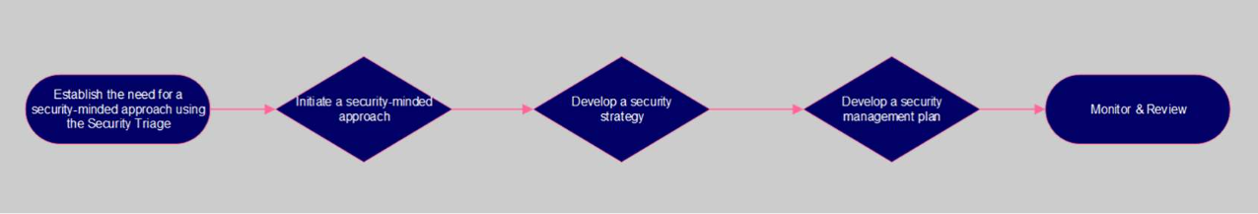
Establish the need for a security-minded approach using the Security Triage( if applicable)
Initiate a security-minded approach
- Establish governance, accountability and responsibility arrangements for the security-minded approach; and
• Commence development of the security-minded approach

This first assessment stage, is also being mandated in the Infrastructure & Projects Authority’s (IPA) 2030 Roadmap.

Develop a security strategy
• Assess the security risks • Develop security mitigation measures • Document tolerated security risks

Develop a security management plan
Develop:
• policies and processes to implement the security mitigation measures
• security information requirements
• requirements relating to provision of information to third parties
• logistical security requirements
• a security breach/incident management plan.

Strategic asset management plan/policy (see ISO 55000)

Learning Summary
Lesson complete! You are now able to:
Understand ISO 19650 part 5 and information security requirements.
Unit 3 Complete!
You should now be able to:
- Understand what international standards are
- Be aware of the key concepts and principles of ISO 19650 pasts 1 & 2
- Have a high level understanding of ISO 19650 part 3, and the operational phase of an asset
- Have a high level understanding of the soon to be released ISO 19650 part 4, and the transition from BS 1192-4
- Describe COBIE
- Have a high level understanding of ISO 19650 part 5 and information security requirements.

Module Complete, you may now close this window to continue your course

