Unit 5 - Lesson 2 - Assemble Shared Resources
Lesson 2 of 3

Lesson Objectives
In this lesson we aim to:
Understand ISO 19650-2 Clause 5.2.2 Assemble reference information and shared resources
Audio transcript (00:09)
This lesson relates to ISO 19650, Dash Two Clause 5.2.2 assemble reference information and shared resources.

Assemble Shared Resources
To facilitate consistent delivery the provision of templates will aid this delivery team. This could be the following:
- BIM Execution Plan Templates
- Responsibility matrix Templates
Audio transcript (00:27)
To facilitate consistent delivery, the provision of templates will aid this process. If an appointing party can provide a BIM execution plan template that maps to its exchange information requirements, then a direct correlation between question and answers can be provided. This also facilitates comparison between responses from multiple suppliers and can aid in applying automation. Similarly, the provision of other templates can reduce waste from the process and facilitate better outcomes.
Source audio: Lesson 2 - Assemble Shared Resources - BIM ISO 19650 12 Project.mp3
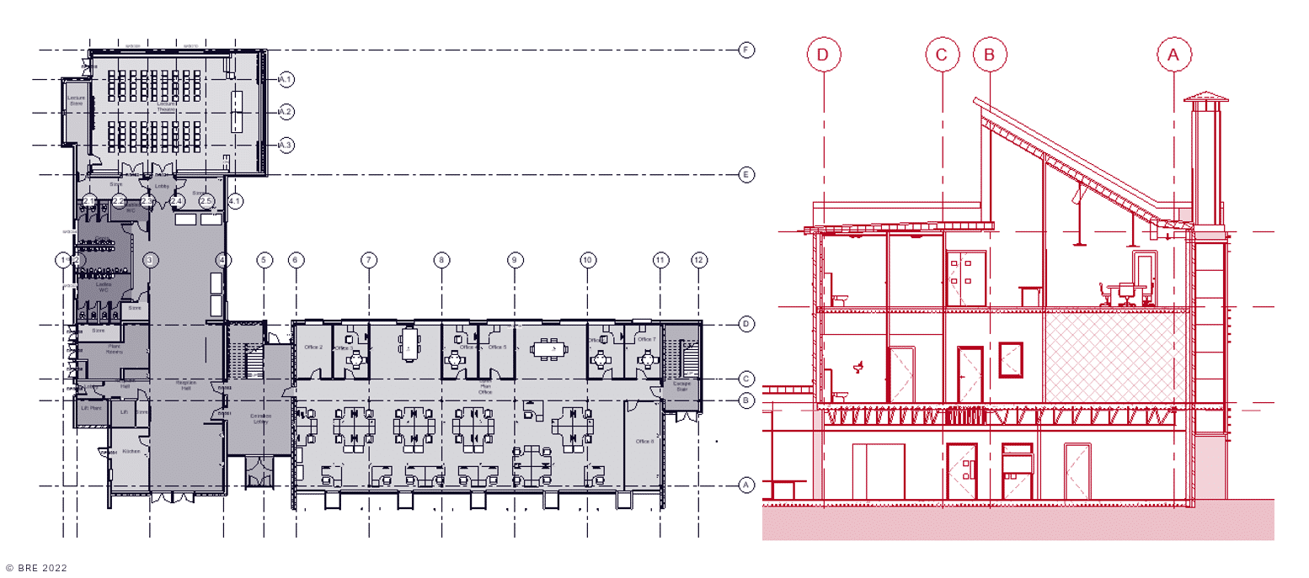
Existing Building model examples

Lesson Summary
Lesson complete! You are now able to:
Understand ISO 19650-2 Clause 5.2.2 Assemble reference information and shared resources
[CONTINUE]

