Unit 5 - Lesson 3 - Tender Response & Evaluation Criteria
Lesson 3 of 3

Lesson Objectives
At the end of this lesson, you will be able to:
Audio transcript (00:12)
Understand Tender Responses and Evaluation Criteria The appointing party shall establish the requirements that tendering organizations shall meet within their tender response. Acceptance criteria is explained in ISO 19650, dash Two clause 5.2.3.

Evaluation Criteria
The systems to support this evaluation and acceptance processes are:
- Project procurement
- BIM execution plan
- I.M competency assessments
- Capability and capacity summary
- Information risk register
- Mobilization plan
Audio transcript (01:13)
The appointing party shall use a set of criteria typically defined in the EIR to either accept or reject the information. Typically evaluation considerations could be grouped under the following sections, price, understanding of the requirements, compliance with ITT requirements, technical skills, resource availability, management skills and systems, proposed methodology. Price is not part of the IM portion of the ISO as the information procurement appointment should be integrated into the project procurement and it is the project procurement that will consider price. The BIM execution plan can be used to consider whether the delivery team has understood the requirements. A completed tender return or checklist system will confirm compliance. The appointing party needs to evaluate the competency for the IM function. The delivery team capability and capacity summary can be used to consider whether the delivery team has the skills and resources available. The BIM execution plan and information delivery risk assessment can be used to consider whether the delivery team has acceptable management skills and systems in place. The mobilization plan is how you're going to test your proposals work. This can be used to consider whether the delivery team has provided an acceptable methodology.
Source audio: Lesson 3 - Tender Response Evaluation Criteria - BIM ISO 19650 1.mp3

Compile Invitation to Tender Information
The appointing party shall assemble the invitation to tender package.
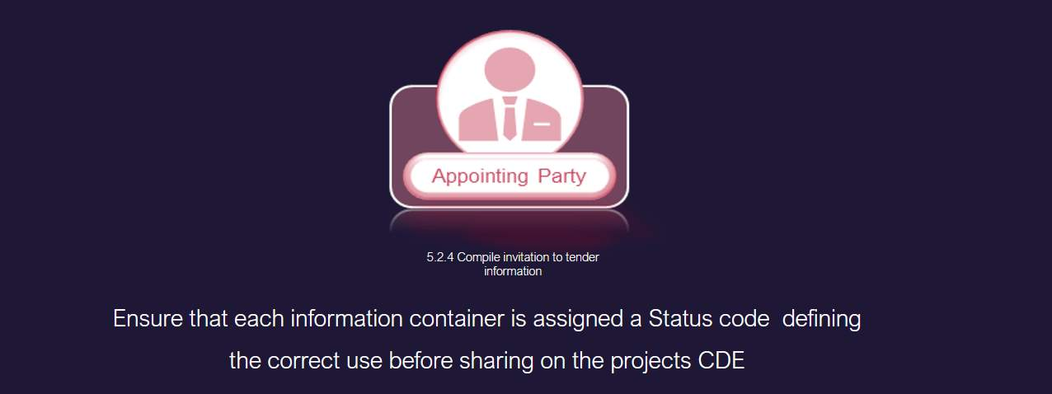
Audio transcript (00:15)
524 Compile invitation to tender information. The appointing party should assemble the invitation to tender package. Ensure that each information container is assigned a status code defining the correct use before sharing on the project. CDE.

Invitation to Tender Activities
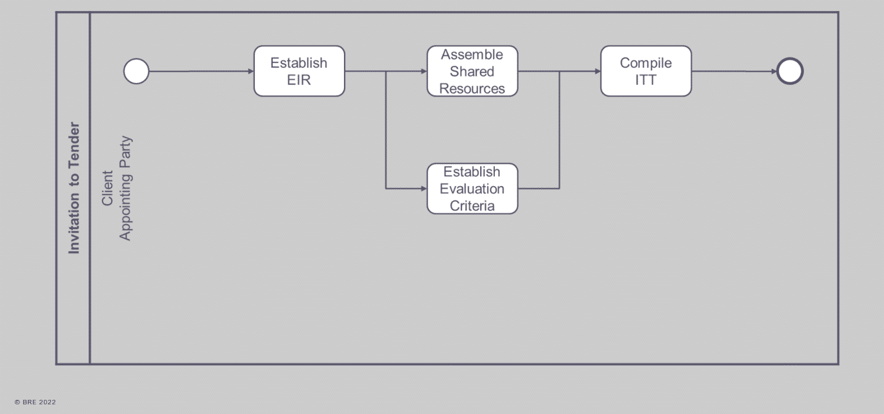
Summary of ITT or invitation to tender activities
The appointing party needs to:
Establish EIRAssemble Shared ResourcesEstablish Evaluation CriteriaAnd then compile the ITT

Learning Summary
Lesson complete! You are now able to:
Understand Tender Responses and Evaluation Criteria
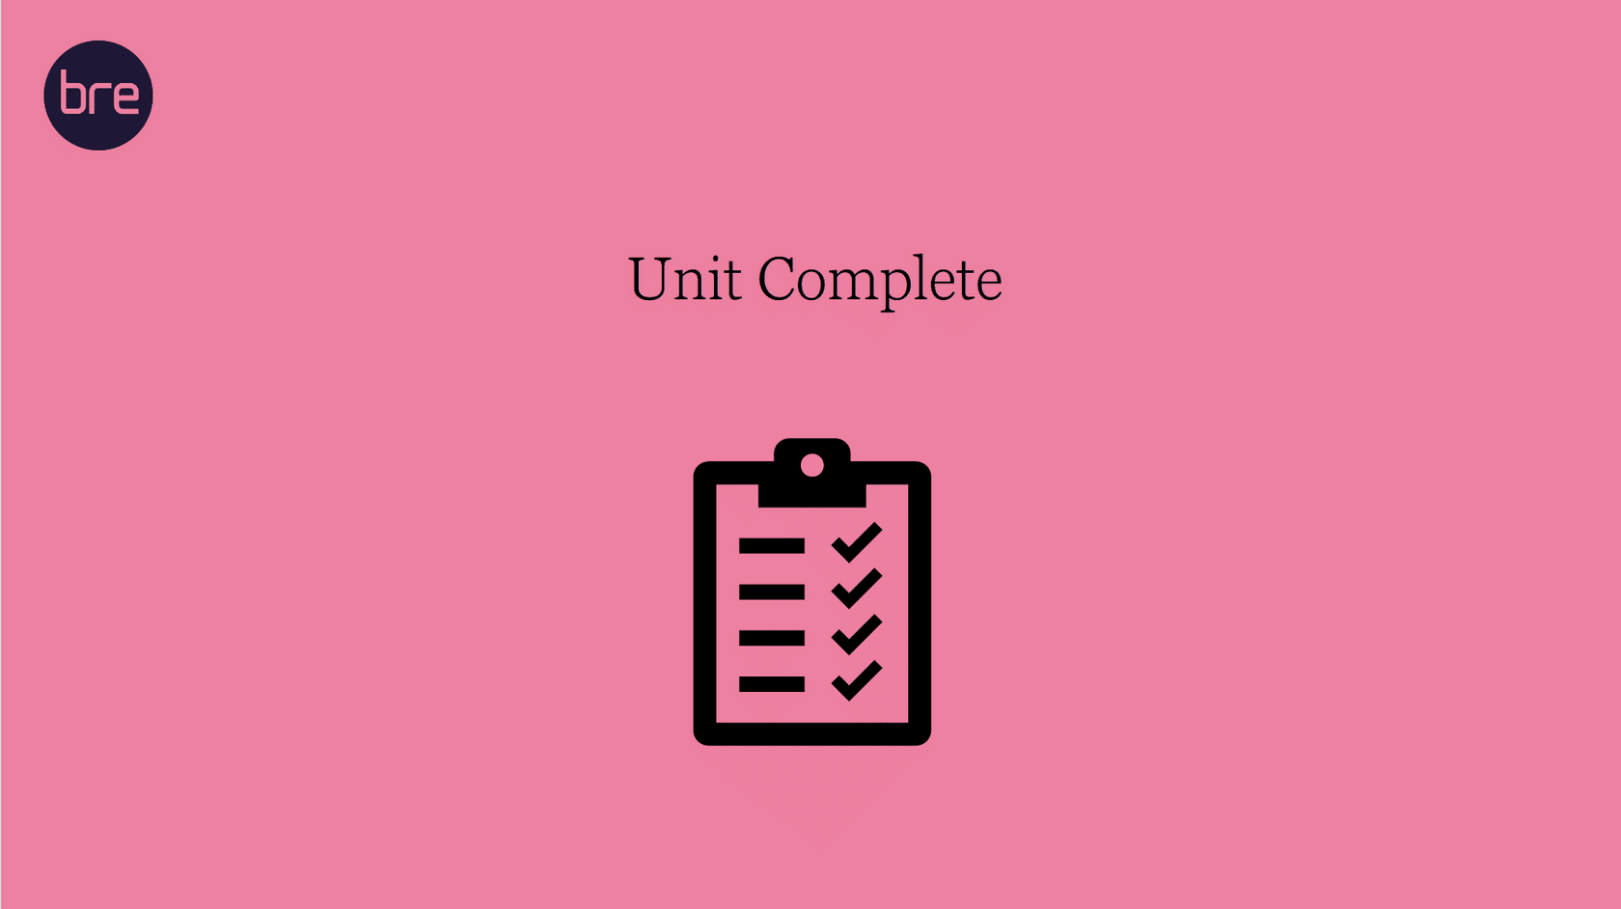
Unit 5 Complete!
Module Complete, you may now close the window and complete this module.

