Unit 11 - Lesson 2 - Capture Lessons Learned
Lesson 2 of 2

Lesson Objectives
At the end of this lesson, you will be able to:
Understand the Capturing of Lessons Learned
Audio transcript (00:11)
The closeout process. During the closeout process, issues should be reviewed and lessons learned captured to enable the improvement in the processes of future projects.

Capture Lessons Learnt
The appointing party, in collaboration with each lead appointed party shall capture lessons learned throughout the entire project.
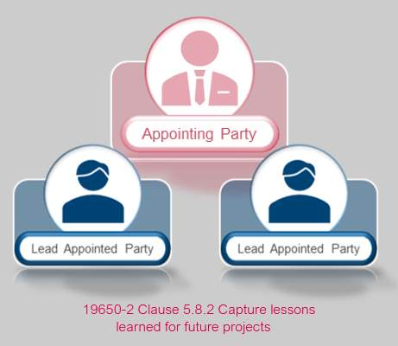
Capture of lessons learned is also an activity referenced in the BS 8536 series as part of soft landings.
Audio transcript (00:57)
The appointing party in collaboration with the lead appointed party shall capture lessons learned throughout the entire project. Adequate time should be set aside to identify, record and understand the lessons learned in order to improve future processes. A structure and consistent format is recommended, typically using a lessons learned tracker that can be configured throughout the project phases. Lessons learned shall be reviewed with the lead appointed party to feedback into the OIR, AIR and other associated briefing documents for future projects and reuse. Capture of lessons learned is also an activity referenced in the BS 8536 series, which remains within the UK BIM framework, as part of soft landings. Soft landings provide a structured methodology whereby lessons can be captured. Post occupancy evaluation is a core part of the soft landings framework, a joint initiative by BS RIA in the Usable Buildings Trust.
Source audio: Lesson 2 - Capture Lessons Learned - BIM ISO 19650 12 Project De.mp3
The UK BIM Framework Information management according to BS EN ISO 19650 Guidance Part 2 lists some example criteria to use during a lessons learned exercise:
• Performance Metrics
• Budget & Programme
• Procurement Process
• Information Management Process
• Final Costs
• Operational Asset Performance
• Social Benefits
• Carbon Impact
Audio transcript (01:33)
The Lessons Learned close-out meeting is a requirement of ISO 9650. The UK BIM Framework Information Management, according to BSEN ISO 9650 Guidance Part 2, lists some example criteria to use during a Lessons Learned exercise. Assess any pre-determined performance metrics. Did the project delivery meet required budget and programme? Did the procurement process satisfy all parties? Did the information management process deliver its required outcomes? What are the final commercial costs for the project for benchmark purposes? Does the operational asset perform as designed? What were the social benefits or values delivered by the project? What was the carbon impact of the investment? Following the construction playbook to drive better, faster and greener delivery in future projects and programmes, we need to collect robust data to understand what went well and where we can improve in relation to the as-built carbon footprint, for example. Identifying project management processes that not only failed but were also a success on this project. Perhaps you implemented a new workflow, we learned from failures as well as successes. Verify if the lesson is unique to this project or whether it can be used for future projects also. It is advisable to use software which can extract data for future use, such as keywords, etc. Consider AI, machine learning, etc. And distribute key learnings to relevant people for future use and efficiency of planning, design, build and operation.
Source audio: Lesson 2 - Capture Lessons Learned - BIM ISO 19650 12 Project De (2).mp3
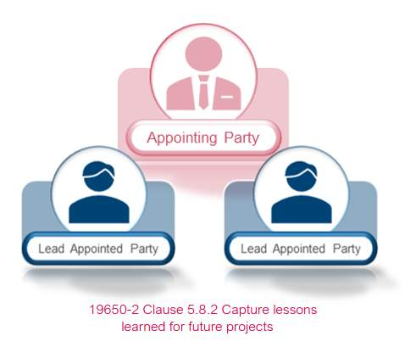
The lessons learned close-out meeting is a requirement of ISO 19650. A meeting agenda will aid in this process, with a typical structure being:
- Close Out
- Project Information
- Gather Lessons Learned
- Lesson Confirmation
- Lesson Capture
- Distribute Findings
Audio transcript (00:58)
The Lessons Learned close-out meeting is a requirement of ISO 9650, a meeting agenda will typically aid in this process with a typical structure being close-out, complete PIM archive, project information, list project team names and contacts, define the project type, sector and purpose, gather lessons learned, identifying project management processes, success and failures, information to be gathered throughout the project lifecycle, not just at close-out. Lesson confirmation, verify if the lesson is unique to this project or whether it can be used for future projects also. Lesson capture, use software which can extract for future use such as AI, machine learning etc. Distribute findings, send findings to relevant people and use data storage processes for future big data harvesting. Distribute key learnings to relevant people for future use and efficiency of planning, design, build and operation. Harness data sorting.
Source audio: Lesson 2 - Capture Lessons Learned - BIM ISO 19650 12 Project De (1).mp3
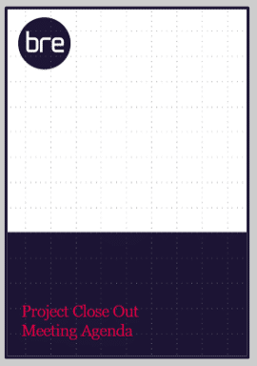

Project Close Out Activities
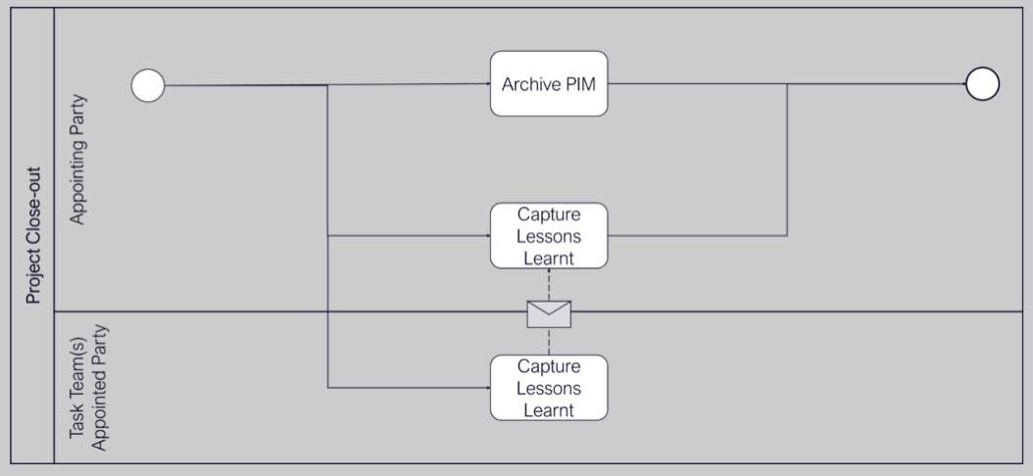
Reference: ISO 19650-2, 5.8
Audio transcript (00:52)
Normally when we're talking about archiving, it is describing an information model passing through a gateway, and therefore each time an archive should be made of the information model. The PIM may need to be moved to a particular location as the project portion of the CDE may no longer be appropriate. The ISO picks up on the Government soft landings approach of capturing lessons learned. These lessons can be from how the building is being operated, but also down to the processes methodologies, standards etc that were used on the project. Advantages and disadvantages of using particular software solutions. All these lessons can then be fed back into the process to make the next project better. Lessons learned shall be reviewed with the lead appointed party to feedback into the OIR, AIR and other associated briefing documents for future projects and reuse in line with procedure.
Source audio: Lesson 2 - Capture Lessons Learned - BIM ISO 19650 12 Project De (3).mp3

Learning Summary
Lesson complete! You are now able to:
Understand the Capturing of Lessons Learned
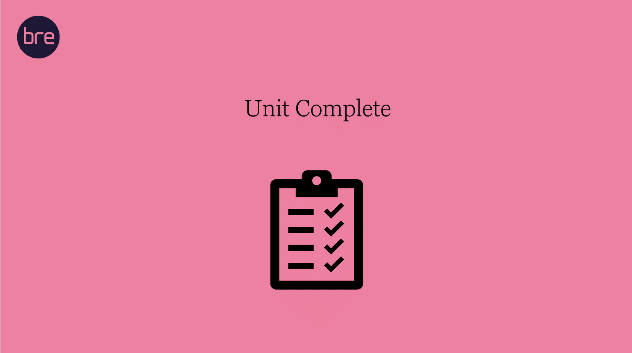
Unit 11 Complete!
You may now close the window and complete this module.

