Unit 12 - Lesson 1 - BRE Individual & Business Certification
Lesson 1 of 1

Lesson Objectives
At the end of this lesson, you will be able to:
Explain the processes and benefits of BIM Certification
* * *
BRE offers both individual and business certification.
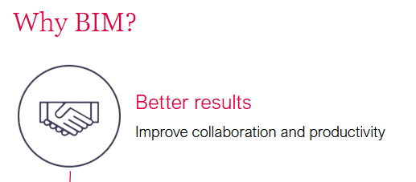
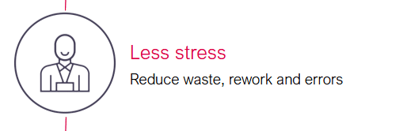
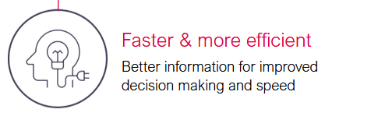
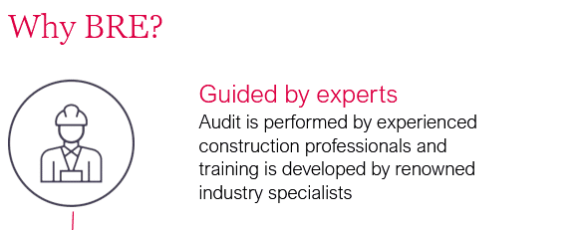
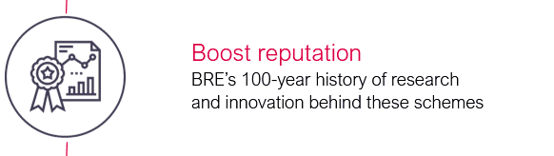


BRE, BIM & Information Management
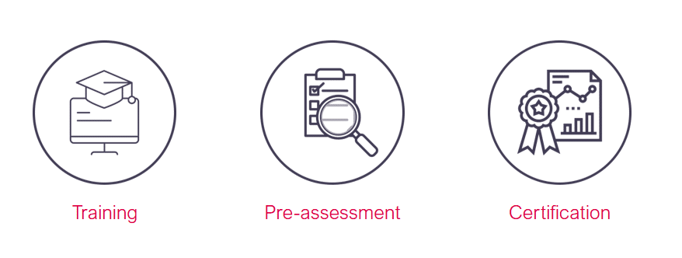

Training with BRE Academy
- Expert-led
World-class training and education programs led by BIM experts
- International
Training delivered in over 40 countries
- The whole supply chain
Suitable for the whole supply chain
- CPD
All course provide Continuous Professional Development (CPD) hours
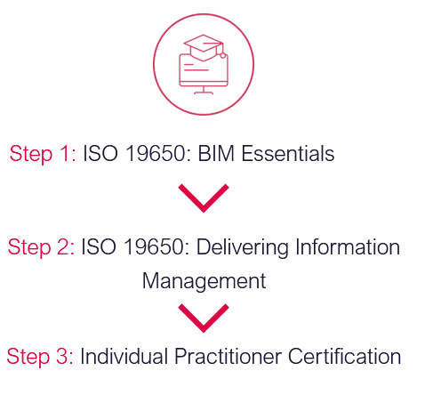

Certification for Individuals
We offer two types of certification for individuals:

Audio transcript (01:03)
We offer two types of certification for individuals. BIM-Informed Professional, ideal for policymakers, advisors, educationalists and construction professionals who are implementing the BIM process. Assessment, demonstration of detailed knowledge and understanding of information management using BIM. BIM Practitioner Certificate, ideal for a project-based construction professional applying an implemented information management process. We offer task information management, TIM and project information management PIM certification routes. You are able to apply for both routes if you wish. Assessment, certification assessment covers the detailed knowledge and understanding of information management using BIM. Applicants are also encouraged to provide project-based evidence where relevant. Experience and evidence are not mandatory for applying to these certification routes but are beneficial. If you do not have experience of working within a BIM environment or cannot provide project-based evidence, you will be required to include explanations and or self-produce workflows instead.
Source audio: Lesson 1 - BRE Individual Business Certification - BIM ISO 19650.mp3

Pre-assessment: for Businesses

Audio transcript (00:28)
Pre-assessment is a gap analysis of BIM processes against the requirements of ISO 9650 Part 2 2018 and the BRE Global Scheme. Having a BRE pre-assessment before applying to BRE Global ISO 9650 Part 2 2018 saves time longer term. It will pinpoint how to prepare better for ISO 9650 Part 2 2018. Please note that pre-assessment is not consultancy.
Source audio: Lesson 1 - BRE Individual Business Certification - BIM ISO 19650 (2).mp3

Businesses BIM Certification Scheme

Audio transcript (00:34)
ISO 9650 Part 2 2018 BIM Certification for Businesses Differentiate from the competition, demonstrating business-wide excellence. Give confidence that products and services perform as expected and are monitored by a program of regular audits. Reduce resources needed to align disparate systems and improve collaboration. Remove the requirement for clients to carry out BIM capability assessments and also increase building opportunities. Ensure clients stay focused and that quality is maintained throughout annual audits from experienced BRE BIM experts.
Source audio: Lesson 1 - BRE Individual Business Certification - BIM ISO 19650 (1).mp3

Client Success Stories
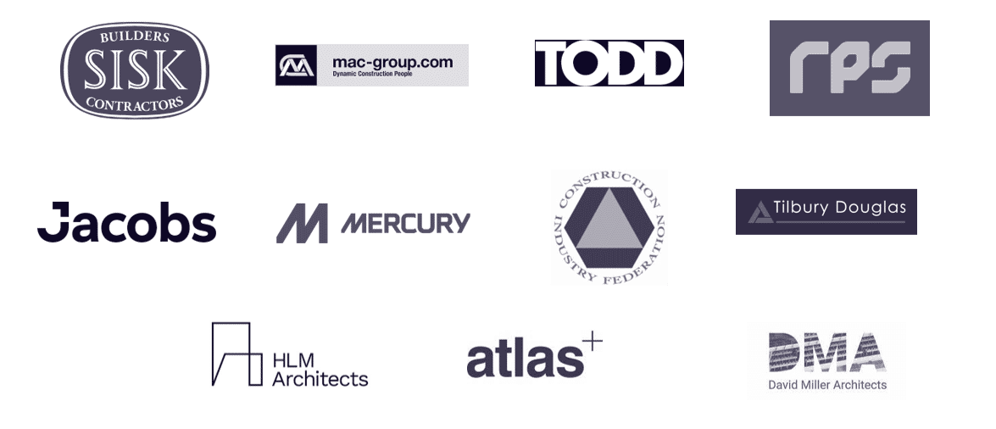
Pathway to ISO 19650 AccreditationJohn Sisk & Son – Ireland’s leading builder and contractor - https://www.johnsiskandson.com/(opens in a new tab) Currently with BRE for: BIM ISO19650 Certification across Ireland and UK officesBIM ISO19650 Essentials and Information Management training
Other services:Smart Waste (Enterprise), BREEAM, SSM, MMC, TestingBIM ISO19650 Essentials and Information Management trainingRPS Group – leading global professional services – www.rpsgroup.com(opens in a new tab)Currently with BRE for: BIM ISO19650 Individual and Company CertificationBIM ISO19650 Essentials and Information Management trainingOther services: BREEAM, CEEQUALMAC Group – Construction, interior and modular – www.mac-group.com(opens in a new tab)Currently with BRE for: BIM ISO19650 Certification across Ireland and UKBIM ISO19650 Individual CertificationBIM ISO19650 Essentials and Information Management training
Other services:BREEAM, MMC, District Heat MappingMercury Engineering – European contractor – www.mercuryeng.com(opens in a new tab)Currently with BRE for: BIM ISO19650 Essentials trainingOther services currently in discussions with: BREEAM, MMC, BIM ISO19650 Company Certification, TestingTODD Architects – www.toddarch.com(opens in a new tab)Currently with BRE for: BIM ISO19650 Certification across Ireland and UKBIM ISO19650 Individual CertificationBIM ISO19650 Essentials and Information Management training
Other services currently in discussions with:BREEAM, Smart WasteConstruction Industry Federation – www.cif.ie(opens in a new tab)Currently with BRE for: BIM ISO19650 Essentials and Information Management trainingOther services: MMCJACOBS – www.jacobs.com(opens in a new tab)Currently with BRE for: BIM ISO19650 Certification across UK, India and Poland for Highways, extending scope each year, currently progressing extension across all UK Business Units.B BIM ISO19650 Individual CertificationBIM ISO19650 Essentials and Information Management trainingTilbury Douglas - https://tilburydouglas.co.uk (opens in a new tab)
Building, Infrastructure, Engineering and fit out company (formerly Interserve)Currently with BRE for: BIM ISO19650 Certification across UK for Construction & EngineeringBIM ISO19650 Individual CertificationBIM ISO19650 Essentials and Information Management training

Learning Summary
Lesson complete! You are now able to:
Explain the processes and benefits of BIM Certification
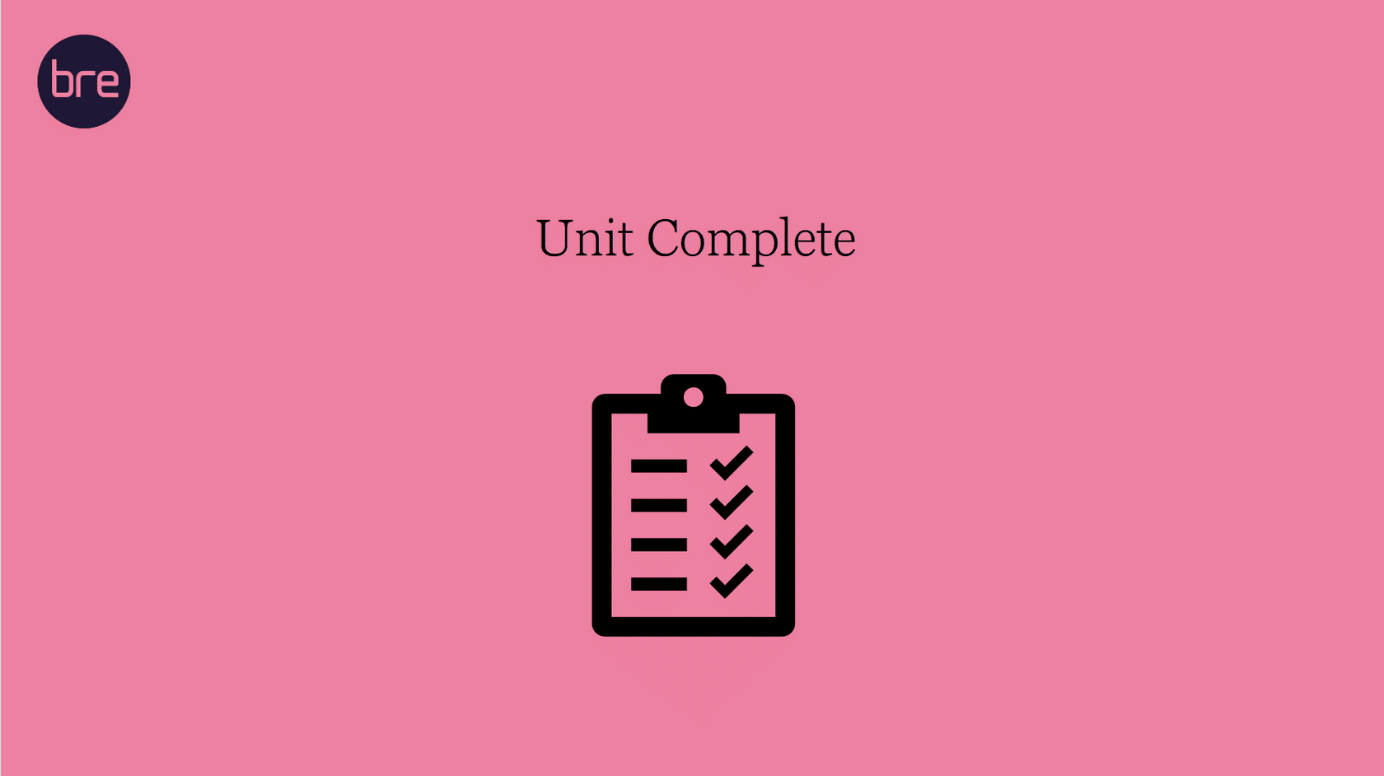
Unit 12 Complete!
Well done! You have completed the
BIM ISO 19650 1&2 Project Delivery Course.
* * *
You may now close the window and complete this course.

