Unit 6 - Lesson 4 - Establish The Mobilization Plan
Lesson 4 of 5

Lesson Objectives
At the end of this lesson, you will be able to:
Understand the process associated with ISO 19650 -2 & 3 Clause 5.3.5 Establish the delivery team’s mobilization plan
Audio transcript (00:57)
This lesson will explain the process associated with ISO19650-2 and 3 clause 5.3.5 establish the delivery team's mobilization plan. The purpose of the mobilization plan is to test what was said would be done in the pre-contract BIM execution plan, can be delivered and that the right people with the right skills are available. 1. Mobileized resources may include developing educational material, developing training material, recruiting additional members or supporting individuals and organizations that join the delivery team. 2. Mobileized IT may include configuring the common data environment as well as procuring and configuring additional hardware, software and infrastructure. 3. Test methods and procedures may include testing and documentation as well as testing information exchanges between task teams and information delivery to the appointing party.
Source audio: Lesson 4 - Establish The Mobilization Plan - BIM ISO 19650 12 Pr.mp3

Establish The Mobilization Plan
The plan will demonstrate the prospective LAP approach to the indicative timescales and responsibilities for things such as:
- Testing Procedures, info exchange & delivery
- Configuring the CDE’s
- Implement software, hardware and IT
- Compile shared resources
- Train the task teams where required
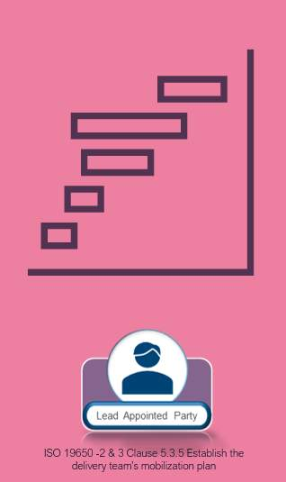

Learning Summary
Lesson complete! You are now able to:
Understand the process associated with ISO 19650 -2 & 3 Clause 5.3.5 Establish the delivery team’s mobilization plan
[CONTINUE]

