Unit 7 - Lesson 2 - Establish the Detailed Responsibility Matrix
Lesson 2 of 6
Audio transcript (00:09)
Using the High-level responsibility matrix, a detailed responsibility matrix is produced to identify the what in terms of information that is to be produced.

Lesson Objectives
In this lesson we aim to:
Understand the Establishment of the Detailed Responsibility Matrix

Establish the Detailed Responsibility Matrix
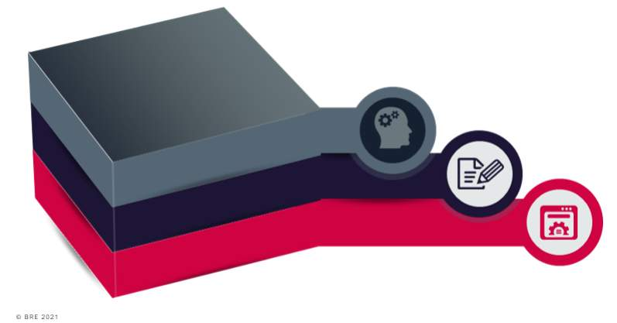
Audio transcript (00:50)
The LAP take the high-level responsibility matrix and go into further detail to establish the detailed responsibility matrix which ascertains a detailed responsibility matrix shall identify what is being produced, when it is being exchanged and which task team is responsible. In doing so, the lead appointed party shall consider Information Delivery milestones, review EIR and ensure all milestones are included in the responsibility matrix. High-level responsibility matrix, review high-level responsibility matrix and ensure all elements or deliverables are transferred and included. Standards, methods and procedures, information container breakdown structure, volume strategy reviewed and volumes included in the responsibility matrix and information production process dependencies. Next we'll look at the responsibility matrix in more detail.
Source audio: Lesson 2 - Establish the Detailed Responsibility Matrix - BIM IS.mp3
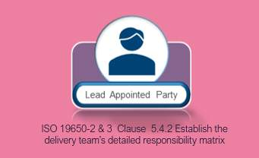
A detailed responsibility matrix shall identify what is being produced, when it is being exchanged, and which task team is responsible.
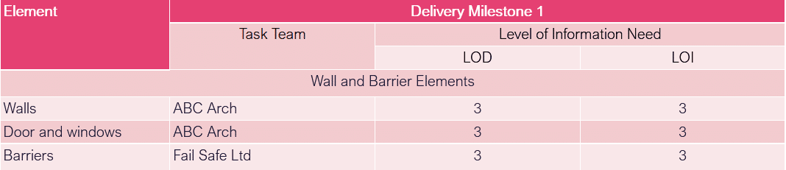
Audio transcript (01:22)
Note, Uniclass is the UK implementation of ISO 12006 Part 2, organization of information about construction works, Part 2, framework for classification. Against each element it is defined who is going to do what, when and to what level of information need. The use of geometry and information to express level of information need within this responsibility matrix is indicative only. This is typical of what was shown in the digital plan of work such as the NBS toolkit. Some people are using a schedule of elements as shown here, as Uniclass 2015 others have started generic where possible. At a high level it could be who is doing the architectural items, who is doing the structural etc. The level of information need is typically defined in numbers 1 to 5 with the number aligning to match the work stage in most cases. This matrix will usually be a spreadsheet with each milestone listed and each element broken down as shown. The responsibility matrix will initially set out high level tasks and who will undertake these. As the BEP is developed these will turn into a detailed responsibility establishing level of geometric and non geometric information requirements. Appropriate choice of plans of work and classification systems will aid in the development of the responsibility matrix. The detailed responsibility matrix is bridged between the high level responsibility matrix and the delivery plans.
Source audio: Lesson 2 - Establish the Detailed Responsibility Matrix - BIM IS (1).mp3
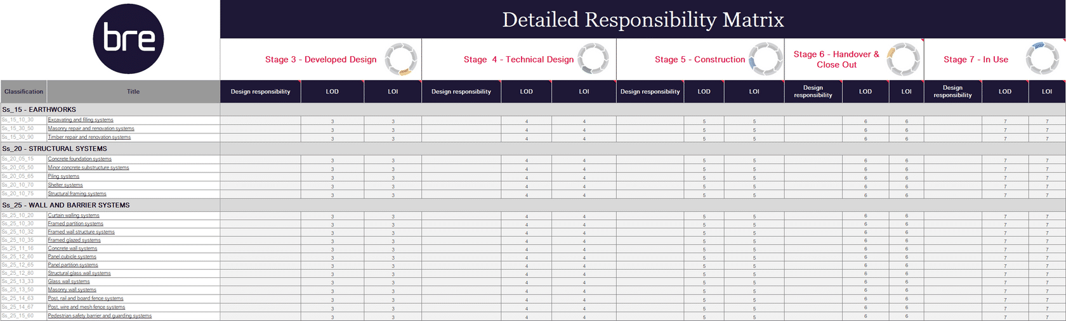
An Example Dataset

Lesson Summary
Lesson complete! You are now able to:
Understand the Establishment of the Detailed Responsibility Matrix
[CONTINUE]

