Unit 7 - Lesson 3 - Establish the Lead Appointed Party EIR
Lesson 3 of 6
Lesson Objectives
Audio transcript (00:36)
At this stage we now have to start with the cascade of the exchange information requirements. In the information procurement phase the lead appointed party's exchange information requirements were delivered. Now the lead appointed party needs to develop their exchange information requirements. The lead appointed party needs to cascade relevant information requirements down to the task teams. A project may consist of multiple appointments. Each appointment by the appointing party shall establish exchange information requirements. Therefore as a project will consist of multiple exchange information requirements which need to be tailored to the party they're going to be issued to.
Source audio: Lesson 3 - Establish the Lead Appointed Party EIR - BIM ISO 1965.mp3

Staged Information Exchange
This diagram below shows that there will be multiple appointments during a project.
Each of these stages: design, construct and operate, is a new appointment and has to follow the whole appointment process.
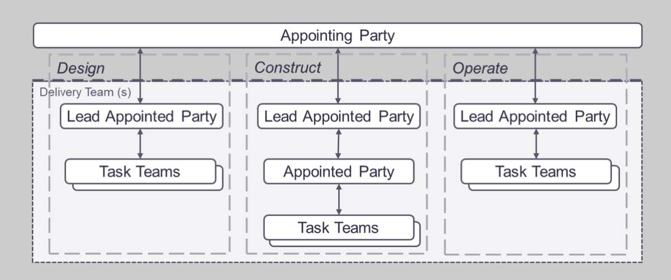
ISO 19650-2 Clause 5.3.7 Compile the delivery team’s tender response

Exchange Information Requirements per Work Stage
The lead appointed party shall establish their EIR for each appointed party (Task team) taking into account the appointing parties EIR.
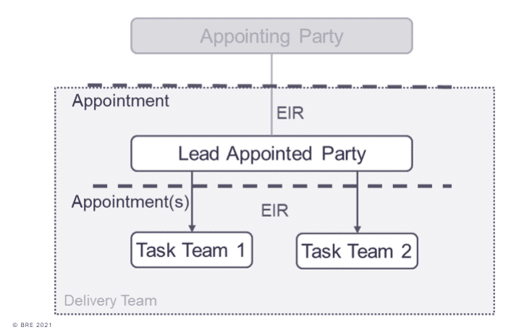
A project may consist of multiple appointments. Each appointment by the appointing party shall establish EIRs.
Therefore a project will consist of multiple EIRs and each to be tailored to the party they are being issued to. For example the people providing the reception desk, do not need everything passed down just certain parts of the higher level EIR.
A project will most likely consist of multiple appointments. Internal work instructions are also treated as appointments. Where a delivery team in the operational phase includes other appointed parties, they too should receive an EIR.
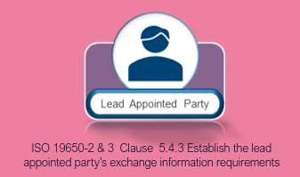

Cascaded Information Requirements
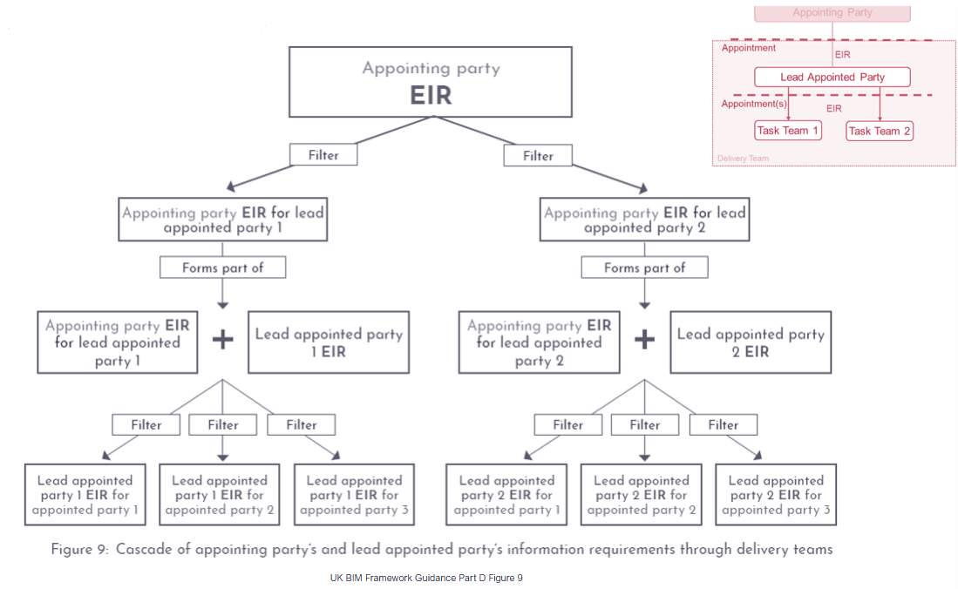
Cascade of Information Requirements as defined in UK BIM Framework Guidance Part D Figure 9

Lead Appointed Party EIR
So why do we have the separate EIR’s?
Lead appointed parties may have their own requirements, defined in the L.A.P EIR.
Examples could be additional information requirements relating to:
- Coordination
- Performance
- Analysis
- Exchange Formats
Audio transcript (00:48)
So, why do we have separate EIRs? The appointing party defined their asset information requirements within the AIR and then the project information requirements that are defined in the PIR. Lead appointed parties may have their own requirements in addition, and this is the purpose of the LAP EIR. Examples could be additional information requirements relating to coordination, performance, analysis and exchange formats. The level of information need may be different to that of the appointing party EIR due to the increased coordination requirements, for example. The LAP must reaffirm and document the level of information need for each deliverable as required by the appointing party's EIR and document other metrics used to define the level of information need. For example, level of detail or level of information.
Source audio: Lesson 3 - Establish the Lead Appointed Party EIR - BIM ISO 1965 (1).mp3

Lead Appointed Party EIR Considerations
It is also important to consider the appointed parties and the support they may need.
Perhaps the lead appointed party is competent in the delivery of IFC COBie exports for example, or experienced in using using a particular CDE solution.
These shared resources were maybe not provided by the appointing party as they may not be an expert in the BIM field, however the LAP could ensure resources are available to task teams such as:
- IFC Export, COBie deliverable, and a CDE set up guide
- Provide a sample IFC model and export for comparison
- Educational onboarding relating to BIM documentation


Learning Summary
Lesson complete! You are now able to:
Understand the Establishment of the Lead Appointed Party EIR
[CONTINUE]

