Unit 7 - Lesson 5 - Establish the MIDP
Lesson 5 of 6
Lesson Objectives
Audio transcript (00:09)
Appointed party shall aggregate the from each task team to establish the delivery team's master information delivery plan MIDP.

Establish the MIDP
The MIDP is a plan incorporating and all relevant task information delivery plans.
Each task team’s task information delivery plan should be aggregated into a single MIDP by the LAP.
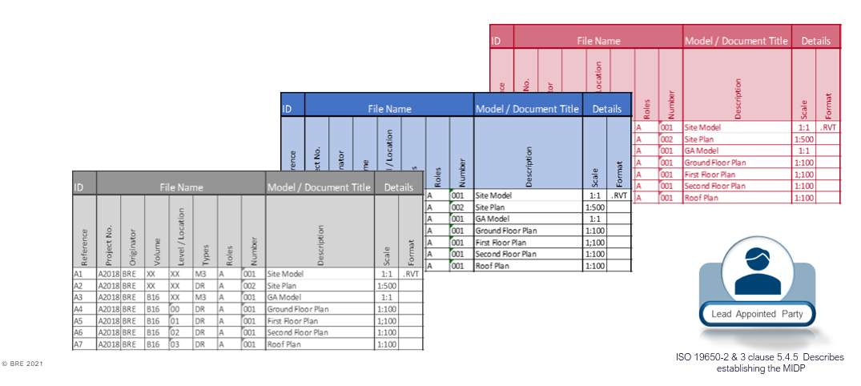
Audio transcript (00:36)
The MIDP is a plan incorporating all relevant task information delivery plans. Each task team's task information delivery plan should be aggregated into a single MIDP by the LAP. As we have mentioned, if the templates are issued within the shared resources for the TIDPs, then the data can be transferred easily to the MIDP. Depending on the size of the project, this could be an Excel, MS project or another project planning solution. However, it is worth noting that ISO 9650 Part 2 does not specify a particular approach, format, software or template style.
Source audio: Lesson 5 - Establish the MIDP - BIM ISO 19650 12 Project Deliver (1).mp3

Aggregate the TIDP’s into a single MIDP
each task team’s task information delivery plan should be aggregated into a single MIDP by the LAP.
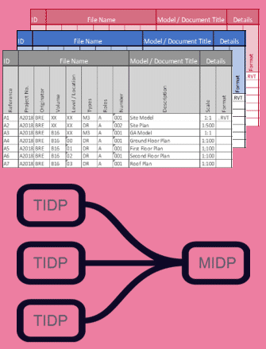
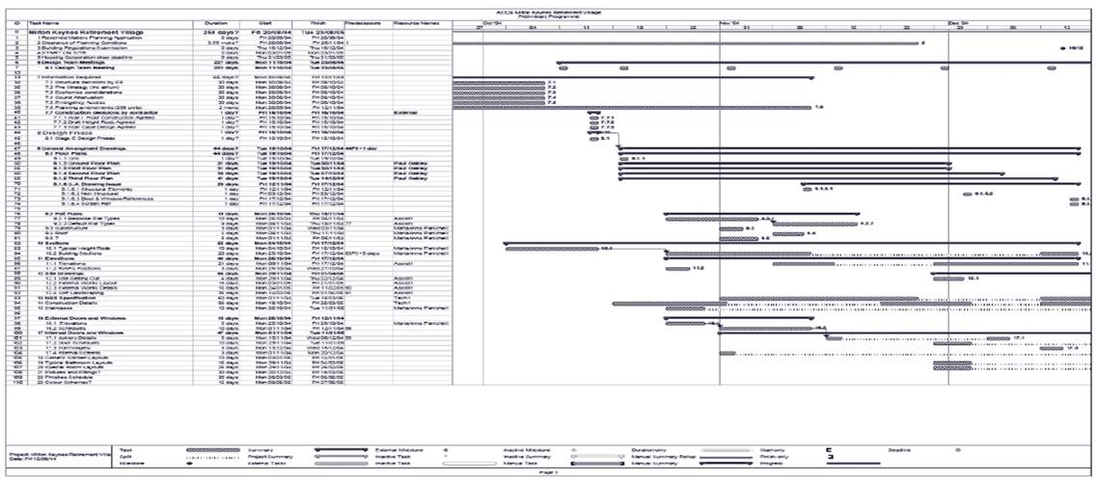
Image for illustration purposes of layout only, the data is not intended to be visible.
Audio transcript (00:48)
Here we have an example of an MIDP in a Gantt chart format, which helps to make overall information delivery process more integrated. These have been around for many years and were carried out well before the terms TIDP and MIDP were used. Now they have become part of the BIM process and helped to make the overall information delivery process more integrated. It is recommended to create templates for the TIDP due to the need to aggregate several task information delivery plans into the master information delivery plan. It will make life much easier. Some of the issues to take on board in the MIDPs are that every appointing party has specific delivery dates and a specific review and authorization process and they may have a particular time they need the information by. Therefore make sure you put these reviews and authorized processes into your program.
Source audio: Lesson 5 - Establish the MIDP - BIM ISO 19650 12 Project Deliver (2).mp3
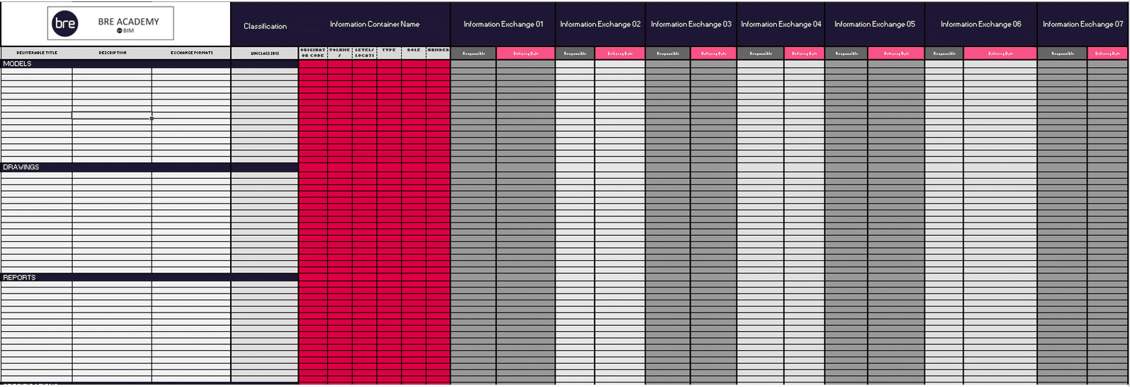
Here we have an example of an MIDP in a Excel format which can sometimes be efficient if similar TIDP template has been issued.

MIDP Considerations
When developing the MIDP, the lead appointed party should consider the following:
- Responsibilities defined in the detailed responsibility matrix
- Task Team dependency
- Review periods defined in the EIR & BEP
Audio transcript (00:36)
When developing the MIDP, the leader-pointed party should consider the following Responsibilities defined in the detailed responsibility matrix, whom, what, when, as defined in previous slides Task team dependency, for example an architectural drawing package for windows may require coordination and depend upon the structural framing layout being approved prior Review periods defined in the EIR and BEP, ensuring sufficient time is allowed for the check-review approved process The MIDP will then provide a clear representation with a visual program indication of what the task teams expect to deliver
Source audio: Lesson 5 - Establish the MIDP - BIM ISO 19650 12 Project Deliver.mp3
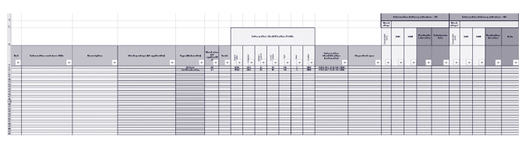

MIDP Process
Once the lead appointed party is happy with the MIDP, there are additional activities that must then take place:
- Set information container deliverables & dates
- Notify the task teams should there be any changes required. Update the TIDP’s where appropriate
- Inform the appointing party of any risks that may impact the project milestones.
Audio transcript (01:22)
Once the lead appointed party is happy with the MIDP, there are additional activities that must then take place. Set information container deliverables and dates. The milestone dates and project stages will typically be shown in the MIDP to plan and track the deliverable plan and the intended date. These should be shared between the delivery team and agreed as part of their obligations. Notify the task teams should there be any changes required. Update the TIDPs where appropriate. As the information management process develops there may be changes required or at a project level additional information requested from the task teams. Any changes no matter whether they be minor tweaks or major modifications on the deliverables they must be fed back from the TIDPs with an update into the aggregated MIDP to reflect this. These changes must be handled in a collaborative manner to avoid any risks. Inform the appointing party of any risks that may impact the project milestones. This relates to the information risk register as previously discussed. A risk that impacts the delivery milestones could very likely come from a change in deliverables or as part of an impact of TIDP modifications. The previous example of an architect's door package relying on a structural framing layout gives an idea of how any changes in delivery information can have a huge impact.
Source audio: Lesson 5 - Establish the MIDP - BIM ISO 19650 12 Project Deliver (3).mp3

MIDP Obligations



Learning Summary
Lesson complete! You are now able to:
Explain establishing Master Information Delivery Plans
[CONTINUE]

