Unit 8 - Lesson 2 - Test Project’s Information Production Methods & Procedures
Lesson 2 of 2
Lesson Objectives
Audio transcript (00:08)
The lead appointed party should test the project's information, production methods and procedures as defined within the delivery team's mobilization plan.

Test Project’s Information Production
Methods & Procedures
This may include the following tasks undertaken by the lead appointed party:
- Test & document - Author the test / mock-up project Update the BEP if any updates are required.
- Communicate - Ensure Project’s Information Production Methods and Procedures are current in the Delivery Team BEP, and all task teams have reviewed/ agreed.
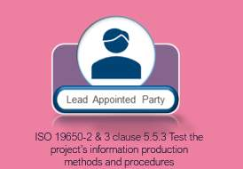
Audio transcript (00:44)
The project information methods and procedures must also be configured and tested during mobilisation to enable the smooth transfer of information during the next phases. This may include the following tasks undertaken by the lead appointed party. The project's information production methods and procedures have been tested and documented. Author the test project, mock-up files utilising the project methods and procedures. Update project's information production methods and procedures within the BEP if any updates are required. The project's information production methods and procedures have been communicated to all task teams. Ensure project's information production methods and procedures is current in the delivery team BEP and all task teams have reviewed and agreed the delivery team BEP.
Source audio: Lesson 2 - Test Projects Information Production Methods Procedur (1).mp3

Federation Strategy
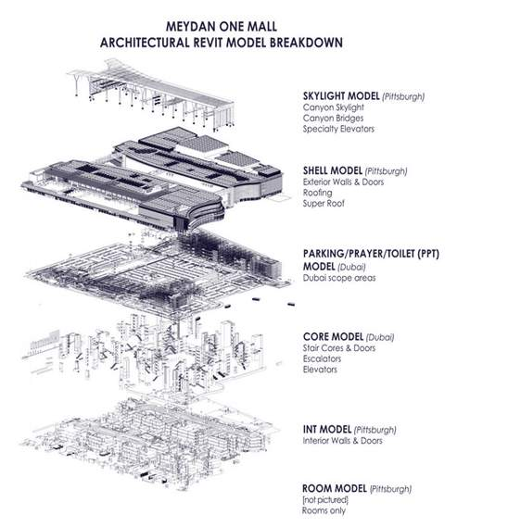
https://archsmarter.com/large-projects-in-revit-1/(opens in a new tab)
Audio transcript (00:18)
The lead appointed party should test that the proposed information container breakdown structure is workable and has been verified and refined. You'll typically review the Federation strategy at induction meeting. See an example from Arch Smarter for a typical large Revit project model breakdown strategy.

Develop Shared Resources
Develop shared resources to be used by the delivery team, including title blocks, shared parameters, document templates, existing surveys etc identified at the project induction meeting.

https://measuredsurvey365.co.uk/services/point-cloud-surveys/(opens in a new tab)
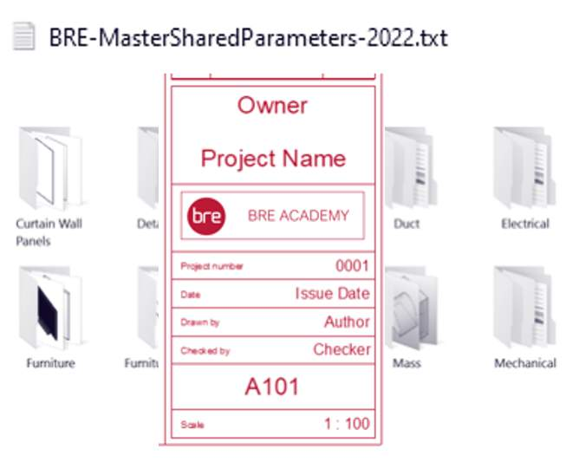
Audio transcript (00:30)
Develop shared resources to be used by the delivery team, including title blocks, shared parameters, document templates, existing surveys, etc., identified at the project induction meeting. The last item to consider is ensuring unresolved issues have been documented in the project risk register. To ensure that the project's information production methods and procedures are communicated to all task teams, it is recommended that any changes are incorporated into the BIM execution plan.
Source audio: Lesson 2 - Test Projects Information Production Methods Procedur.mp3

Mobilization Activities
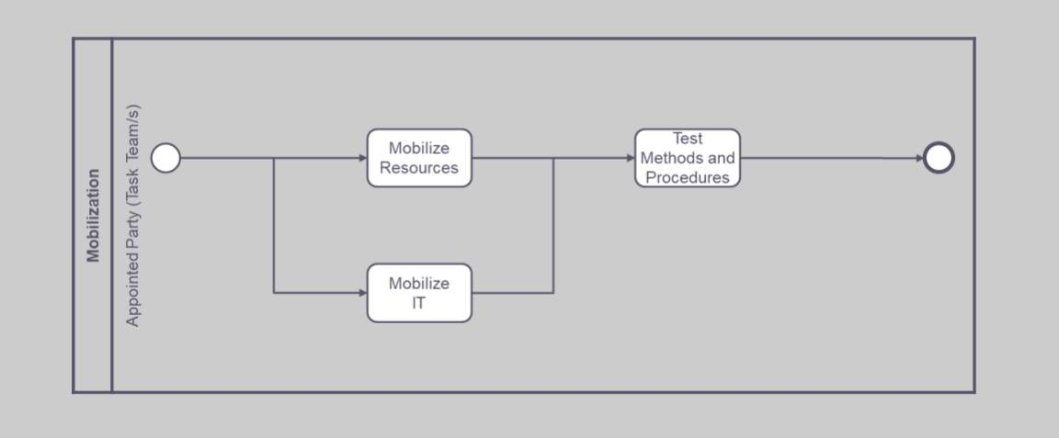
5.1 mobilize resources
5.2 mobilize information technology
5.3 test the project’s information production methods and procedures

Knowledge Check
Take a moment to identify what you consider as the benefits of applying Information Management to a project. Consider the following:
- What benefits do project documents (such as the BIM execution plan) provide, and;
- What benefits do agreed project information standards, methods and procedures provide.

Learning Summary
Lesson complete! You are now able to:
Understand the testing of the project’s information production methods and procedures, as defined within the delivery team’s mobilization plan
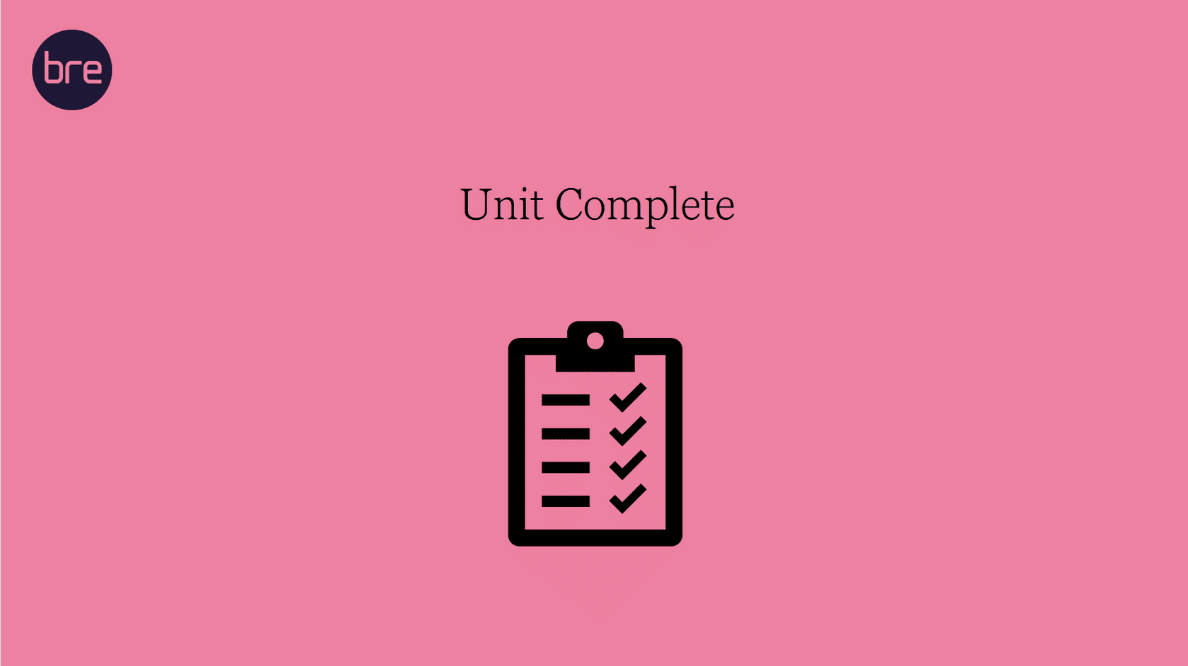
Unit 8 Complete!
You may now close the window and complete this module.

