Unit 9 - Lesson 2 - Undertake Quality Assurance Checks
Lesson 2 of 3
Lesson Objectives
Audio transcript (00:15)
Each task team shall undertake quality assurance check of each information container. Prior to review. Task teams should check information containers are in accordance with the project’s information production methods and procedures and also against the project's information standards.

Undertake Quality Assurance Check
Both The information within the container and the container must be reviewed. The processes will satisfy clause 5.6.3:
- Check the TIDP for files to be produced at the work stage in question
- Check the information container aligns with the Project Information Standard
- Has the information container been produced in line with the Project Information Production Methods & Procedures
Reject or Accept & proceed to 5.6.4
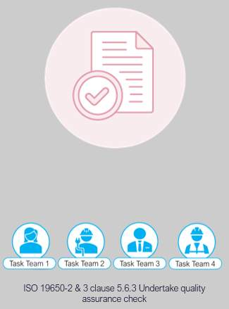
Audio transcript (01:16)
Now, we move on to the check review approved process. The standards, methods and procedures dictate how elements of the quality assurance check should be undertaken. It does not check for accuracy but for compliance to the project's information standards, project information production methods and procedures etc. Both the information within the container and the container must be reviewed. The processes will satisfy clause 5.6.3, check the TIDP for files to be produced at the work stage in question, check the information container aligns with the project information standard with consideration given to naming, classification, status and revision codes. Has the information container been produced in line with the project information production methods and procedures? If OK, then mark is checked and accepted and proceed to 5.6.4. If not OK, reject and inform the author to undertake corrections. If documents are delivered in a structured format, checks can be automated. However, most are written in Word and delivered in PDF so automation is not possible. At the moment, most EIR documents are written in Word and delivered in PDF so they are not available as a structured data format. If they were, software would then be able to be checked more efficiently.
Source audio: Lesson 2 - Undertake Quality Assurance Checks - BIM ISO 19650 12 (1).mp3

Information Quality
The check on the information is to ensure it meets the required quality, and typically includes the following:
- Information formats
- Delivery formats
- Structure & Classification;
- Parameter Naming.
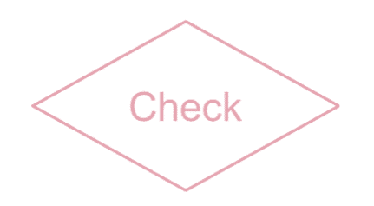
(opens in a new tab)
Audio transcript (00:59)
During the checking stage, the following things will be checked against. This activity will typically align with the appointed party's ISO 9001 quality management system. 1. Information formats, for example, IFC, will generally be used as it is the exchange format rather than a file type. 2. Delivery formats, for example, PDF, will generally be used as the record of documents issued because it is generally in a fixed format. 3. How the information model is broken down, as included with the BIM execution plan. 4. The classification which should be included within the project's information standards. 5. That the required properties, attributes and parameters are used. These should be listed within the project's information standards, that is, what are the naming conventions of these properties to deliver the structured information. 6. Celebrity model checker, for example, is great for this type of task.
Source audio: Lesson 2 - Undertake Quality Assurance Checks - BIM ISO 19650 12.mp3
Video Player is loading.Loaded: 59.67%1:160:48Remaining Time -0:301x2x1.75x1.5x1.25x1x, selected0.75x0.5x0.25xcaptions off, selectedThis is a modal window.
Video Player is loading.Loaded: 28.03%0:32Remaining Time -1:591x2x1.75x1.5x1.25x1x, selected0.75x0.5x0.25xcaptions off, selectedThis is a modal window.

Learning Summary
Lesson complete! You are now able to:
Understand the Undertaking of Quality Assurance Checks
[CONTINUE]

