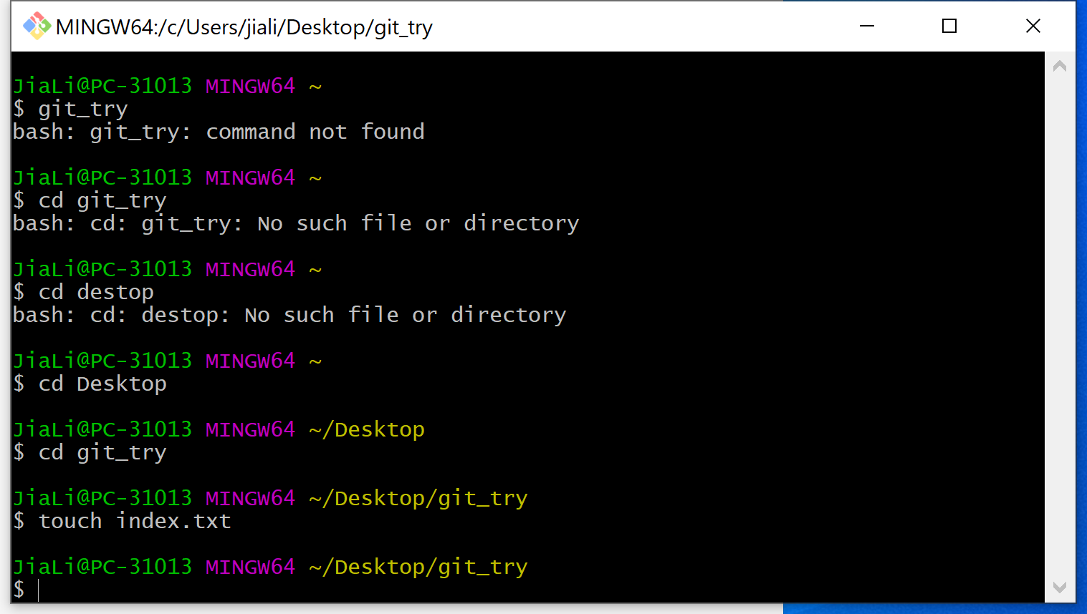
Changed the branch from master to login
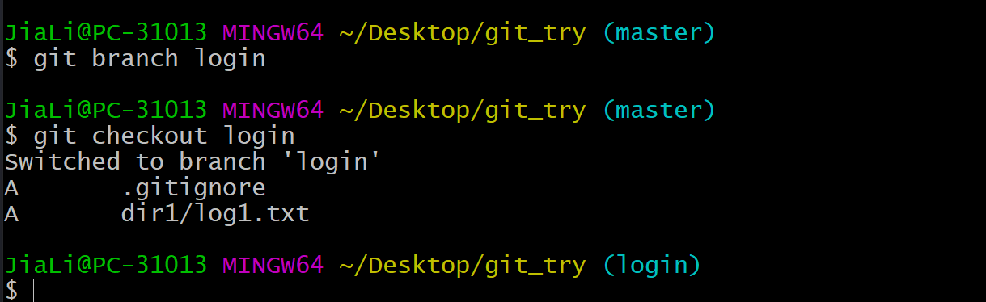
pc
hub
push
Fetch , pull , clone

