**Finding Lane Lines on the Road**

Longxing Tan

**Finding Lane Lines on the Road**

The goals / steps of this project are the following:

* Make a pipeline that finds lane lines on the road
* Reflect on your work in a written report

**Reflection**

**1. Pipeline to find lane lines in an individual picture.**

My pipeline consisted of 5 steps:

* Converted the images to grayscale
* Implement the Gaussian blur
* Canny Edge Detection
* Choose the region of interest
* Detect the line in the Hough space

What’s more, In order to draw a single line on the left and right lanes, I modified the draw_lines() function.

* Separate the left and right lane by its slope
* Record the average slope for all left or right lines detected by Hough detect
* Draw the line according to the slope and boundary

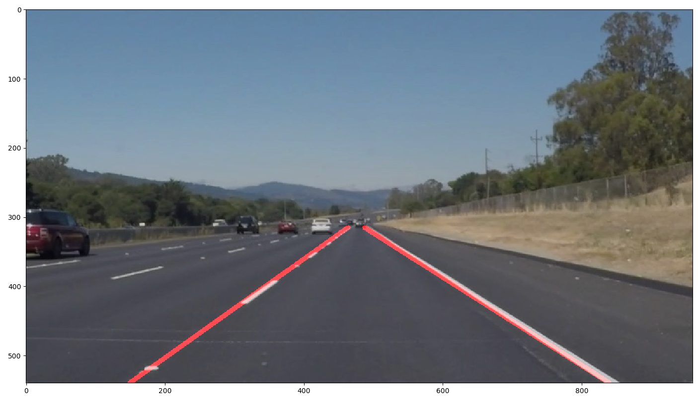

**2. Potential shortcomings**

One potential shortcoming would be the performance highly depends on the region of interest chosen in the program. The performance is not satisfied if the program run for another car, or the camera moves.

Another shortcoming could be it only works well while the vehicle are driven exactly between two lines, otherwise when change the lane, it also influence the detect result.

**3. Possible improvements**

A possible improvement would be to average the line according to the time line making the line more stable