Assignment 8P

*Assignment:* *Write a computer code to solve by the Crank-Nicolson method over the time interval $0≤t≤T$ the one dimensional diffusion equation*

$$\frac{∂u}{∂t}=D\frac{∂^{2}u}{∂x^{2}}+F(x,t)$$

*With $0≤x≤L$ and the constant D and the function F(x,t) prescribed along with the initial conditions and boundary conditions,*

$$u\left(x,0\right)=f\left(x\right)$$

$$u\left(0,t\right)=g_{0}(t)$$

$$u\left(L,t\right)=g_{L}(t)$$

# Part I

The parameters used to initialize the implementation of the Crank-Nicolson scheme can be found in Table 1. The code used to solve this assignment can be found in the .git folder submitted with this report.

Table 1. Parameters used to initialize the Crank-Nicolson scheme for Part I

|  |  |
| --- | --- |
| $$L=π$$ | $$g_{0}(t)=0$$ |
| $$D=0.1$$ | $$g_{L}(t)=0$$ |
| $$T=10$$ | $$f\left(x\right)=\sin\left(kx\right)$$ |
| $$F(x,t)=0$$ | $$k=1$$ |

The exact solution to the differential equation is

$$u\left(x,t\right)=\exp\left(-Dk^{2}t\right)sin⁡(kx)$$

For Part I, grid convergence occurred without issue. Figure 1 offers a brief comparison between the exact solution and the solution approximated by the Crank-Nicolson scheme. Two comparisons are made in the figure for the case where the number of discrete points on each axis are the same, N = 5 and N = 10.

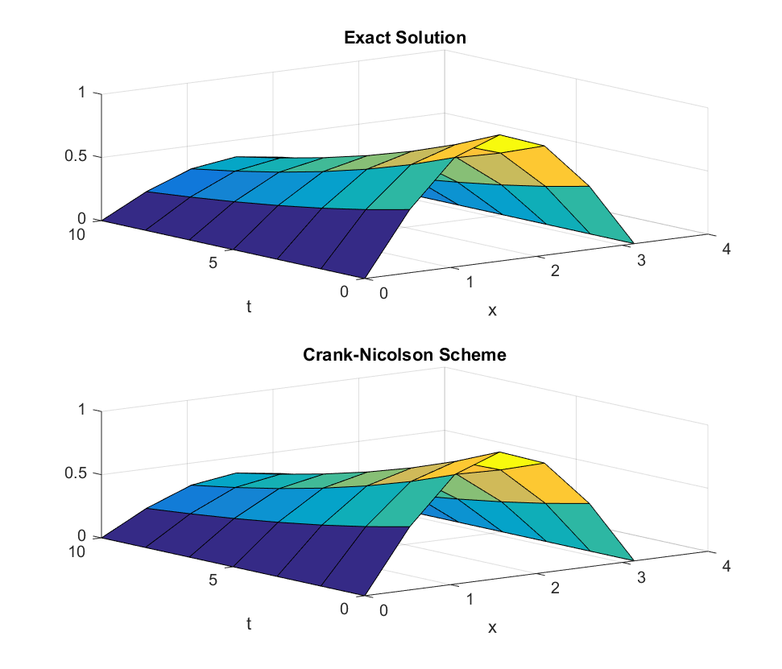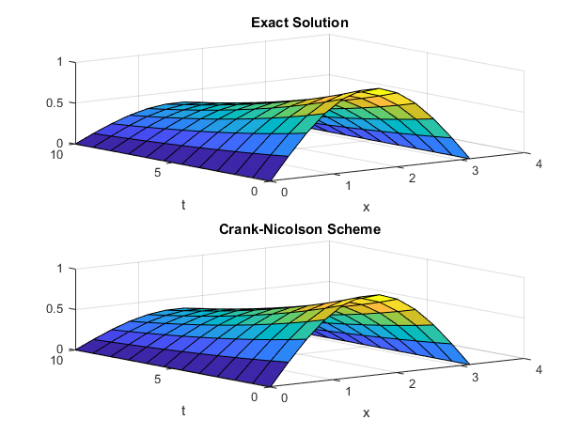

Figure 1. Comparison of Exact Solution and Crank-Nicolson Scheme for (a) N = 5 (b) N = 10

Figure 2 offers an example of the grid convergence at t = T. Several other comparisons between the exact solution and the one provided by the Crank-Nicolson discretization can be found in Figure 3 and Figure 4.

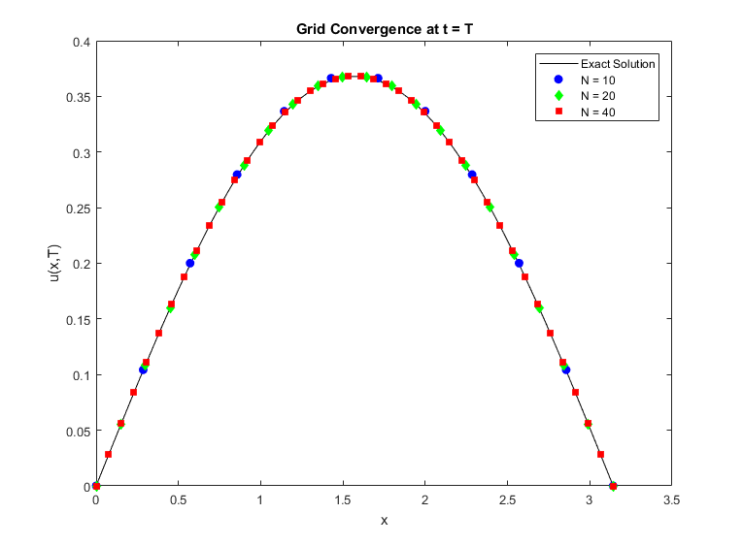

Figure 2. Grid Convergence of Crank-Nicolson Scheme at t = T

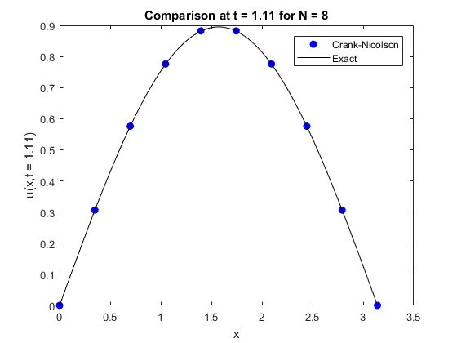

Figure 3. Comparison between exact solution and Crank-Nicolson implementation for t = 1.11 and N = 8

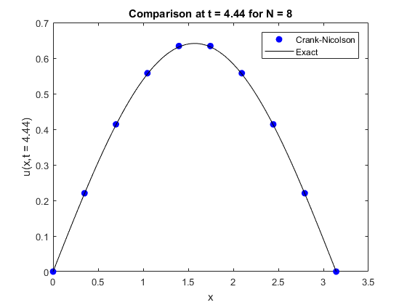

Figure 3. Comparison between exact solution and Crank-Nicolson implementation for t = 1.11 and N = 8

It is known that the error associated with the Crank-Nicolson scheme due to Taylor series truncation is $O(Δx^{2},Δt^{2})$ which can be verified by increasing the number of discrete points in the domain and computing the average error. The result of such a computation for t = T can be seen in Figure 4 where the order of accuracy is verified by the polynomial fit.

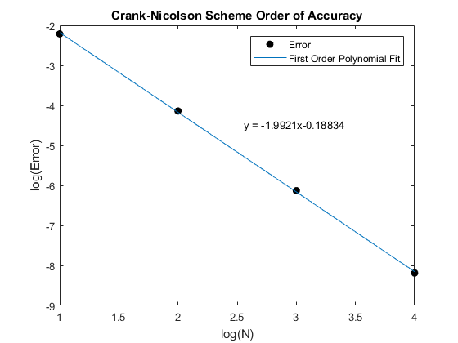

Figure 5. Order of accuracy for Crank-Nicolson discretization at t = T

The implementation of this discretization appears to be correct based on the results. It should be noted that increasing the value of *k* in the initial condition has a large effect on the error produced. In effect, *k* is a wave number and increasing its value also makes the derivatives of the solution increase, particularly along the x axis. This is also true for Part II.

# Part II

The solution to part II differs primarily in the addition of a non-zero F(x,t) to the right side of the diffusion equation. There are also different boundary conditions and a different exact solution. The parameters used to initialize the method can be found in Table 2.

Table 2. Parameters used to initialize the Crank-Nicolson scheme for Part II

|  |  |
| --- | --- |
| $$L=π$$ | $$g_{0}(t)=sin⁡(ωt)$$ |
| $$D=0.1$$ | $$g_{L}(t)=\sin\left(ωt\right)cos⁡(kL)$$ |
| $$T=10$$ | $$f\left(x\right)=0$$ |
| $$F(x,t)=\left(ω\cos\left(ωt\right)+Dk^{2}\sin\left(ωt\right)\right)cos⁡(kx)$$ | $$k=1$$ |
| $$ω=0.1 (initially)$$ |  |

In this case, the exact solution is

$$u\left(x,t\right)=\sin\left(ωt\right)cos⁡(kx)$$

Grid convergence again occurred without issue except for one large caveat – ω must be kept small to keep the error manageable. Figure 6 offers a quick visual comparison of the exact solution and the one produced by the Crank-Nicolson discretization

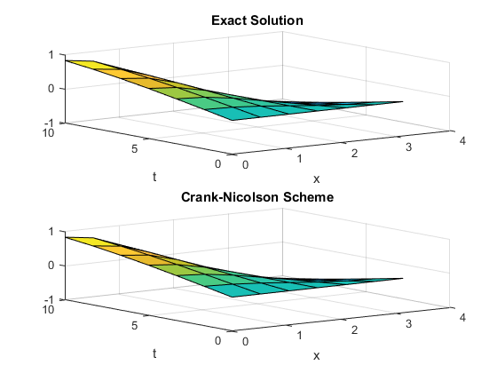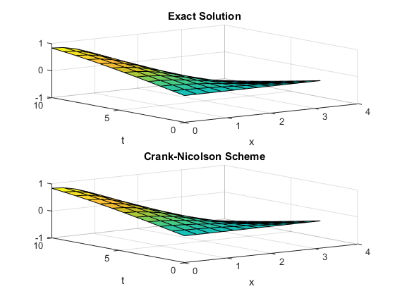

Figure 6. Comparison of Exact Solution and Crank-Nicolson Scheme for (a) N = 5 (b) N = 10

An example of grid convergence at t = T can be found in Figure 7. Several other comparisons between the exact solution and the one provided by the Crank-Nicolson discretization can be found in Figure 8 and Figure 9.

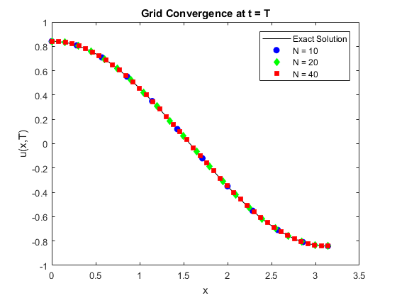

Figure 7. Grid Convergence of Crank-Nicolson Scheme at t = T

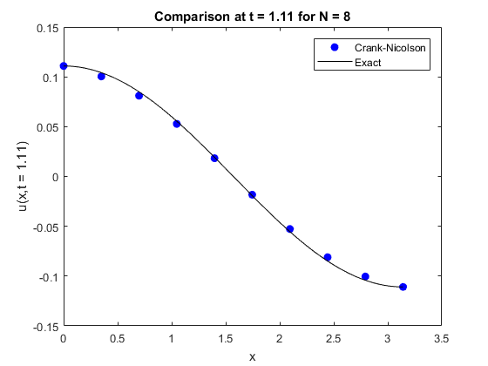

Figure 8. Comparison between exact solution and Crank-Nicolson implementation for t = 1.11 and N = 8

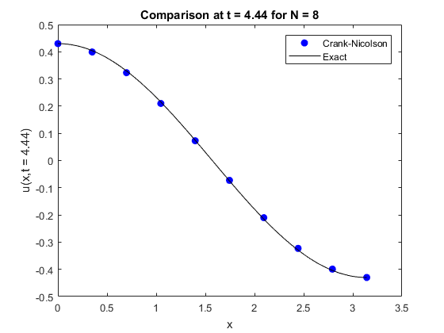

Figure 9. Comparison between exact solution and Crank-Nicolson implementation for t = 4.44and N = 8

A graphic depiction of the order of accuracy can be found in Figure 10, analogous to Figure 5.

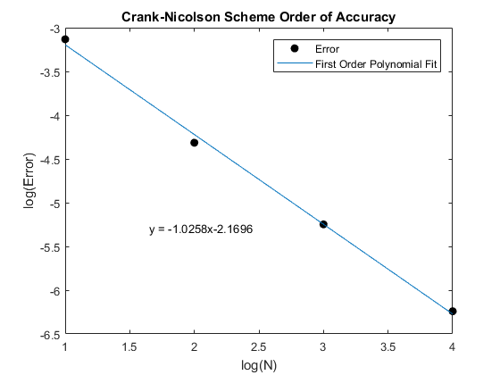

Somehow it appears that second order accuracy has not persisted into part II. While we are not exactly sure what has caused this, an initial guess is that it has something to do with the source term F(x,t) on the right side of the equation. Anecdotally, it appears that part II depends on a small time step in order to maintain the error. While the Crank-Nicolson method is unconditionally stable, that does not mean that one should choose a coarse discretization nor should one ignore parameters that increase the derivatives of the solution. The solution may never “blow up”, however there is no guarantee of accuracy.