### Netops Instructions:

*A ticket will be created in service now and referenced in the above hexagon ticket, the information from the hexagon ticket will be included in the service now ticket as well as any notes specific to the site such as switches that need manual installs and/or cannot be pushed via dnac.*

Software Activation Steps:

1. Log into Cisco Catalyst Center (Formerly DNAC) [Home - Cisco Catalyst Center](https://tulpadna01/dna/home)
2. From the top left menu navigate to **Provision > Inentory**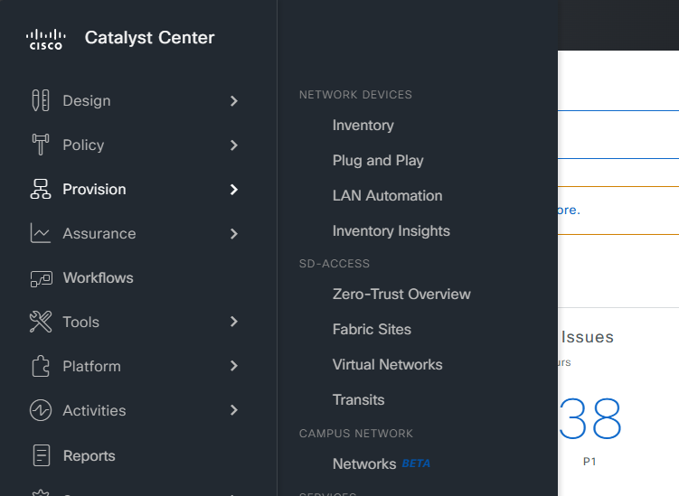
3. At the top left click on **Global** (or if you have a site already selected click the site shown) 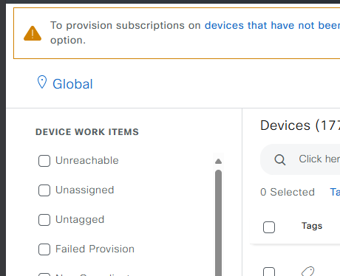
4. Search and Select the site you are wanting to activate software for. This will filter to just this location.   
   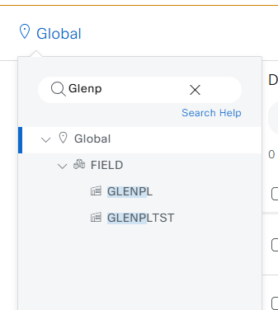
5. In this list, verify that each device in the ticket shows both a green check next to Needs Update and has the Activation Pending OS Update Status. 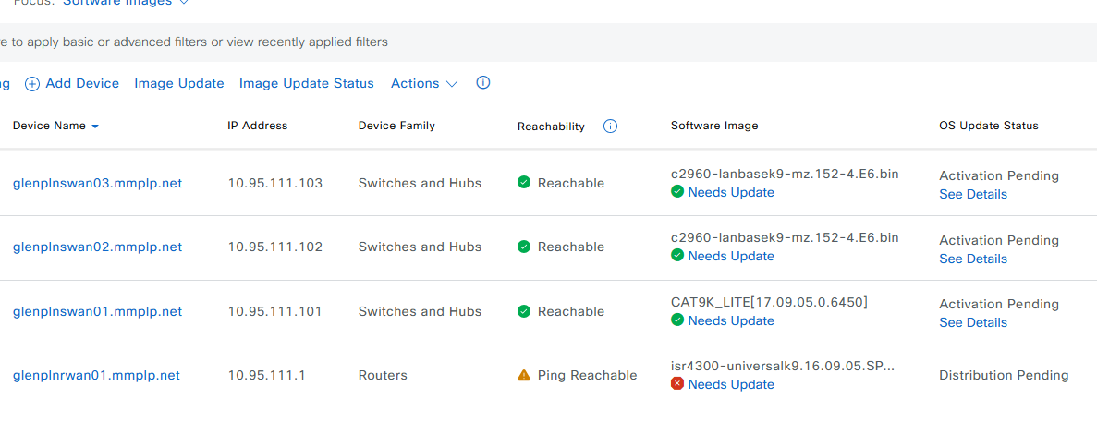
6. Check the device that you are applying the update for and then open the actions dropdown and choose **Software Image > Image Update**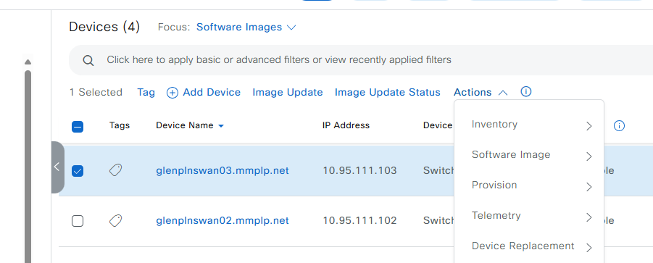
7. Enter a name for the task see the example below and press next.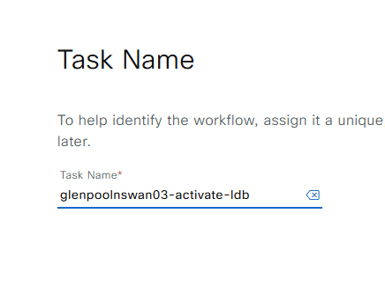
8. You should now see this screen. Press Next again. 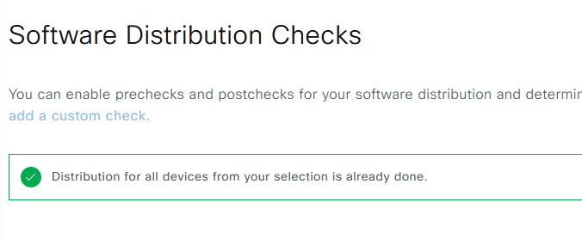
9. Enable all activation checks by default and press Next again.   
   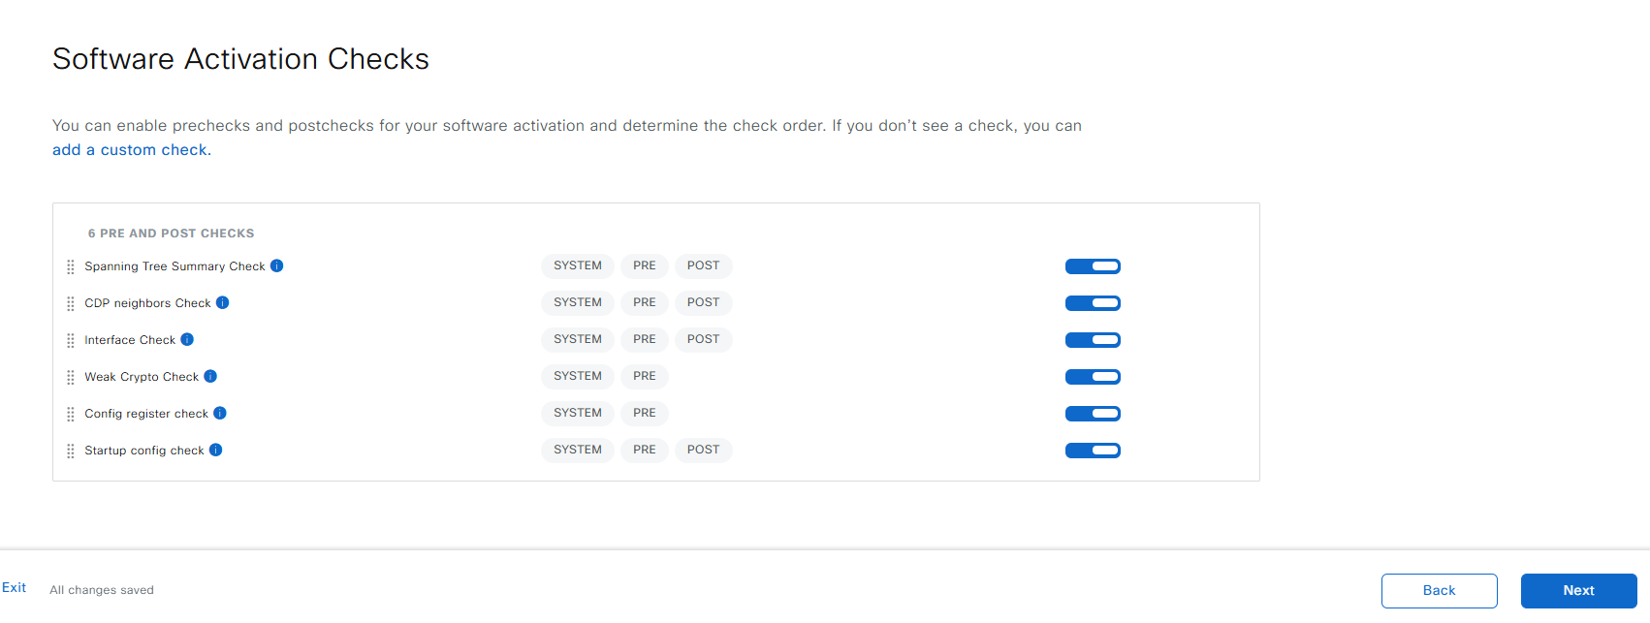
10. You have the option to schedule the activation and reboot, but we should be doing it live so choose now and press next.   
    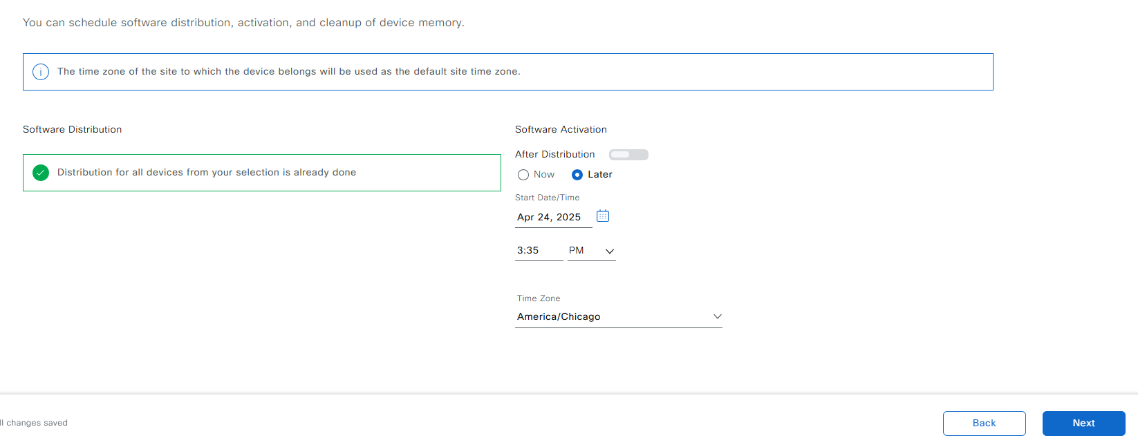

**At this point the switch will begin the upgrade and it will impact production. You can monitor the job in the tasks menu. Further screenshots to be gathered during the actual install.**