Netops Weekly Vulnerability Comparison Report
Comparing: sample_vulnerabilities_week1.csv vs sample_vulnerabilities_week2.csv
Generated: February 06, 2026 at 01:33

Table of Contents
Executive Summary | 2
Overall Summary | 2
Breakdown by Severity | 2
Breakdown by Vendor | 2
Detailed Breakdown: Vendor x Severity | 3
Top Vulnerability Changes by Vendor | 4
Current Top Vulnerabilities by Vendor | 5
Asset Risk Analysis | 6
Most Vulnerable Assets | 6
Assets with Critical Vulnerabilities | 6
KEV Analysis (if available) | 7
Definition & Asset Changes | 8
CVE Change Analysis | 9

Executive Summary
This report compares vulnerability scan data between two periods. The current dataset shows a net increase of 155 vulnerability instances. Asset inventory changed by +14 (63 added, 49 removed).

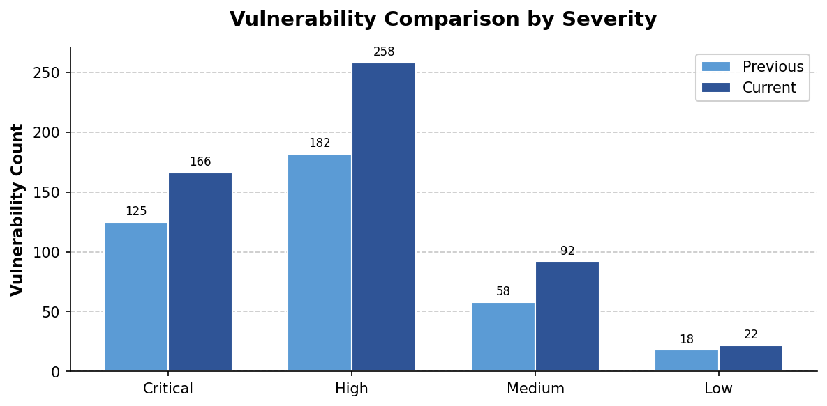

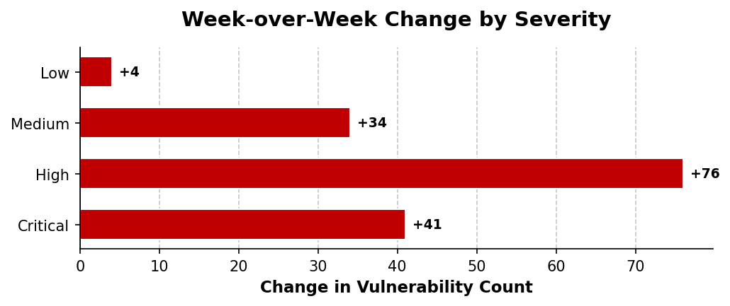

Overall Summary
Metric | Previous | Current | Change
Total Vulnerabilities | 383 | 538 | +155
Unique Assets | 49 | 63 | +14
Unique Definitions | 374 | 515 | +141

Breakdown by Severity
Severity | Previous | Current | Change
Critical | 125 | 166 | +41
High | 182 | 258 | +76
Medium | 58 | 92 | +34
Low | 18 | 22 | +4

Breakdown by Vendor
Vendor | Previous | Current | Change
Cisco | 298 | 440 | +142
Palo Alto | 85 | 98 | +13

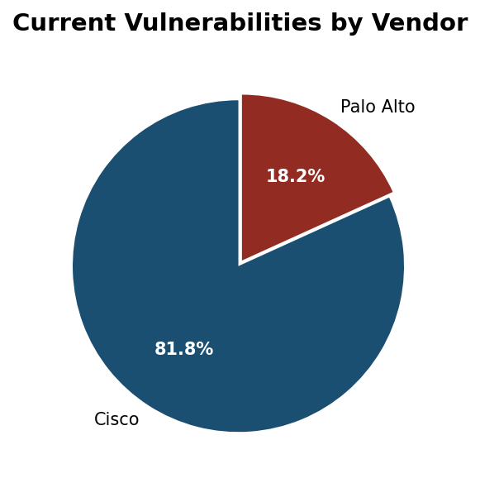

Detailed Breakdown: Vendor x Severity

Cisco
Severity | Previous | Current | Change
Critical | 83 | 117 | +34
High | 139 | 209 | +70
Medium | 58 | 92 | +34
Low | 18 | 22 | +4

Palo Alto
Severity | Previous | Current | Change
Critical | 42 | 49 | +7
High | 43 | 49 | +6
Medium | 0 | 0 | 0
Low | 0 | 0 | 0

Top Vulnerability Changes by Vendor

Cisco
Top Increases:
CVE | Severity | Prev | Curr | Change
CVE-2020-3566 | Medium | 0 | 2 | +2
CVE-2020-3452 | High | 0 | 2 | +2
CVE-2023-20269 | High | 0 | 1 | +1
CVE-2021-1473 | Low | 0 | 1 | +1
CVE-2022-20699 | Critical | 0 | 1 | +1

Top Decreases:
CVE | Severity | Prev | Curr | Change
CVE-2023-20269 | High | 1 | 0 | -1
CVE-2018-0171 | Critical | 1 | 0 | -1
CVE-2021-1497 | Critical | 1 | 0 | -1
CVE-2023-20032 | High | 1 | 0 | -1
CVE-2021-1473 | Low | 1 | 0 | -1

Palo Alto
Top Increases:
CVE | Severity | Prev | Curr | Change
CVE-2019-1579 | High | 0 | 1 | +1
CVE-2024-3400 | Critical | 0 | 1 | +1
CVE-2024-9474 | High | 0 | 1 | +1
CVE-2022-0028 | High | 0 | 1 | +1
CVE-2024-3400 | Critical | 0 | 1 | +1

Top Decreases:
CVE | Severity | Prev | Curr | Change
CVE-2023-38802 | High | 1 | 0 | -1
CVE-2021-3064 | Critical | 1 | 0 | -1
CVE-2024-9474 | High | 1 | 0 | -1
CVE-2024-0012 | Critical | 1 | 0 | -1
CVE-2024-0012 | Critical | 1 | 0 | -1

Current Top Vulnerabilities by Vendor

Cisco
Critical:
CVE | Assets | Description
CVE-2022-20699 | 1 | Cisco Small Business Routers RCE
CVE-2022-20699 | 1 | Cisco Small Business Routers RCE
CVE-2022-20699 | 1 | Cisco Small Business Routers RCE
CVE-2023-20198 | 1 | Cisco IOS XE Software Web UI Privilege Escalation
CVE-2018-0171 | 1 | Cisco IOS and IOS XE Software Smart Install

High:
CVE | Assets | Description
CVE-2020-3452 | 2 | Cisco ASA and FTD Software Path Traversal
CVE-2023-20269 | 1 | Cisco ASA and FTD Software Remote Access VPN
CVE-2024-20353 | 1 | Cisco ASA and FTD Software Web Services DoS
CVE-2024-20353 | 1 | Cisco ASA and FTD Software Web Services DoS
CVE-2023-20032 | 1 | Cisco IOS XE Software SNMP Denial of Service

Medium:
CVE | Assets | Description
CVE-2020-3566 | 2 | Cisco IOS XR Software DVMRP Memory Exhaustion
CVE-2020-3566 | 1 | Cisco IOS XR Software DVMRP Memory Exhaustion
CVE-2022-20968 | 1 | Cisco IP Phone Buffer Overflow
CVE-2024-20359 | 1 | Cisco ASA and FTD Software Arbitrary File Read
CVE-2020-3566 | 1 | Cisco IOS XR Software DVMRP Memory Exhaustion

Palo Alto
Critical:
CVE | Assets | Description
CVE-2024-3400 | 1 | Palo Alto Networks PAN-OS Command Injection
CVE-2024-3400 | 1 | Palo Alto Networks PAN-OS Command Injection
CVE-2020-2021 | 1 | Palo Alto Networks PAN-OS SAML Authentication Bypass
CVE-2024-3400 | 1 | Palo Alto Networks PAN-OS Command Injection
CVE-2024-0012 | 1 | Palo Alto Networks PAN-OS Authentication Bypass

High:
CVE | Assets | Description
CVE-2019-1579 | 1 | Palo Alto Networks GlobalProtect RCE
CVE-2024-9474 | 1 | Palo Alto Networks PAN-OS Privilege Escalation
CVE-2022-0028 | 1 | Palo Alto Networks PAN-OS Reflected DoS
CVE-2024-9474 | 1 | Palo Alto Networks PAN-OS Privilege Escalation
CVE-2019-1579 | 1 | Palo Alto Networks GlobalProtect RCE

Medium:
- No medium vulnerabilities found.

Most Vulnerable Assets (by VPR Score)

Cisco
Asset | VPR Sum | CVE Count
abortr01.example.net | 117.5 | 15
remotesw01.example.net | 116.4 | 15
remotesw03.example.net | 114.5 | 15
miamifw01.example.net | 113.4 | 15
nyrtr01.example.net | 110.7 | 14

Palo Alto
Asset | VPR Sum | CVE Count
branchnfpan02.example.net | 74.1 | 8
hqdnfpan02.example.net | 72.6 | 8
devpan01.example.net | 71.2 | 8
hqdnfpan01.example.net | 70.9 | 8
intpan02.example.net | 56.0 | 6

Assets with Critical Vulnerabilities
Total: 61 assets with critical vulnerabilities

Asset | Vendor | Critical CVE | VPR
abortr01.example.net | Cisco | CVE-2023-20198 | 40.5
branchnfpan02.example.net | Palo Alto | CVE-2021-3064 | 40.4
mainswan01.example.net | Cisco | CVE-2018-0171 | 40.4
datacenterrtr02.example.net | Cisco | CVE-2023-20198 | 39.7
devpan01.example.net | Palo Alto | CVE-2021-3064 | 39.7
eastswan01.example.net | Cisco | CVE-2018-0171 | 39.5
branchswan01.example.net | Cisco | CVE-2018-0171 | 39.4
remotesw03.example.net | Cisco | CVE-2022-20699 | 39.4
hqdnfpan02.example.net | Palo Alto | CVE-2020-2021 | 39.3
intpan02.example.net | Palo Alto | CVE-2020-2021 | 39.3
mainswan02.example.net | Cisco | CVE-2022-20699 | 39.3
nyrtr02.example.net | Cisco | CVE-2022-20699 | 39.3
phoenixswan01.example.net | Cisco | CVE-2023-20198 | 39.3
nyrtr01.example.net | Cisco | CVE-2023-20198 | 39.2
lobrtr01.example.net | Cisco | CVE-2018-0171 | 39.1
miamifw01.example.net | Cisco | CVE-2022-20699 | 39.0
remotesw01.example.net | Cisco | CVE-2018-0171 | 38.9
chirtr02.example.net | Cisco | CVE-2022-20699 | 38.8
extpan02.example.net | Palo Alto | CVE-2024-3400 | 38.7
hqdnfpan01.example.net | Palo Alto | CVE-2020-2021 | 38.4
devpan02.example.net | Palo Alto | CVE-2024-0012 | 30.6
hqnfpan02.example.net | Palo Alto | CVE-2020-2021 | 30.0
abortr02.example.net | Cisco | CVE-2018-0171 | 29.9
lobrtr02.example.net | Cisco | CVE-2021-1497 | 29.9
intpan01.example.net | Palo Alto | CVE-2020-2021 | 29.8
hqfw02.example.net | Cisco | CVE-2018-0171 | 29.6
atlswan02.example.net | Cisco | CVE-2023-20198 | 29.5
seattlertr01.example.net | Cisco | CVE-2022-20699 | 29.5
southswan01.example.net | Cisco | CVE-2018-0171 | 29.4
hqfw01.example.net | Cisco | CVE-2018-0171 | 29.3
remotesw02.example.net | Cisco | CVE-2022-20699 | 29.2
datacenterrtr01.example.net | Cisco | CVE-2021-1497 | 29.1
dcnfpan01.example.net | Palo Alto | CVE-2024-3400 | 29.0
hqcoreswan01.example.net | Cisco | CVE-2023-20198 | 28.7
branchswan02.example.net | Cisco | CVE-2022-20699 | 28.6
campuspan01.example.net | Palo Alto | CVE-2024-0012 | 20.3
denverrtr01.example.net | Cisco | CVE-2022-20699 | 20.3
chirtr01.example.net | Cisco | CVE-2022-20699 | 20.0
houstonrtr01.example.net | Cisco | CVE-2021-1497 | 20.0
hqnfpan01.example.net | Palo Alto | CVE-2021-3064 | 19.9
dallasrtr01.example.net | Cisco | CVE-2022-20699 | 19.8
extpan01.example.net | Palo Alto | CVE-2024-0012 | 19.7
sfortr01.example.net | Cisco | CVE-2018-0171 | 19.7
westnfpan01.example.net | Palo Alto | CVE-2024-0012 | 19.7
branchfw02.example.net | Cisco | CVE-2018-0171 | 19.5
eastnfpan01.example.net | Palo Alto | CVE-2021-3064 | 19.5
hqasa01.example.net | Cisco | CVE-2018-0171 | 19.3
atlswan01.example.net | Cisco | CVE-2018-0171 | 19.2
mabortr01.example.net | Cisco | CVE-2022-20699 | 19.2
westswan02.example.net | Cisco | CVE-2018-0171 | 19.0
campuspan02.example.net | Palo Alto | CVE-2024-0012 | 10.3
branchnfpan01.example.net | Palo Alto | CVE-2024-0012 | 10.2
hqcoreswan02.example.net | Cisco | CVE-2018-0171 | 10.2
tampafw01.example.net | Cisco | CVE-2021-1497 | 10.1
mainswan03.example.net | Cisco | CVE-2021-1497 | 9.9
dcnfpan02.example.net | Palo Alto | CVE-2021-3064 | 9.7
northswan01.example.net | Cisco | CVE-2018-0171 | 9.7
phoenixswan02.example.net | Cisco | CVE-2021-1497 | 9.6
hqasa02.example.net | Cisco | CVE-2022-20699 | 9.5
branchswan03.example.net | Cisco | CVE-2022-20699 | 9.4
westswan01.example.net | Cisco | CVE-2022-20699 | 9.3

KEV (Known Exploited Vulnerabilities) Analysis
CISA Known Exploited Vulnerabilities found in environment: 18 KEV CVEs affecting 63 assets. These vulnerabilities have confirmed active exploitation and should be prioritized for remediation.

KEV CVEs by Asset Impact
CVE | Severity | Vendor | Assets | KEV Name
CVE-2022-20699 | Critical | Cisco | 34 | Cisco Small Business RV Series Rout
CVE-2021-34527 | High | Cisco | 33 | Microsoft Windows Print Spooler Rem
CVE-2020-3566 | Medium | Cisco | 33 | Cisco IOS XR Software DVMRP Memory
CVE-2018-0171 | Critical | Cisco | 32 | Cisco IOS and IOS XE Software Smart
CVE-2023-20273 | High | Cisco | 31 | Cisco IOS XE Web UI Command Injecti
CVE-2019-1653 | High | Cisco | 31 | Cisco Small Business RV320 and RV32
CVE-2024-20353 | High | Cisco | 30 | Cisco ASA and FTD Denial of Service
CVE-2020-3452 | High | Cisco | 28 | Cisco ASA and FTD Read-Only Path Tr
CVE-2021-1497 | Critical | Cisco | 26 | Cisco HyperFlex HX Installer Virtua
CVE-2023-20198 | Critical | Cisco | 25 | Cisco IOS XE Web UI Privilege Escal
CVE-2023-20269 | High | Cisco | 25 | Cisco Adaptive Security Appliance a
CVE-2024-20359 | Medium | Cisco | 24 | Cisco ASA and FTD Privilege Escalat
CVE-2024-0012 | Critical | Palo Alto | 15 | Palo Alto Networks PAN-OS Managemen
CVE-2022-0028 | High | Palo Alto | 13 | Palo Alto Networks PAN-OS Reflected
CVE-2019-1579 | High | Palo Alto | 12 | Palo Alto Networks PAN-OS Remote Co
CVE-2024-9474 | High | Palo Alto | 12 | Palo Alto Networks PAN-OS Managemen
CVE-2020-2021 | Critical | Palo Alto | 12 | Palo Alto Networks PAN-OS Authentic
CVE-2024-3400 | Critical | Palo Alto | 7 | Palo Alto Networks PAN-OS Command I

Assets with Multiple KEV Vulnerabilities
Total: 62 assets with multiple KEV vulnerabilities

Asset | Vendor | KEVs | Severity
abortr01.example.net | Cisco | 12 | Critical
chirtr02.example.net | Cisco | 12 | Critical
mainswan01.example.net | Cisco | 12 | Critical
miamifw01.example.net | Cisco | 12 | Critical
nyrtr01.example.net | Cisco | 12 | Critical
nyrtr02.example.net | Cisco | 12 | Critical
remotesw01.example.net | Cisco | 12 | Critical
remotesw03.example.net | Cisco | 12 | Critical
atlswan02.example.net | Cisco | 11 | Critical
eastswan01.example.net | Cisco | 10 | Critical
hqfw01.example.net | Cisco | 10 | Critical
lobrtr01.example.net | Cisco | 10 | Critical
phoenixswan01.example.net | Cisco | 10 | Critical
seattlertr01.example.net | Cisco | 10 | Critical
branchswan01.example.net | Cisco | 9 | Critical
datacenterrtr02.example.net | Cisco | 9 | Critical
hqcoreswan01.example.net | Cisco | 9 | Critical
hqfw02.example.net | Cisco | 9 | Critical
lobrtr02.example.net | Cisco | 9 | Critical
mainswan02.example.net | Cisco | 9 | Critical
southswan01.example.net | Cisco | 9 | Critical
abortr02.example.net | Cisco | 8 | Critical
dallasrtr01.example.net | Cisco | 8 | Critical
mabortr01.example.net | Cisco | 8 | Critical
remotesw02.example.net | Cisco | 8 | Critical
atlswan01.example.net | Cisco | 7 | Critical
branchswan02.example.net | Cisco | 7 | Critical
hqasa01.example.net | Cisco | 7 | Critical
hqasa02.example.net | Cisco | 7 | Critical
sfortr01.example.net | Cisco | 7 | Critical
tampafw01.example.net | Cisco | 7 | Critical
branchnfpan02.example.net | Palo Alto | 6 | Critical
datacenterrtr01.example.net | Cisco | 6 | Critical
denverrtr01.example.net | Cisco | 6 | Critical
devpan01.example.net | Palo Alto | 6 | Critical
hqdnfpan01.example.net | Palo Alto | 6 | Critical
hqdnfpan02.example.net | Palo Alto | 6 | Critical
branchfw02.example.net | Cisco | 5 | Critical
extpan02.example.net | Palo Alto | 5 | Critical
houstonrtr01.example.net | Cisco | 5 | Critical

Asset | Vendor | KEVs | Severity
westswan02.example.net | Cisco | 5 | Critical
campuspan02.example.net | Palo Alto | 4 | Critical
dcnfpan01.example.net | Palo Alto | 4 | Critical
devpan02.example.net | Palo Alto | 4 | Critical
hqcoreswan02.example.net | Cisco | 4 | Critical
hqnfpan01.example.net | Palo Alto | 4 | Critical
intpan01.example.net | Palo Alto | 4 | Critical
intpan02.example.net | Palo Alto | 4 | Critical
mainswan03.example.net | Cisco | 4 | Critical
westnfpan01.example.net | Palo Alto | 4 | Critical
westswan01.example.net | Cisco | 4 | Critical
branchfw01.example.net | Cisco | 4 | High
branchnfpan01.example.net | Palo Alto | 3 | Critical
branchswan03.example.net | Cisco | 3 | Critical
campuspan01.example.net | Palo Alto | 3 | Critical
chirtr01.example.net | Cisco | 3 | Critical
extpan01.example.net | Palo Alto | 3 | Critical
northswan01.example.net | Cisco | 3 | Critical
phoenixswan02.example.net | Cisco | 3 | Critical
eastswan02.example.net | Cisco | 3 | High
eastnfpan01.example.net | Palo Alto | 2 | Critical
hqnfpan02.example.net | Palo Alto | 2 | Critical

New Vulnerability Definitions
Vulnerability | CVE | Severity | Vendor
Cisco ASA and FTD Software Web Services DoS | CVE-2024-20353 | High | Cisco
Cisco IOS XE Software Buffer Overflow | CVE-2021-34527 | High | Cisco
Cisco IOS XE Software Web UI Privilege Escalation | CVE-2023-20198 | Critical | Cisco
Cisco ASA and FTD Software Arbitrary File Read | CVE-2024-20359 | Medium | Cisco
Cisco IOS XE Software SNMP Denial of Service | CVE-2023-20032 | High | Cisco
Cisco Small Business Routers RCE | CVE-2022-20699 | Critical | Cisco
Cisco IOS XR Software DVMRP Memory Exhaustion | CVE-2020-3566 | Medium | Cisco
Cisco IOS XE Software Web UI Command Injection | CVE-2023-20273 | High | Cisco
Cisco IP Phone Buffer Overflow | CVE-2022-20968 | Medium | Cisco
Cisco Small Business Routers Information Disclosure | CVE-2019-1653 | High | Cisco
Cisco HyperFlex HX Command Injection | CVE-2021-1497 | Critical | Cisco
Cisco Small Business Router Management Interface | CVE-2021-1473 | Low | Cisco
Cisco IOS and IOS XE Software Smart Install | CVE-2018-0171 | Critical | Cisco
Cisco ASA and FTD Software Remote Access VPN | CVE-2023-20269 | High | Cisco
Cisco ASA and FTD Software Path Traversal | CVE-2020-3452 | High | Cisco
Palo Alto Networks GlobalProtect Buffer Overflow | CVE-2021-3064 | Critical | Palo Alto
Palo Alto Networks PAN-OS Reflected DoS | CVE-2022-0028 | High | Palo Alto
Palo Alto Networks GlobalProtect RCE | CVE-2019-1579 | High | Palo Alto
Palo Alto Networks PAN-OS Authentication Bypass | CVE-2024-0012 | Critical | Palo Alto
Palo Alto Networks PAN-OS Privilege Escalation | CVE-2024-9474 | High | Palo Alto
Palo Alto Networks PAN-OS SAML Authentication Bypass | CVE-2020-2021 | Critical | Palo Alto
Palo Alto Networks Cortex XSOAR SQL Injection | CVE-2023-38802 | High | Palo Alto
Palo Alto Networks PAN-OS Command Injection | CVE-2024-3400 | Critical | Palo Alto

Removed Vulnerability Definitions
Vulnerability | CVE | Severity | Vendor
Cisco IOS XE Software Web UI Privilege Escalation | CVE-2023-20198 | Critical | Cisco
Cisco IOS XE Software SNMP Denial of Service | CVE-2023-20032 | High | Cisco
Cisco ASA and FTD Software Remote Access VPN | CVE-2023-20269 | High | Cisco
Cisco ASA and FTD Software Arbitrary File Read | CVE-2024-20359 | Medium | Cisco
Cisco IOS and IOS XE Software Smart Install | CVE-2018-0171 | Critical | Cisco
Cisco Small Business Router Management Interface | CVE-2021-1473 | Low | Cisco
Cisco ASA and FTD Software Web Services DoS | CVE-2024-20353 | High | Cisco
Cisco IOS XR Software DVMRP Memory Exhaustion | CVE-2020-3566 | Medium | Cisco
Cisco Small Business Routers Information Disclosure | CVE-2019-1653 | High | Cisco
Cisco HyperFlex HX Command Injection | CVE-2021-1497 | Critical | Cisco
Cisco IOS XE Software Buffer Overflow | CVE-2021-34527 | High | Cisco
Cisco IOS XE Software Web UI Command Injection | CVE-2023-20273 | High | Cisco
Cisco IP Phone Buffer Overflow | CVE-2022-20968 | Medium | Cisco
Cisco Small Business Routers RCE | CVE-2022-20699 | Critical | Cisco
Cisco ASA and FTD Software Path Traversal | CVE-2020-3452 | High | Cisco
Palo Alto Networks PAN-OS SAML Authentication Bypass | CVE-2020-2021 | Critical | Palo Alto
Palo Alto Networks Cortex XSOAR SQL Injection | CVE-2023-38802 | High | Palo Alto
Palo Alto Networks GlobalProtect Buffer Overflow | CVE-2021-3064 | Critical | Palo Alto
Palo Alto Networks PAN-OS Privilege Escalation | CVE-2024-9474 | High | Palo Alto
Palo Alto Networks PAN-OS Command Injection | CVE-2024-3400 | Critical | Palo Alto
Palo Alto Networks GlobalProtect RCE | CVE-2019-1579 | High | Palo Alto
Palo Alto Networks PAN-OS Reflected DoS | CVE-2022-0028 | High | Palo Alto
Palo Alto Networks PAN-OS Authentication Bypass | CVE-2024-0012 | Critical | Palo Alto

Asset Inventory Changes
New assets: 63 | Removed assets: 49

New Assets
- + hqcoreswan01.example.net
- + hqcoreswan02.example.net
- + branchswan01.example.net
- + branchswan02.example.net
- + branchswan03.example.net
- + datacenterrtr01.example.net
- + datacenterrtr02.example.net
- + abortr01.example.net
- + abortr02.example.net
- + hqfw01.example.net
- + hqfw02.example.net
- + branchfw01.example.net
- + branchfw02.example.net
- + hqasa01.example.net
- + hqasa02.example.net
... and 48 more

Removed Assets
- - hqcoreswan01.example.net
- - hqcoreswan02.example.net
- - branchswan01.example.net
- - branchswan02.example.net
- - branchswan03.example.net
- - datacenterrtr01.example.net
- - datacenterrtr02.example.net
- - abortr01.example.net
- - abortr02.example.net
- - hqfw01.example.net
- - hqfw02.example.net
- - branchfw01.example.net
- - branchfw02.example.net
- - hqasa01.example.net
- - hqasa02.example.net
... and 34 more

CVE Change Analysis
This section explains the week-over-week changes by showing which specific devices were added or removed for the top-changing CVEs. Change values represent the difference in unique device counts.

Cisco - Top Changes
Top Increases (more devices affected):
CVE-2021-34527 (High) — Previous: 17 → Current: 33 (+16 devices)
New devices (20 total):
New Devices
atlswan01.example.net
atlswan02.example.net
dallasrtr01.example.net
datacenterrtr02.example.net
denverrtr01.example.net
hqasa02.example.net
hqcoreswan01.example.net
lobrtr02.example.net
mainswan01.example.net
miamifw01.example.net
... and 10 more new devices
CVE-2022-20968 (Medium) — Previous: 20 → Current: 35 (+15 devices)
New devices (19 total):
New Devices
atlswan01.example.net
atlswan02.example.net
branchfw01.example.net
branchswan01.example.net
branchswan03.example.net
chirtr02.example.net
denverrtr01.example.net
eastswan02.example.net
hqcoreswan01.example.net
lobrtr02.example.net
... and 9 more new devices
CVE-2020-3566 (Medium) — Previous: 19 → Current: 33 (+14 devices)
New devices (19 total):
New Devices
abortr02.example.net
atlswan01.example.net
atlswan02.example.net
branchswan01.example.net
chirtr02.example.net
hqasa02.example.net
hqcoreswan01.example.net
hqfw01.example.net
lobrtr02.example.net
mabortr01.example.net
... and 9 more new devices

Palo Alto - Top Changes
Top Increases (more devices affected):
CVE-2021-3064 (Critical) — Previous: 9 → Current: 15 (+6 devices)
New devices (7 total):
New Devices
branchnfpan02.example.net
eastnfpan01.example.net
extpan01.example.net
extpan02.example.net
hqdnfpan01.example.net
hqdnfpan02.example.net
intpan02.example.net
CVE-2024-0012 (Critical) — Previous: 9 → Current: 15 (+6 devices)
New devices (8 total):
New Devices
branchnfpan02.example.net
campuspan02.example.net
devpan02.example.net
extpan02.example.net
hqdnfpan01.example.net
hqdnfpan02.example.net
hqnfpan01.example.net
westnfpan01.example.net
CVE-2019-1579 (High) — Previous: 10 → Current: 12 (+2 devices)
New devices (8 total):
New Devices
branchnfpan02.example.net
dcnfpan01.example.net
devpan01.example.net
eastnfpan01.example.net
extpan01.example.net
hqdnfpan01.example.net
hqdnfpan02.example.net
westnfpan01.example.net

Top Decreases (fewer devices affected):
CVE-2024-3400 (Critical) — Previous: 12 → Current: 7 (-5 devices)
Removed devices (9 total):
Removed Devices
branchnfpan01.example.net
campuspan01.example.net
campuspan02.example.net
dcnfpan02.example.net
devpan02.example.net
extpan01.example.net
hqnfpan01.example.net
hqnfpan02.example.net
intpan01.example.net

