

SYNC API for TiTeca
MANUAL Procedure

Document version 1.01 – Jan 2022
Reviewed by pvh.

Table of content

1 Procedure overview 3
2.1 Connect to the sync human interface 3
2.2 Doublons removal 3
2.3 Upload new and updated items 3
2.4 Acknowledge 3
2.5 Execute diagnosis 3
2 Procedure details 4
2.1 Connect to the sync human interface 4
2.2 Doublons removal 6
2.3 Upload new and updated items 8
2.4 Acknowledge 9
2.5 Execute diagnosis 10
3 csv files format 12
3.1 Visitors csv format 12
3.2 Multi line fields encoding in csv files 13

Procedure overview

Objective of this procedure:
Using a csv file, keep SBIM patients list in sync with Mobminder agenda.

This procedure executes in 5 phases :

2.1 Connect to the sync human interface

Using a Web Browser, go to the sync utility web page and enter your credentials.

2.2 Doublons removal

Beofre uploading the data, use the doublons removal utility so to merge patients in Mobminder.

2.3 Upload new and updated items

Pass your csv file to the Update utility, first in check mode, then in actual mode.

2.4 Acknowledge

Confirm the upload.

2.5 Execute diagnosis

Run a diagnostic and check some parameters.

Procedure details

Connect to the sync human interface

Step 1 : get your credentials

To retrieve your sync credentials, go to the Setup space of your Mobminder account, select the “Access” tab. Click the SBIM synchro item. This opens up the SBIM window. Copy the Login and Password ( in this example, these are identical and are SBIM_link2022 ).

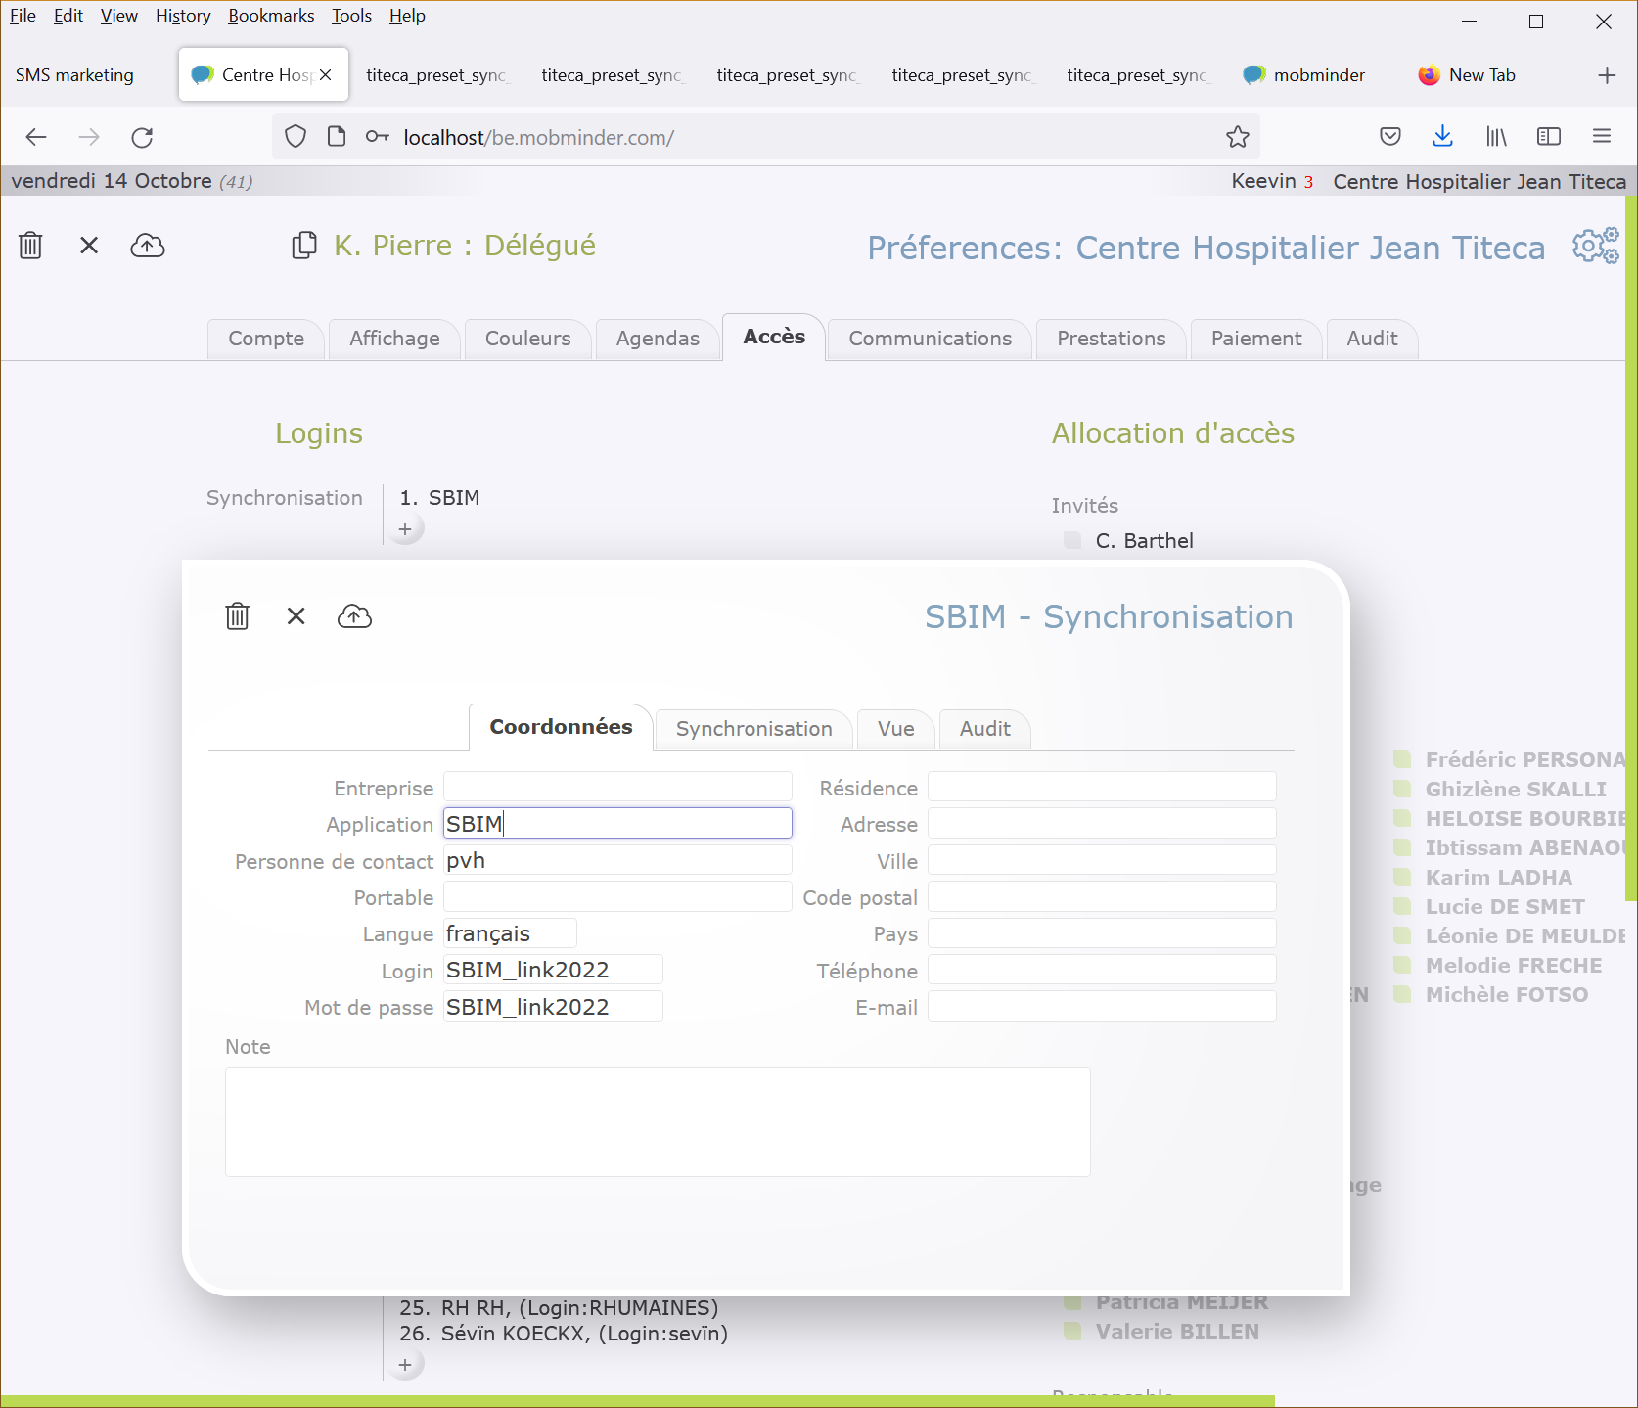

Step 2 : Open the sync utility page

From your browser, reach to this page:

https://be.mobminder.com/synctest.php

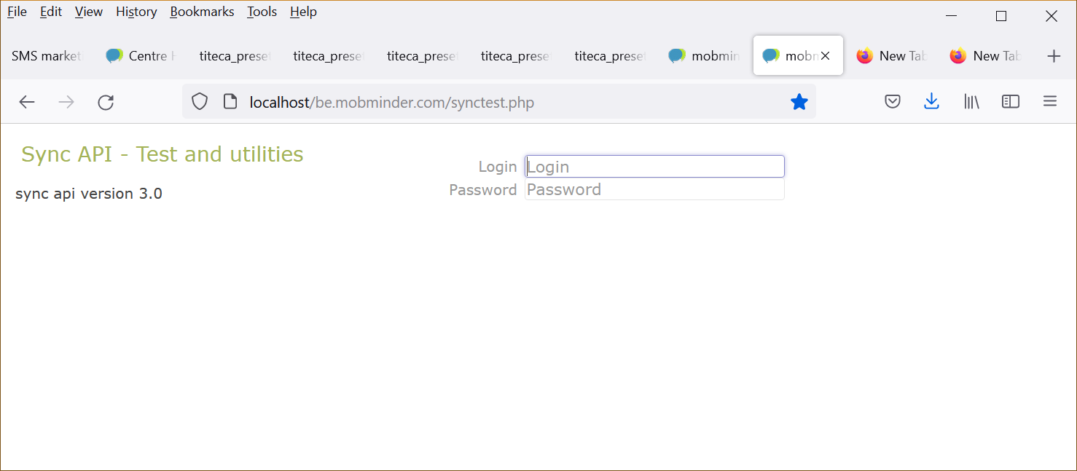

Paste your credentials ( login and password )

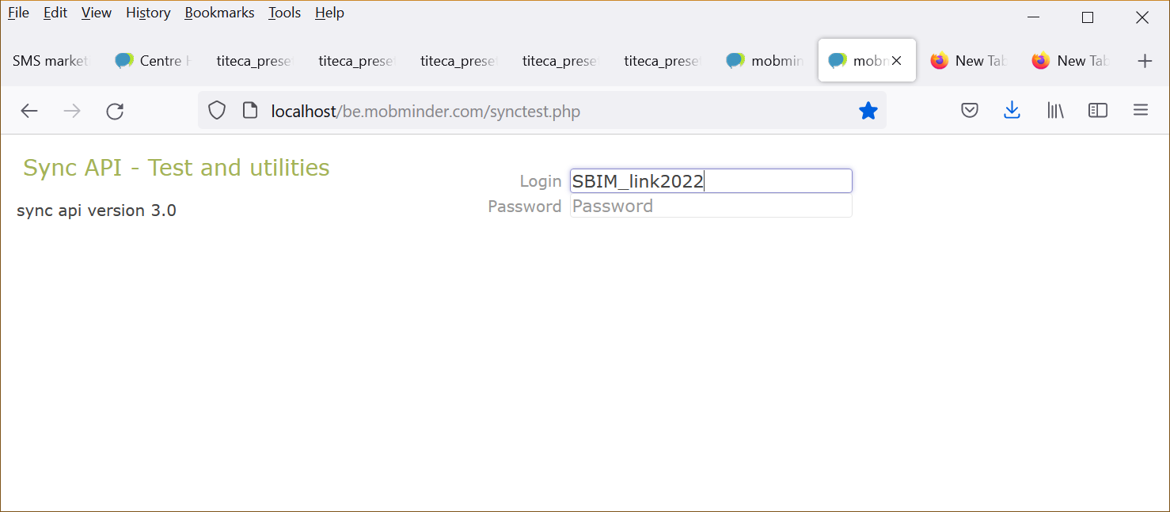

You now have access to the sync utility interface.

Doublons removal

Step 1 : check mode

Before uploading the data, we will use the doublons removal utility so to merge patients in Mobminder.

Select the Utilities tab.

Run the utility first in check mode by keeping checked the “ check mode “ option then click on [remove doublons].

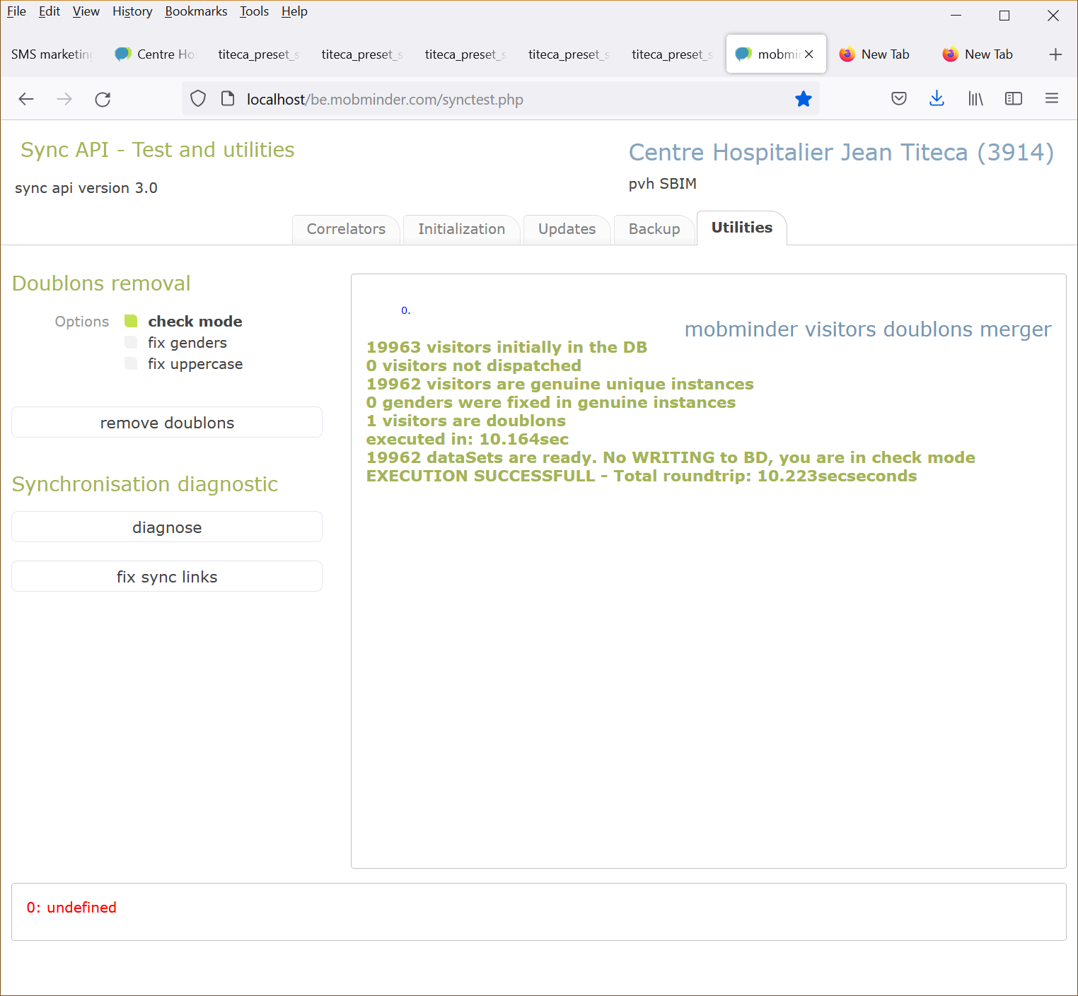

If no error message pops up, go to step 2.
If error messages pop up, stop here and contact your Mobminder account manager.

Step 2 : Do mode

Unchek the “ check mode “ option, then click the [remove doublons] button.

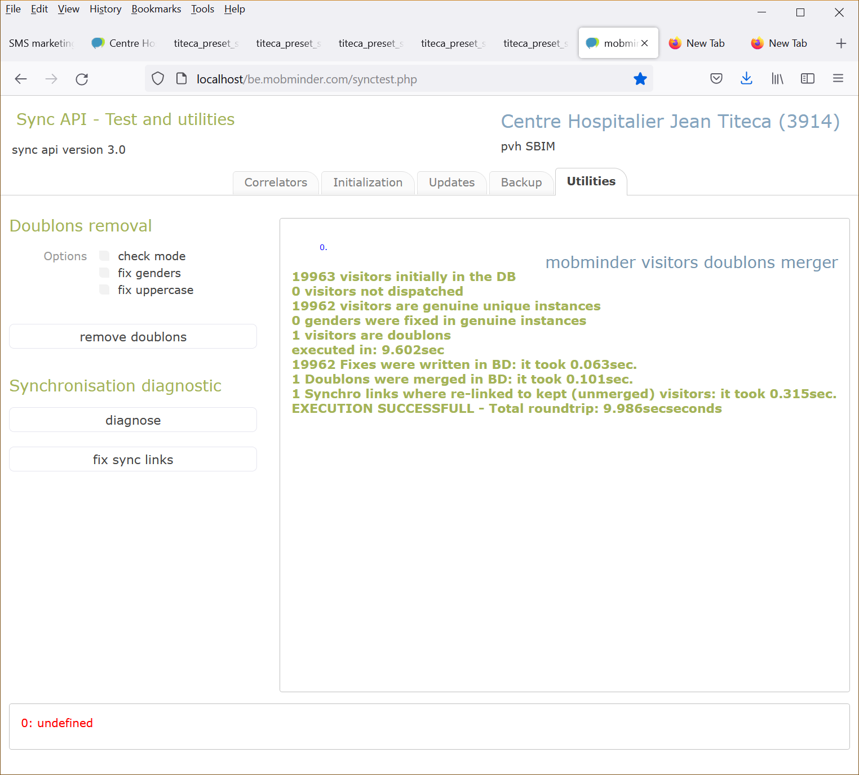

You are ready to jump to phase 3

Upload new and updated items

Pass your csv file to the Update utility, first in check mode. Keep the “clever merge” checked. Drop your file on the [Clients] area (see screenshot here under).

This procedure can take up to one minute of execution time. If csv format errors occur, please check section C: csv file format.

If the lower red status reads “0: process successful, goobye” then you are ready to execute in actual mode (unchecked “check mode” )”.

If – other than csv file format - errors appear in check mode, contact your Mobminder account manager.

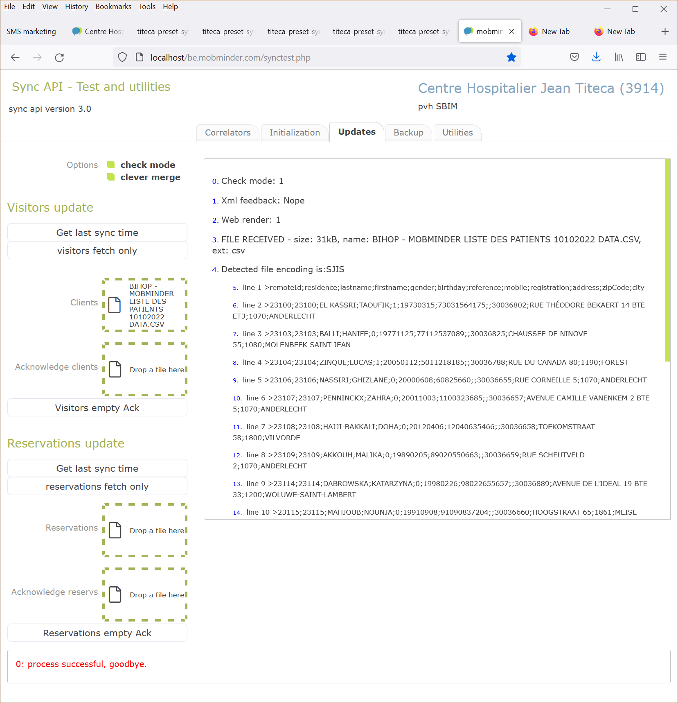

When actual mode displays “0: process successful, goobye”, please head to the phase 4.

Acknowledge

Confirm the upload by hitting the [Visitors empty Ack] button.

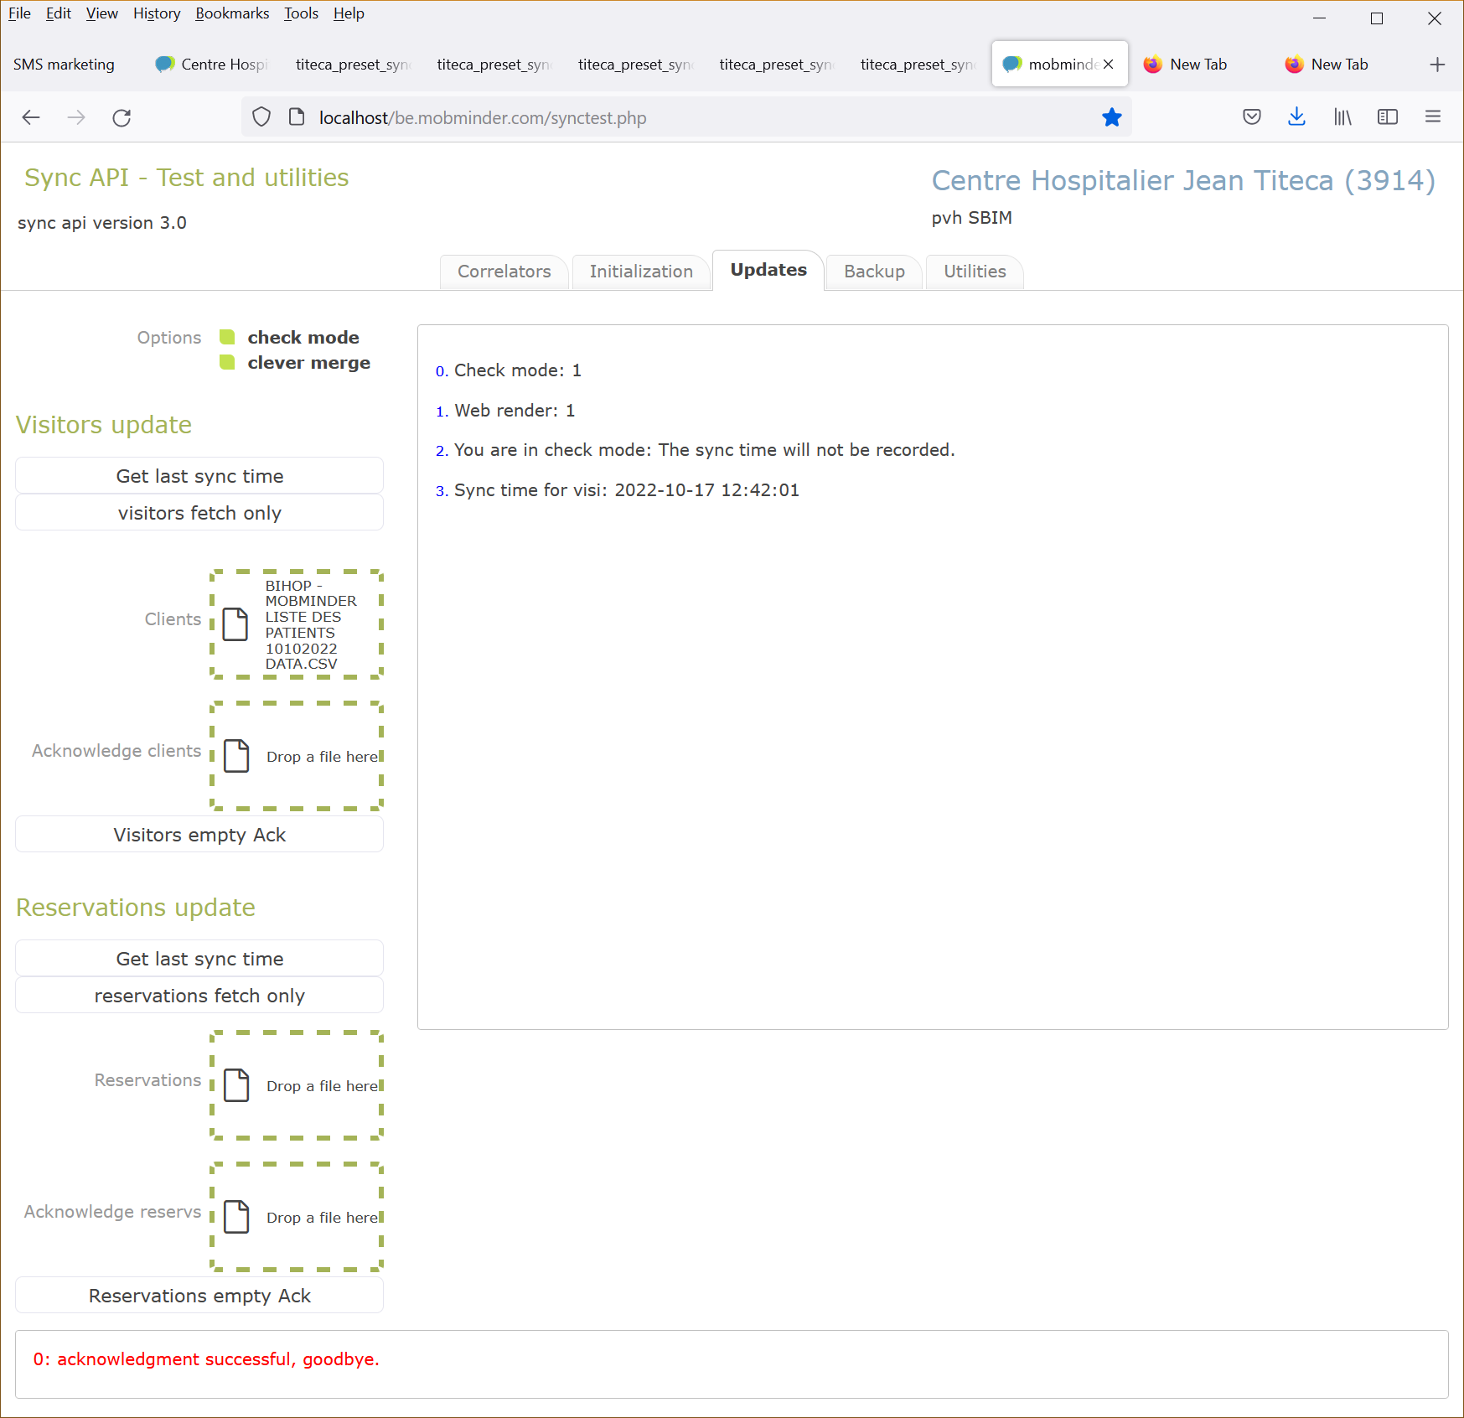

This pahse will never produce any error.

Execute diagnosis

In this section, we will assess the sanity of your sync_table. The sync table makes a link between

Please execute this page:

https://be.mobminder.com/utilities/spoofies/titeca_preset_sync_visitors.php

Check this document next page screenshot and follow the guidelines here:

If figures do not match the expected, please contact your account manager.

4. Total visitors with duplicate residence id

This section should always display zero.

6.Detect multiple entry for local ids in the sync table

Should be zero

7.Detect multiple entry for remote (SBIM) ids in the sync table

Should be zero

9. Links having NO match in the patients table

Should be zero

Note: On this page you ignore the chapter 10: Re-writing sync_table. This is for repair and should be executed only by Mobminder experts.

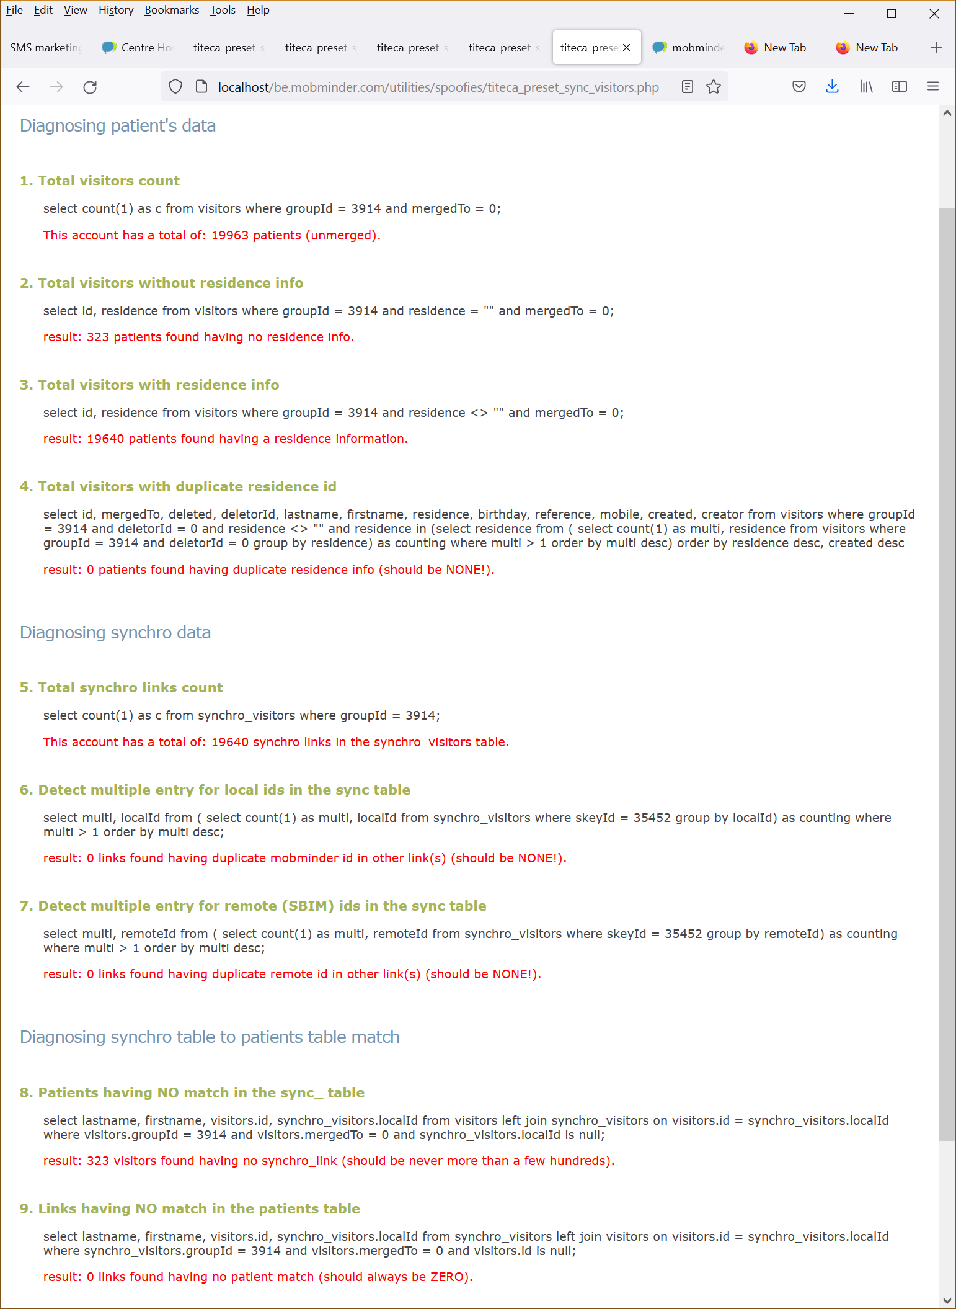

csv files format

Visitors csv format

id | remoteId | birthday | gender | lastname | firstname | mobile | phone | …
12650811 | 3555 | 19801231 | 1 | Vertoom | Bart | 32497401626 | 026621800
12650812 | 3556 | 19750820 | 0 | Bietsen | Rita | 32493655599 | 061879898

… | address | zipCode | city | country | email | Note | rcolor | …
 | Briljant str. 45, | 2100 | Gent | Belgium | bart@me.com |  | RED1
 | Markt str. 12, | 3003 | Ieper | France | rita@live.com

… | company | residence | language | reference | registration | …
 | Intuitim | Brillant | 1 |  | 1-LBB-441
 | Voxiness |  | 3 |  | 1-PAH-934

… | created | changed | deleted | mergedTo
 | 2012-08-30 | 2015-04-12 | 2018-05-22 | 3554
 | 2017-05-24 | 0 | 0

Fields description

- remoteId is your local id (from the Mobminder server perspective, you are the remote side). Is unique and numeric !

- gender is 1 for males, 0 for females. You can ignore this column or leave the value empty, it will be deduced from the firstname.

- mobile phone numbers MUST have the ICC (International Country Code) ahead. No special chars are allowed.

- Phone numbers must be numeric ( no “ (father) “ comment allowed…).

- rcolor is your local id for the color, it can be alphanumeric or null.

- Check the birthday format: yyyymmdd.

- You do not need to respect the columns sequence nor use all columns, but the headers caption must be respected.

- id is present only in server responses, it gives you the mobminderId that you use for acknowledgments.

- note can be a multi line field under condition that the mlf encoding rule is followed. See this chapter: “mlf encoding in csv files”.

- language is an integer value indicating which language to choose for automatic communications to the visitor (SMS and emails). The following range is possible :
[ 0:'english',1:'français', 2:'polski', 3:'nederlands', 4:'deutsch', 5:'italiano', 6:'español', 7:'português' ]
If your software supports a language that does not fit this list, please default to 0 (English).

All fields documented here will be present in the server response. But you may call the server choosing appropriate fields depending on your application and the purpose of the call. So you can call mobminder in a triggered way, each time an item is modified, or use polling.

Example of valid calls on visitor objects:

Example 1: declaring new visitors, or updating visitors

remoteId;lastname;firstname;gender;address;city;zipCode;phone;mobile;email;rcolor
1000;AARTS;Clara;0;Beekstraat 26;Wezembeek-Oppem;1970;22151982;;;BL
1002;ABITBOL;Rebecca;0;73, avenue de l'Aulne;Uccle;1180;25344456;;;PVPP
1003;ACAR;Esra;0;Rue Verte 209;Schaerbeek;1030;;;;BL

Example 2: changing the mobile number of a visitor

remoteId;mobile
1001;33621123456

Example 3: changing the color of a visitor

remoteId;rcolor
1002;PVPP

Example 4: declaring a merge

remoteId;merged;mergedTo
1010;2018-05-23;1003

Acknowledge csv format

This section is only relevant for updates. Ignore it if you are only developing initialization.

When items are new in Mobminder and are not acknowledged yet by your remote software, they have a Mob id and the remoteId is sent to you as 0. That is how you know you need to record this item as a new item. You need to acknowledge new items to Mobminder. So Mobminder knows your local id for those new items. New items can be visitors or appointments. Wether you acknowledge a visitor or an appointment is defined by the “class” parameter passed along the call to the acknowledge api door (see the chapter about api doors parameters).

mobminderId | remoteId
991234567 | 1111112

Tips:
- When none of remoteId is zero in a Mobminder feedback, you do not need to acknowledge at all.
- You can acknowledge without sending a file, or sending an empty file
- Acknowledge returns the sync time to you. If chapter “troubleshooting dataloss” is relevant for you, please store this sync time.
- Check also section 10 about color sync, it features nice csv examples that can be useful for developing.

Multi line fields encoding in csv files

This chapter is of interest for you if your application authorizes mutli-line note fields.
Multi-line fields contain newline ( “\n” or chr(10) ) characters. When encoded in csv format, they introduce lines in the file that break the regular rule of having one line for one record.

When opened to MS Excel, mlf will appear like a multi-line text in a single cell.

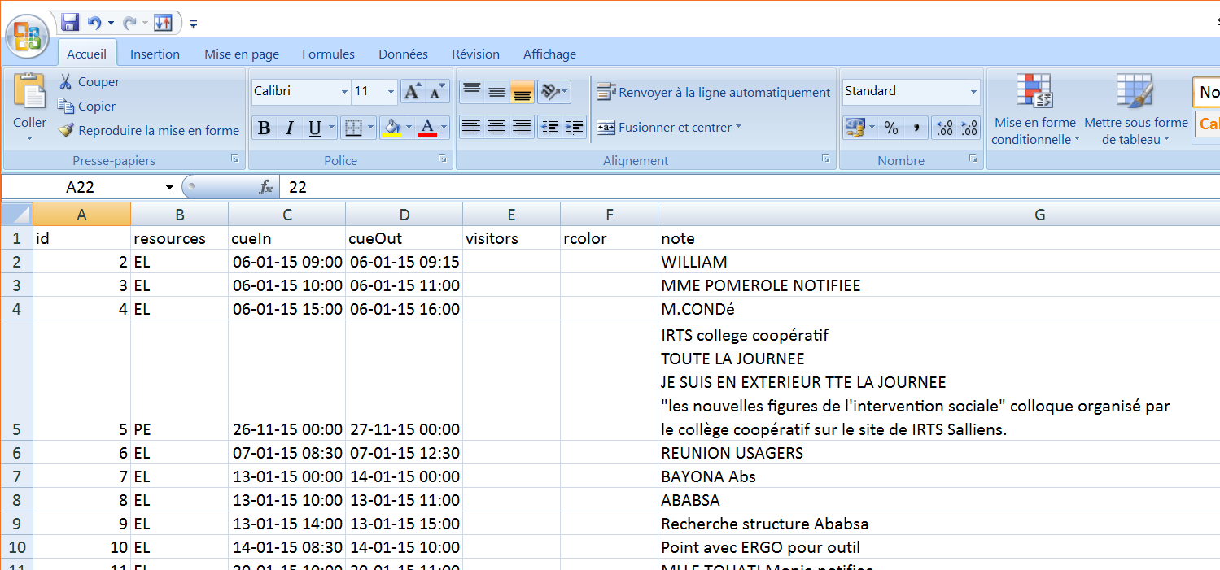

But the same file viewed in a text editor looks like this:

id;resources;cueIn;cueOut;visitors;rcolor;note
2;EL;2015-01-06 09:00;2015-01-06 09:15;;;WILLIAM
3;EL;2015-01-06 10:00;2015-01-06 11:00;;;MME POMEROLE NOTIFIEE
4;EL;2015-01-06 15:00;2015-01-06 16:00;;;M.CONDé
5;PE;2015-11-26 00:00;2015-11-27 00:00;;;"IRTS college coopératif
TOUTE LA JOURNEE
JE SUIS EN EXTERIEUR TTE LA JOURNEE
""les nouvelles figures de l'intervention sociale"" colloque organisé par
le collège coopératif sur le site de IRTS Salliens."
6;EL;2015-01-07 08:30;2015-01-07 12:30;;;REUNION USAGERS
7;EL;2015-01-13 00:00;2015-01-14 00:00;;;BAYONA Abs
8;EL;2015-01-13 10:00;2015-01-13 11:00;;;ABABSA

Mobminder supports the encoding rules of MS-Excel multi-line-fields.

Encoding rules are as follow:
- The content is enclosed in double quotes
- Inside the mlf, double quotes are doubled

Csv format, Summary

You do not need to record any Mobminder id. The correlation from remote id to Mobminder id is made and recorded in Mobminder.

When new items are created in Mobminder first, you need to declare the localId you apply for these items. We call this declaration “acknowledgement of Mobminder new items”. Your local id must be mentioned in the remoteId column, it should match the mobminderId you got through the update sync.

A call to the Acknowledge door returns the sync time for the given class. We advise that you test the update scenario (including acknowledgement) on the stub Web page.

