Mạch sạc pin cho node

<https://hshop.vn/products/mach-sac-pin-lithium1a-v2?fbclid=IwZXh0bgNhZW0CMTAAAR1NrUkb3_sDt-Eqlxa9hgA9rHrHJThmJZ8ZSuw6FduZ8hxAp36Y09Cer_Q_aem_AbCejajdrbt8QP2WpTDJ-gGVSEy3hVpED_s4-qzUeBERwofk-GF1mMx5RvrehvO4oMLw2LiAbPFZJNLApzhPrB7W>

<https://hshop.vn/products/pin-nang-luong-mat-troi-monocrystalline-solar-panel-5v-1a>

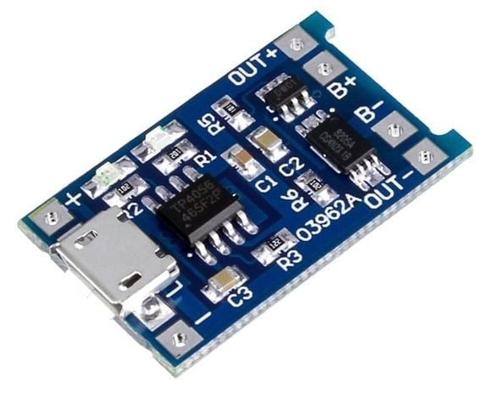

giá: 6K

Mạch sạc pin Gateway