**BỘ CÔNG THƯƠNG**

**TRƯỜNG ĐẠI HỌC CÔNG NGHIỆP TP. HCM**



**VI ĐIỀU KHIỂN**

**BÀI BÁO CÁO 4**

**NHÓM 3**

Giảng viên : **PHẠM QUANG TRÍ**

Sinh viên :

* Trần Công Hòa 20017691
* Đỗ Tuấn Duy 20061261
* Nguyễn Quốc Dương 20123251

**TP.HCM – 2022**

**Bài tập mức độ 3:**

1. **Sơ đồ nguyên lí kết nối phần cứng tối thiểu dùng STM32:**

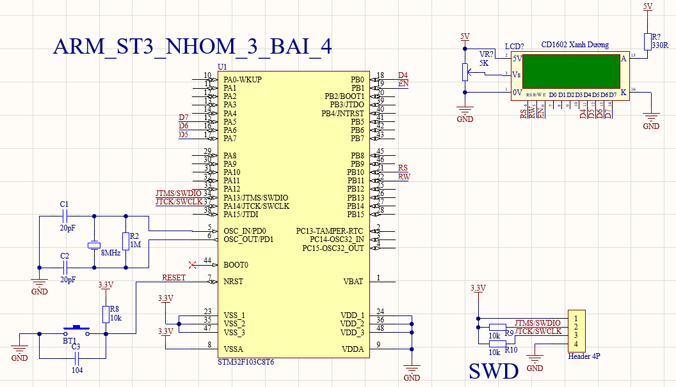

1. **Cách thiết lập chức năng trong phần mềm CubeMX:**

**Bước 1**: Khởi động phần mềm CubeMX, tạo New Project và chọn mã số STM32F103C8T6.

**Bước 2**: Chọn mạch nạp:

**Bước 3**: Chọn bộ mạch động:

**Bước 4:** Chọn tần số giao động:

**Bước 5**: Cấu hình chân GPIO Output

**Bước 6**: Đặt tên cho Project và chọn nơi lưu trữ, chọn phần mềm viết chương trình

1. **Lưu đồ giải thuật:**

**Chương trình con:**

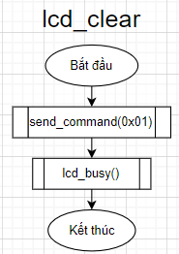

**Chương trình chính:**

1. **Mã nguồn chương trình:**

**Chương trình con:**

void write_to_lcd_4bits(uint8_t rs, uint8_t data)

{

HAL_GPIO_WritePin(RS_GPIO_Port, RS_Pin, rs);

HAL_GPIO_WritePin(RW_GPIO_Port, RW_Pin, 0);

HAL_GPIO_WritePin(EN_GPIO_Port, EN_Pin, 1);

HAL_GPIO_WritePin(D7_GPIO_Port, D7_Pin, ((data>>3)&0x01));

HAL_GPIO_WritePin(D6_GPIO_Port, D6_Pin, ((data>>2)&0x01));

HAL_GPIO_WritePin(D5_GPIO_Port, D5_Pin, ((data>>1)&0x01));

HAL_GPIO_WritePin(D4_GPIO_Port, D4_Pin, ((data>>0)&0x01));

for(i = 0; i < 72; i++)

{

__asm("NOP");

}

HAL_GPIO_WritePin(EN_GPIO_Port, EN_Pin, 0);

lcd_busy();

}

void send_command(uint8_t data)

{

write_to_lcd_4bits(0, (data>>4)&0x0f);

write_to_lcd_4bits (0, (data>>0)&0x0f);

}

void display_lcd(uint8_t data)

{

write_to_lcd_4bits(1, (data>>4)&0x0f);

write_to_lcd_4bits (1, (data>>0)&0x0f);

}

void display_text(char *data)

{

uint8_t j;

for(j=0; j<strlen(data); j++)

{

display_lcd(data[j]);

}

}

void lcd_clear()

{

send_command(0x01);

lcd_busy();

}

void nap_tudien(void)

{

char i = 0;

send_command(0x40); // che do nap tu dien moi

while(Font[i] != 0x99)

{

display_lcd(Font[i]);

i++;

}

}

void nap_tudien2(void)

{

char i = 0;

send_command(0x40); // che do nap tu dien moi

while(Font2[i] != 0x99)

{

display_lcd(Font2[i]);

i++;

}

}

void set_cursor(uint8_t row, uint8_t col)

{

uint8_t temp;

switch(row)

{

case 0:

temp = col|0x80;

break;

case 1:

temp = col|0xC0;

break;

default:

temp = col|0x80;

}

send_command(temp);

}

void lcd_config()

{

send_command(0x28); //LCD 4bit, 2-line, 5x8 hieu 2

lcd_busy();

send_command(0x28); //LCD 4bit, 2-line, 5x8 hieu 8

lcd_busy();

send_command(0x0f);

lcd_busy();

send_command(0x06);

lcd_busy();

send_command(0x01);

lcd_busy();

}

void lcd_busy(void)

{

uint8_t busy_flag_copy;

GPIO_InitTypeDef GPIO_InitStruct = {0};

GPIO_InitStruct.Pin = GPIO_PIN_5;

GPIO_InitStruct.Mode = GPIO_MODE_INPUT;

GPIO_InitStruct.Pull = GPIO_NOPULL;

HAL_GPIO_Init(GPIOA, &GPIO_InitStruct);

HAL_GPIO_WritePin(RS_GPIO_Port, RS_Pin, 0);

HAL_GPIO_WritePin(RW_GPIO_Port, RW_Pin, 1);

do{

busy_flag_copy = 0;

HAL_GPIO_WritePin(EN_GPIO_Port, EN_Pin, 1);

for(int i = 0; i < 72; i++);

busy_flag_copy = HAL_GPIO_ReadPin(GPIOA, GPIO_PIN_5);

HAL_GPIO_WritePin(EN_GPIO_Port, EN_Pin, 0);

for(int i = 0; i < 72; i++);

HAL_GPIO_WritePin(EN_GPIO_Port, EN_Pin, 1);

for(int i = 0; i < 72; i++);

HAL_GPIO_WritePin(EN_GPIO_Port, EN_Pin, 0);

for(int i = 0; i < 72; i++);

}while(busy_flag_copy);

HAL_GPIO_WritePin(RW_GPIO_Port, RW_Pin, 0);

GPIO_InitStruct.Pin = GPIO_PIN_5;

GPIO_InitStruct.Mode = GPIO_MODE_OUTPUT_PP;

GPIO_InitStruct.Pull = GPIO_NOPULL;

GPIO_InitStruct.Speed = GPIO_SPEED_FREQ_LOW;

HAL_GPIO_Init(GPIOA, &GPIO_InitStruct);

}

**Chương trình chính:**

#include "main.h"

/* Private includes ----------------------------------------------------------*/

/* USER CODE BEGIN Includes */

#include "string.h"

/* USER CODE END Includes */

…

/* USER CODE BEGIN PV */

uint16_t i;

const unsigned char Font[] = {

0x00, 0x04, 0x0A, 0x0E, 0x11, 0x11, 0x0E, 0x00,//?

0x06, 0x0B, 0x0E, 0x01, 0x0F, 0x11, 0x0F, 0x00,//? huyen

0x00, 0x04, 0x02, 0x0E, 0x11, 0x11, 0x0E, 0x00,//?

0x05, 0x0A, 0x03, 0x0E, 0x11, 0x11, 0x0E, 0x00,//? nga

0x0C, 0x0A, 0x09, 0x1D, 0x09, 0x0A, 0x0C, 0x00,// ?

0x0C, 0x1A, 0x0E, 0x01, 0x0F, 0x11, 0x0F, 0x00,// ? sac

0x99};

const unsigned char Font2[] = {

0x05, 0x0E, 0x0A, 0x0E, 0x11, 0x1E, 0x0E, 0x00,//? nga

0x04, 0x0C, 0x0A, 0x0E, 0x11, 0x11, 0x0E, 0x00,//? sac

0x00, 0x00, 0x03, 0x12, 0x12, 0x12, 0x0C, 0x00,// uw

0x00, 0x00, 0x03, 0x0E, 0x11, 0x11, 0x0E, 0x00,// ow

0x99};

const unsigned char line1_1[] ={0x54,0x72,0x01,0x6E,' ', 0x43, 0x00, 0x6E,0x67,' ',0x48,0x02,0x61};

const unsigned char line1_2[] = {0x04,0x03,' ',0x54,0x75,0x05,0x6E,' ',0x44,0x75,0x79};

const unsigned char line1_3[] = {0x4E,0x67,' ',0x51,0x75,0x01,0x63,

' ',0x44,0x02,0x03,0x6E,0x67};

void lcd_busy(void);

/* USER CODE END PV */

…

int main(void)

{

/* USER CODE BEGIN 1 */

/* USER CODE END 1 */

/* MCU Configuration--------------------------------------------------------*/

/* Reset of all peripherals, Initializes the Flash interface and the Systick. */

HAL_Init();

/* USER CODE BEGIN Init */

/* USER CODE END Init */

/* Configure the system clock */

SystemClock_Config();

/* USER CODE BEGIN SysInit */

/* USER CODE END SysInit */

/* Initialize all configured peripherals */

MX_GPIO_Init();

/* USER CODE BEGIN 2 */

lcd_config();

/* USER CODE END 2 */

/* Infinite loop */

/* USER CODE BEGIN WHILE */

while (1)

{

/* USER CODE END WHILE */

/* USER CODE BEGIN 3 */

lcd_clear();

nap_tudien();

set_cursor(0,2);

for(int i = 0 ; i < 13; i++)

{

display_lcd(line1_1[i]);

}

set_cursor(1,4);

display_text("20017691");

HAL_Delay(5000);

lcd_clear();

set_cursor(0,2);

for(int i = 0 ; i < 11; i++)

{

display_lcd(line1_2[i]);

}

set_cursor(1,4);

display_text("20061261");

HAL_Delay(5000);

lcd_clear();

nap_tudien2();

set_cursor(0,1);

for(int i = 0 ; i < 13; i++)

{

display_lcd(line1_3[i]);

}

set_cursor(1,4);

display_text("20123251");

HAL_Delay(5000);

}

/* USER CODE END 3 */

}

1. **Video minh chứng:**

Link youtube: <https://www.youtube.com/watch?v=1a4OgqHPVIM>