Alex Look
CSC 355-402
Assignment 1
9/21/20

1 Data of one of the five tables (STUDENT table used here)
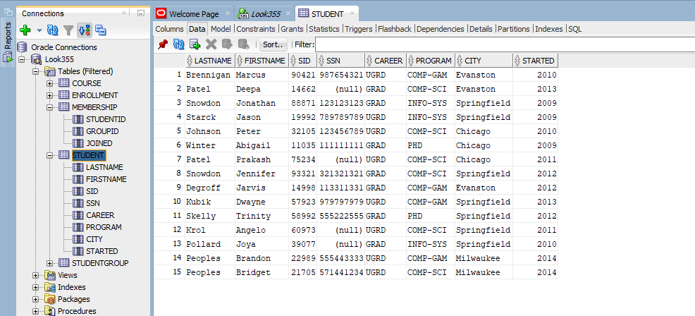
2 Query Result of SQL Statement (COURSE table used here)
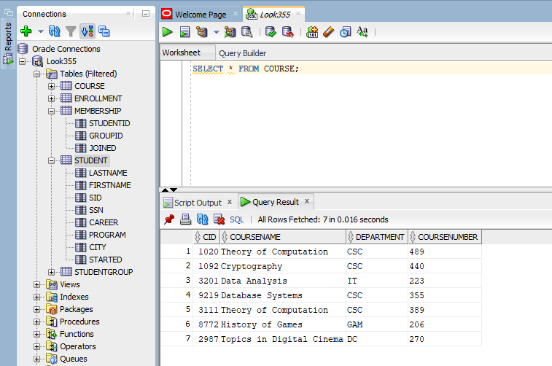

3a The primary key is CID in CUSTOMER
3b The primary key is CrID in CRUISE
3c The primary keys are CustomerID and CruiseID in TICKET
3d The foreign key in CUSTOMER does not exist
3e The foreign key is ShipID in CRUISE
3f The are two separate foreign keys pointing to two tables CustomerID refers to CUSTOMER table and CruiseID refers to CRUISE those are foreign keys in the TICKET table.
3g (‘20’, ‘882’, 01-JUL-19) I used the CID from CUSTOMER table that is a primary key so 20 to refer to CustomerID that is a foreign key in that table. As well as CruiseID is a primary key in the CRUISE table CrID is the foreign key so I used 882 to refer to the two tables. From there the rest of the data does not matter.
3h (‘55’, ‘847’, 04-JAN-20) For this table to violate referential integrity I needed no links to the CID primary key in CUSTOMER table and no links to the CrID in the CRUISE table. I made all the data especially CustomerID and CruiseID attributes of the tuple to not already exist in either CUSTOMER and CRUISE table to not refer to the CUSTOMER table CID primary key and CRUISE table CrID primary key previously made.
3i (‘600’, ‘N1’, ‘12’, ‘4000’) I made a whole new CrID unique for the CRUISE table. Otherwise I used a reference with the foreign key to the SHIP table with primary key SID and N1 and the rest of the data did not matter.
3j (‘906’, ‘D1’, ‘10’, ‘3000’) for this not to work I needed the ShipID attribute to be nonexistent in the SID SHIP table the rest of the data I did not think mattered.
3k The tuples that cannot be removed (‘N2’, ‘Getaway’, ‘New York’), (‘N3’, Runaway’, ‘Miami’), (‘C4’, ‘Adventure’, ‘New York’). Since N2, N3, and C4 are the foreign keys in CRUISE table and would violate referential integrity if removed because it would not have that reference from CRUISE table foreign key to the SHIP table primary key being the SID attribute. Referential integrity in the lectures said there needed to be a reference or linking of the foreign keys to the primary keys of a table to another table.

