**Analytics Project (Ariyan Shaw)**

**1.Item-wise order quantity**

1. **Which Items have been ordered most and which items have been ordered least?**

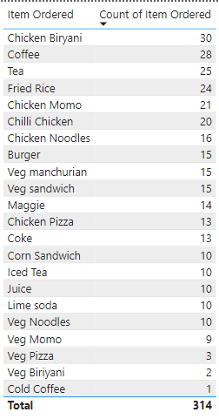

Most ordered items: Chicken Biryani, Coffee, Tea

Least ordered items: Veg Pizza, Veg Biriyani, Cold Coffee

1. **What will be your conclusion based on this?**

The items containing chicken (non veg) are sold the most when compared to the veg items. In veg meal items fried rice is the one which has been ordered the most and within non veg items chicken biryani secures the top spot. And also overall chicken biryani is sold the most. Within beverages people like Coffee & tea the most with a order count of 28 & 25 respectively. And within beverages cold coffee is sold the least and people are not liking it.

**2.Find out for which item more units are ordered in a single order.**

1. **Do we observe more units ordered against lower-priced items or higher-priced items?**

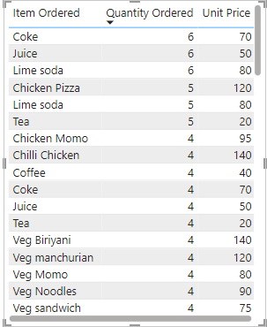

We see more order units ordered in single order for lower priced items. Coke, Juice & Lime soda have been ordered 6 times in single order which has a price of 70, 50 & 80 respectively.

**3.Visually present the following in a single view:**

1. **The percentage of sales amount generated for each item in different types of orders; we should be able to filter the order type.**

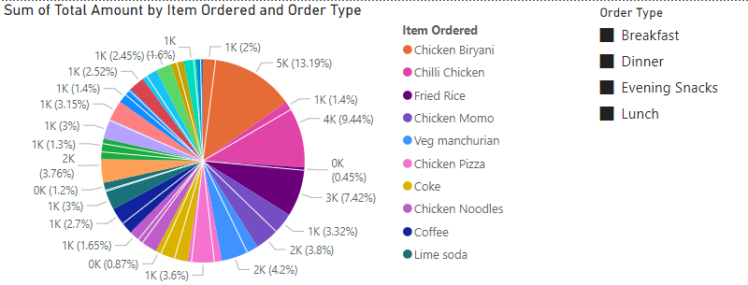

1. 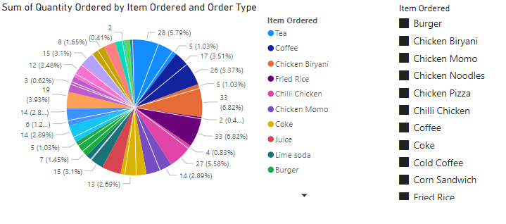**The total quantity ordered for each item in different order types; we should be able to filter the items ordered.**
2. **Identify the 3 top selling items and 3 least selling items in each order type in terms of quantity.**

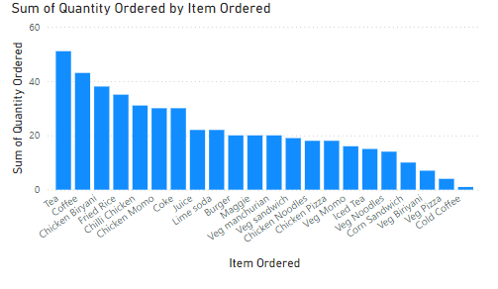

Top 3 items ordered: Tea, Coffee, and Chicken Biryani

Least 3 items ordered: Veg Biryani, Veg Pizza, and Cold Coffee

1. **Identify 3 items that are contributing higher to the sale amount and the 3 items that are contributing much less to the sales amount.**

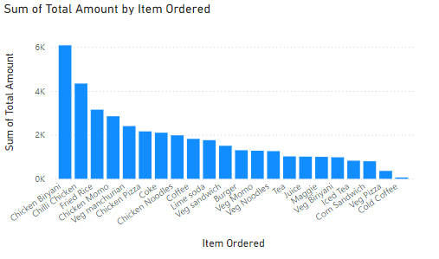

3 items contributing higher: Chicken Biryani, Chilli Chicken, Fried Rice

3 items contributing much less: Corn Sandwich, Veg Pizza, Cold Coffee

**4.Find out:**

1. **Which are the items being ordered by customers in at least 3 meal types?**

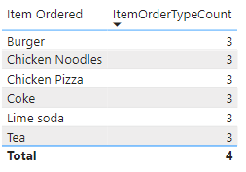

Burger, Chicken Noodles, Chicken Pizza, Coke, Lime soda and Tea are the items being ordered by customers in at least 3 meal types

1. **Which are the items being ordered in more than one meal type?**

Burger, Chicken Noodles, Chicken Pizza, Coke, Lime soda, Tea, Chicken Biryani, Chicken Momo, Chilli Chicken, Coffee, Corn Sandwich, Fried Rice, Iced Tea, Maggie, Veg manchurian, Veg Momo, & Veg Pizza are the items which are being ordered in more than one meal type.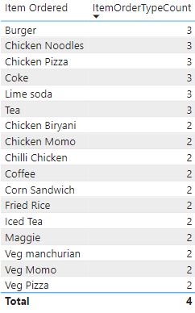

1. **What insights do we get from this? Should we discontinue any of these items, and why?**

The insights we get from this is that high order value items are being ordered 3 times in a day, this is generating a lot of revenue for the items with meal types being more than or equal to 3. This gives us a conclusion that we should stock the items and keep them available so that it never goes out of stock due to high demand.

Items such as veg pizza need to be discontinued. It is being ordered 2 times a day and the sales amount is also very low for veg pizza. Discontinuing this item will help the store in the long run.