Lab 7 White Box Testing

The goal of this lab is to practice white box testing of small software modules.

Define test cases in a high-level format (e.g. tables), using WB techniques (statement coverage, decision coverage, ...)

In es2 and es3: compare test cases written using BB techniques and those written using WB techniques. Compare the WB coverage obtained from test cases written using BB techniques.

For es4, es5, es6, write WB test cases in high-level format,

For es4, es5, es6, transform the test cases written in step 3 into code format (JS + Jest). Run the test cases and verify the coverage calculated by Jest.
- For es7 and es8, define test cases for statement coverage, decision coverage, multiple condition coverage, and path coverage (where possible)

The Jest project is available at this link: https://git-softeng.polito.it/d023270/jest can be used to create test cases in Typescript

Exercise 1 – Absolute Maximum

This function must return the absolute maximum value of an array of integers, containing at most 5 elements. Returns -1 on error.

1 function max_absolute(numbers: number[]): number {
2 if (numbers.length > 5)
3 return -1;
4 let max_value = 0;
5 for (let i = 0; i < numbers.length; i++) {
6 if (numbers[i] < 0)
7 max_value = Math.max(max_value, Math.abs(numbers[i]));
8 else
9 max_value = Math.max(max_value, numbers[i]);
10 }
11 return max_value;
12 }

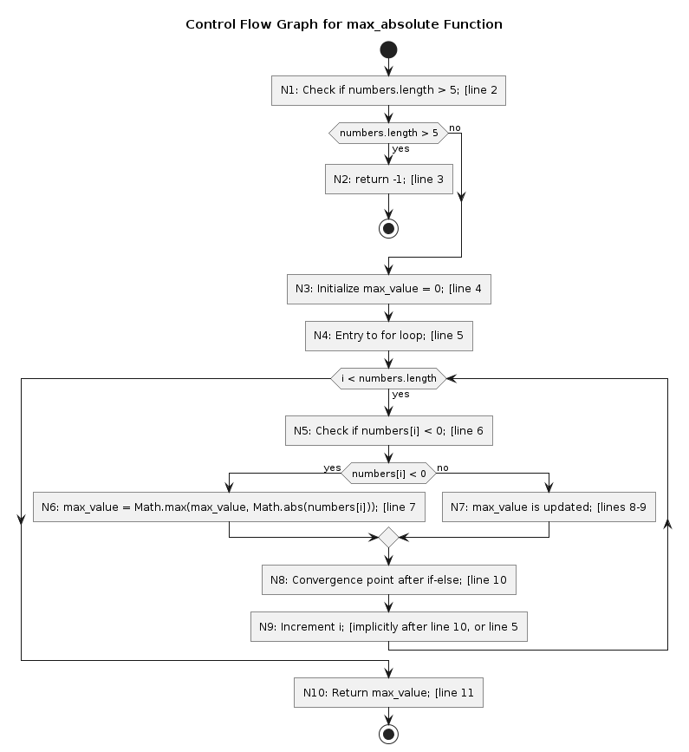

Compute coverage for the given test cases

Test cases | Nodes covered | Node coverage per test case | Node coverage per test suite | Edge covered | Edge coverage per test case  Per test suite | Loop in line 5
all_equals = {0,0,0,0,0};
all_positive = {1,2,3,4,5};
all_negative = {-1,-2,-3,-4,-5}
[] out_of_size = {1,2,3,4,5,6};
mixed = {-10,10,3,5,-6};
empty = {};
One {1}

Exercise 2 – Convert Int

A function converts a sequence of characters to an integer. The sequence can start with a '-' (negative number). If the sequence is shorter than 6 characters, it is filled with spaces (on the left side). The integer must be in the range minint = -32768 to maxint = 32767. The function reports an error if the character sequence is not allowed.

1 class ConvertInt {
2 public convert(str: string[]): number | Error {
3 if (str.length > 6)
4 throw new Error("Invalid length");
5 let number = 0, digit, i = 0;
6 if (str[0] === '-')
7 i = 1;
8 for (; i < str.length; i++) {
9 digit = str[i].charCodeAt(0) - '0'.charCodeAt(0);
10 number = number * 10 + digit;
11 }
12 if (str[0] === '-')
13 number = -number;
14 if (number > 32767 || number < -32768)
15 throw new Error("Number out of range");
16 return number;
17 }
18 }

Exercise 3 – Event Queue

An event queue in a simulation system receives events. Each event has a time tag. You can pull events from the queue, the extract must return the event with the lowest time tag. The queue discards events with negative or no time tag. The queue must accept at least 100,000 events. Events with the same time tag must be merged (i.e. the second received is discarded).

1 class EventsQueue {
2 private queue: number[] = [];
3
4 public insert(event: number): void {
5 let index = 0;
6 while (index < this.queue.length && this.queue[index] < event) {
7 index++;
8 }
9 this.queue.splice(index, 0, event);
10 }
11
12 public pop(): number {
13 if (this.queue.length === 0) {
14 return -1;
15 }
16 return this.queue.shift()!;
17 }
18
19 public print(): void {
20 this.queue.forEach(event => console.log(event + " "));
21 }
22 }

Exercise 4 – Acceptable to Eat

1 class Example4 {
2 static acceptableToEat(carb: number, protein: number, fat: number): boolean {
4 if (carb < 0 || protein < 0 || fat < 0) {
5 return false;
6 }
7 const totalCalories = 4 * carb + 4 * protein + 9 * fat;
8 const ratio = (carb + protein) / fat;
9 return totalCalories < 1000 && ratio > 0.5;
10 }
11 }

Exercise 5 – Bike Rental (computeFee)

1 class Example5 {
2 static computeFee(duration: number, minRate: number, minRate2: number): number {
3 if (duration < 0 || minRate < 0 || minRate2 < 0) {
4 return -1.0;
5 }
6 if (duration < 30) {
7 return 0.0;
8 }
9 if (duration >= 30 && duration < 90) {
10 return minRate * (duration - 30);
11 }
12 return 60 * minRate + (duration - 90) * minRate2;
13 }
14 }

Exercise 6 – Railway Ticket (computeFee2)
1 class Example6 {
2 static computeFee(basePrice: number, n_passengers: number, n_over18: number, n_under15: number): number {
3 if (basePrice < 0 || n_passengers < 0 || n_over18 < 0 || n_under15 < 0) {
4 return -1.0;
5 }
6 if (n_over18 + n_under15 > n_passengers) {
7 return -1.0;
8 }
9 if (n_passengers >= 2 && n_passengers <= 5 && n_over18 > 0) {
10 return basePrice * (n_passengers - n_under15);
11 } else {
12 return basePrice * n_passengers;
13 }
14 }
15 }

Exercise 7 – Tax Calculator
Define test cases for statement coverage, decision coverage, and path coverage (if possible).

1 public elonianTaxCalculator(income: number, nDependents: number): number {
2 if (income < 0) {
3 console.log("You cannot have a negative income.\n");
4 return -1;
4 }
5 if (nDependents <= 0) {
6 console.log("You must have at least one dependent.\n");
7 return -2;
8 }
9
10 let TaxSubTotal: number;
11 if (income < 10000) {
12 TaxSubTotal = 0.02 * income;
13 } else if (income < 50000) {
14 TaxSubTotal = 200 + 0.03 * (income - 10000);
15 } else {
16 TaxSubTotal = 1400 + 0.04 * (income - 50000);
17 }
18
19 let Exemption = nDependents * 50;
20 let TaxTotal = TaxSubTotal - Exemption;
21
22 if (TaxTotal < 0) {
23 TaxTotal = 0;
24 }
25
26 console.log("Elbonian Tax Collection Agency \n");
27 console.log("Tax Bill \n");
28 console.log("Citizen's Income: " + income + '\n');
29 console.log("Tax Subtotal: " + TaxSubTotal + '\n');
30 console.log("Number of Dependents: " + nDependents + '\n');
31 console.log("Tax Exemption: " + Exemption + '\n');
32 console.log("Final Tax Bill: " + TaxTotal + '\n');
33
34 return TaxTotal;
35 }

Exercise 8 – foo

Define test cases for statement coverage, decision coverage, multiple condition coverage, and path coverage (if possible).

1 function foo(a: number, b: number, c: number, d: number, e: number): number {
2 if (a === 0) {
3 return 0;
4 }
5 let x = 0;
6 if (a === b || (c === d && Example8.bug(a))) {
7 x = 1;
8 }
9 e = 1 / x;
10 return e;
11 }
12
13 function bug(a: number): boolean {
14 return a === 1;
15 }

