York St John Zoo

Design

**Program brief:**

We will create a virtual York St John zoo. The program will need to have a list of all animals it holds. There will be 4 different animal types: Mammals, birds, fish and reptiles. The animals also have different environments and diets. The program has to display the details of a single animal, and of multiple animals at once, as well. It must be able to create a food list for different animals, display the environment of a specific animal and create a list of all animals of a specific type.

**Design overview:**

An Animal class will be created, the base for all of the animal objects. It contains the basic information such as: Type, Diet, Environment and Name. This class will have a constructor to initialize all the values. It will also have a method that returns the details, giveDetails() that will group all the above mentioned details and return them as a single string, when called.

4 more classes will be created which extend Animal for each type of animal: mammal, bird, fish and reptile.

The program will have a simple flow: The user first chooses between 2 big actions:

1. To search for animals and add them to a list:

* The user can then view all the animals’ details or diets;
* Or he can stop after adding only one animal and view that.

1. To search for animals by certain criteria:

* Type;
* Diet;
* Environment.

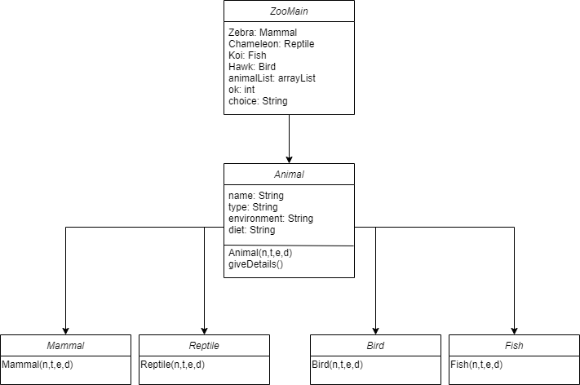

Above is the diagram for the classes that will be created and the relationships between them.

**Feature List:**

* The system will store all the zoo animals and the searched animals in 2 separate array lists.
* The Animal class will only have 1 method: giveDetails().
* The program is flexible and allows searches of all sorts, and after each iteration it returns to the main menu, ready for more input.
* The program is really flexible in the first action: the user can add as many animals as he wants and view whatever he wants about them, or he can just add 1 and view that animal’s details.