# PCB:

136x180mm  
Fr4 double layer   
2oz, 8mil clearance

# Case (zs-8247)

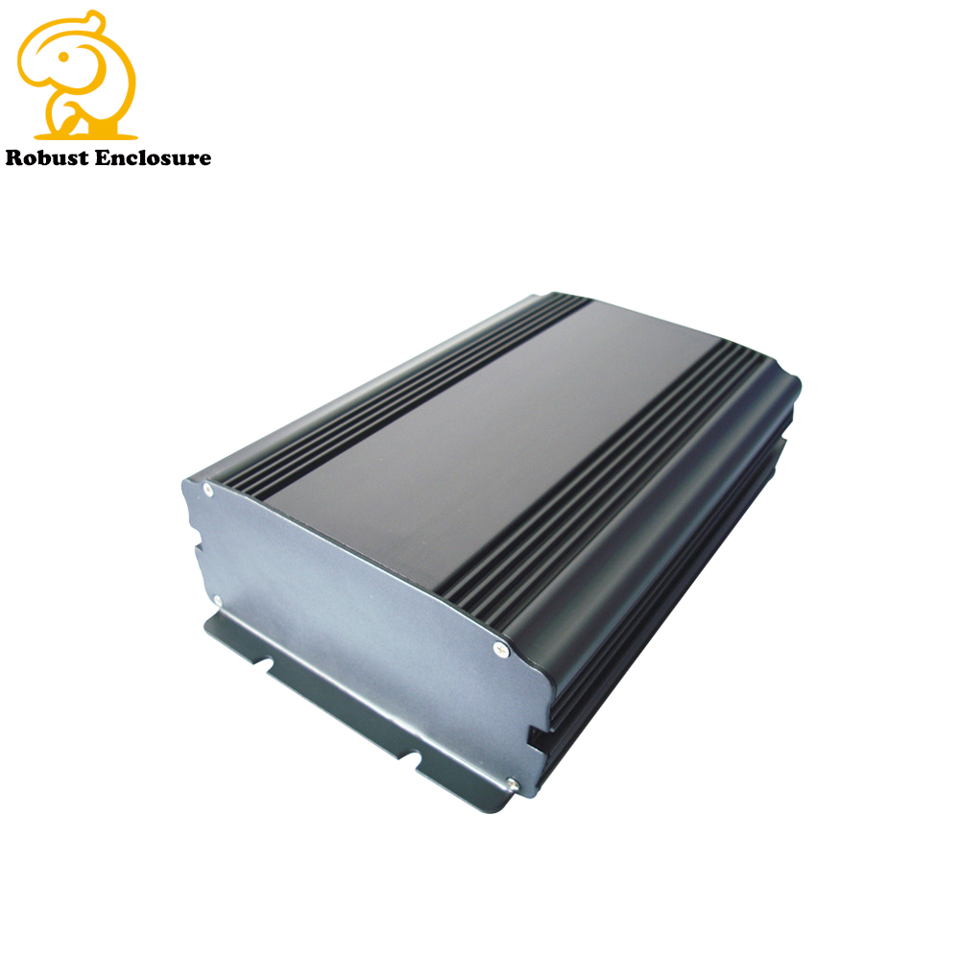(optional: color of the case: black)

Vendor Ningbo Sunyoung Enclosure Co.,Ltd   
Address: Room802,TianHong Building ,No 555 ,RenheRoad ,Cultural Business Zone,Cixi ,Ningbo China 315300  
Tel: +86-574-63086395 Fax : ++86-574-63086395  
Mobile :+8615157753600   
Skype :+8615157753600 Whats App :+ 8615157753600  
Wechat : cjh15157753600

E-mail : [sales2@robustcasing.com](mailto:sales2@robustcasing.com)  
[www.robustcasing.com](http://www.robustcasing.com)  
https://robustcase.en.alibaba.com/

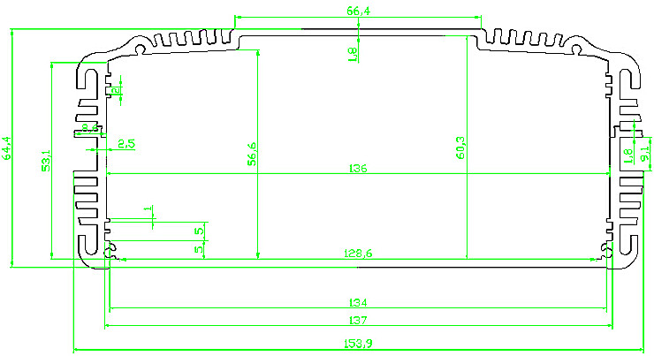

# Plate drill/mill guid

Front Platte

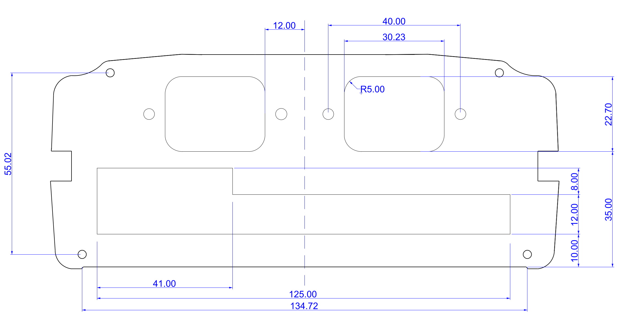

Backe Platte

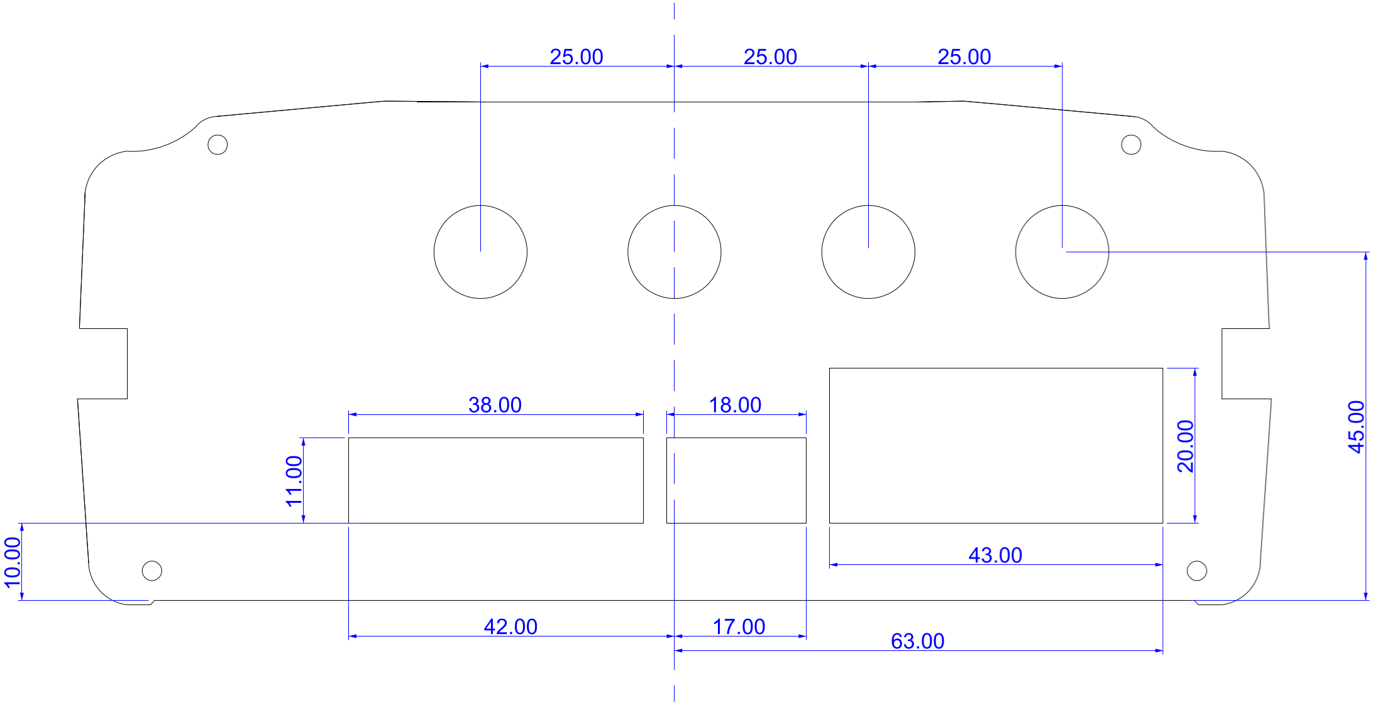

# Engraving/Labeling

Front

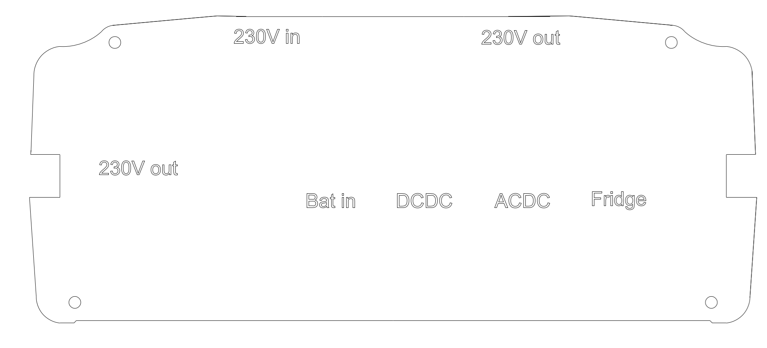

Back

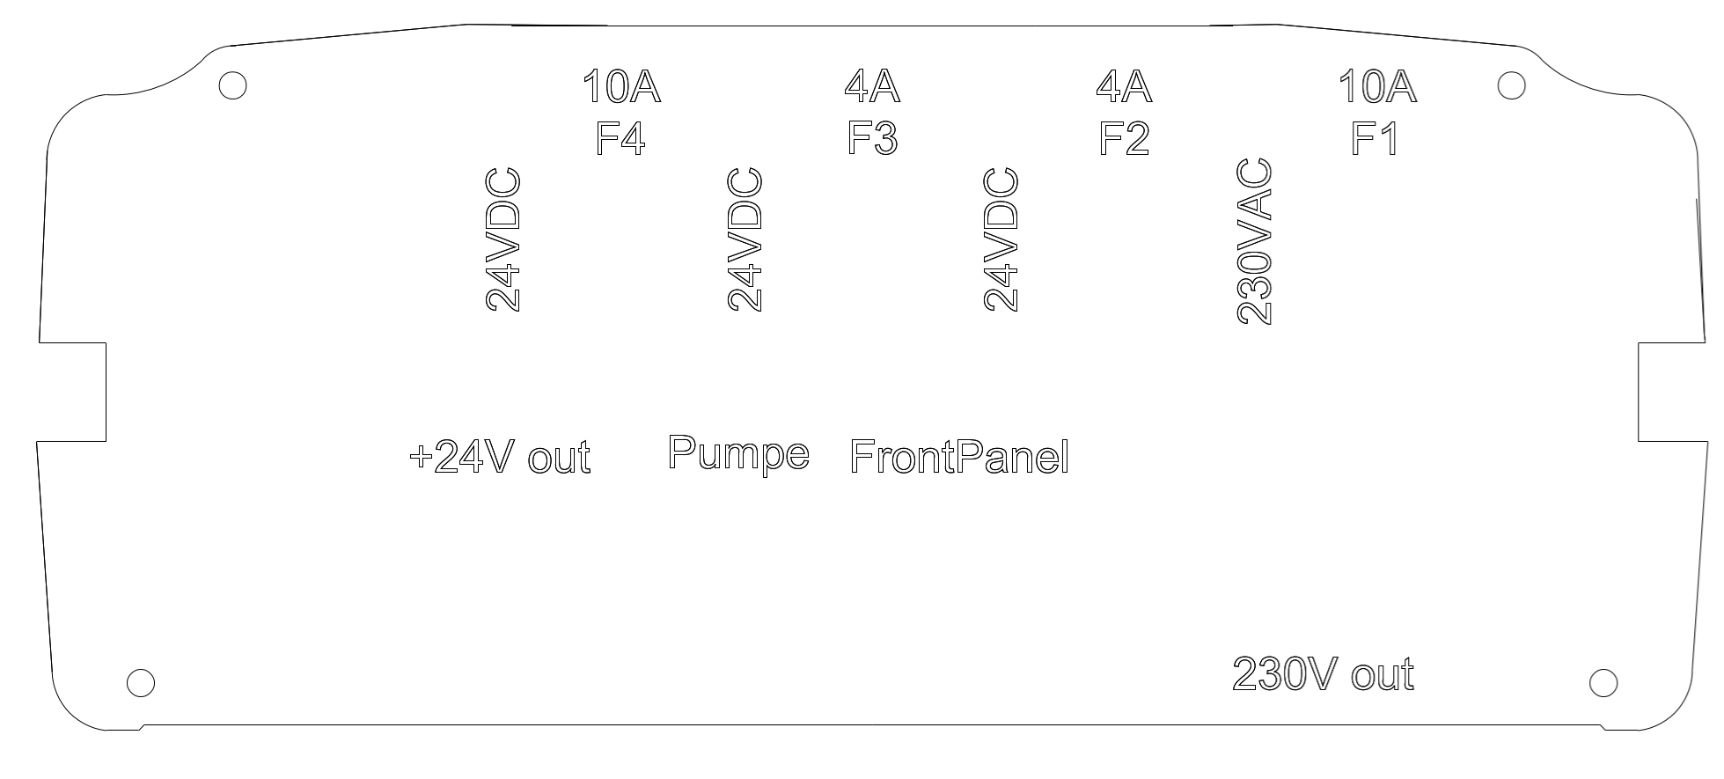

# Assembly

IEC C14  
Male

IEC C13  
Female

Panel Front:

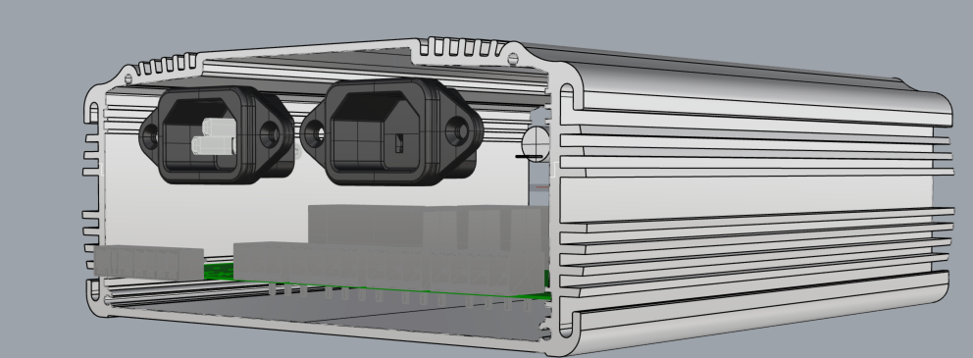



On the Front Panel two IEC connectors have to be added. Left one is the male C14 and the left connector is Female C13.

Panel Back:

4 Fuse holder (20x5mm) have to be mounted on the BackPanel

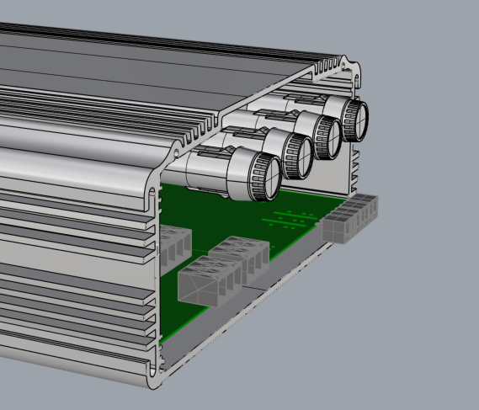

!ALL cabels must have a shrinking tube

When the pcb got assembled, a few wires must be added.

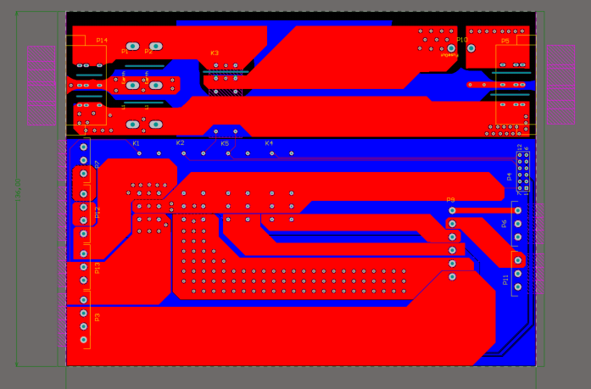

P1, P2 -> 2.5mm^2 (P1 needs to be connected to IEC C14 and P2 needs to be connected to IEC C13)   
!ALL cabels must have a shrinking tube





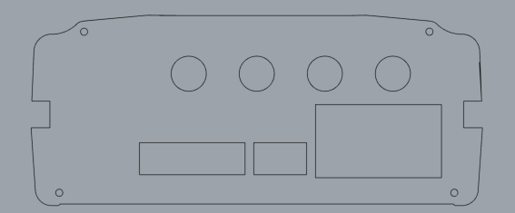



P10 -> 2.5mm^2 (to Fuse 1)



P9 -> 1.5mm^2

* 1 -> Fuse2
* 2 -> Fuse3
* 3 -> Fuse2
* 4 -> Fuse3
* 5 -> Fuse 4
* 6 -> Fuse 4



!ALL cabels must have a shrinking tube

The pcb shall be placed as shown in the following picture

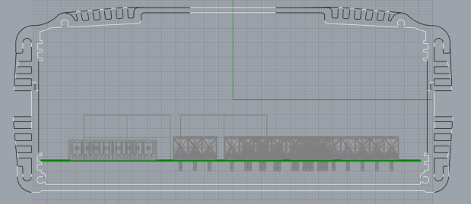

# Finish

And in the End the fuses shall be put in like:

* Fuse1, 230VAC ~15A AC
* Fuse2, 24VDC ~4A **DC**
* Fuse3, 24VDC ~4A **DC**
* Fuse4, 24VDC ~10A **DC**