实验报告
学 号 | 23120014029 |  | 姓 名 | 张心顺 | 专业班级 |  | 经济学23级
课程名称 | 数据库系统 |  |  |  | 学期 |  | 2025年秋季学期
任课教师 | 刘艳艳 |  | 完成日期 | 20251028 |  | 上机课时间 |  | 20251023
实验名称 |  | MySQL实现教务系统的数据库设计
一、实验要求（10%）

在教务系统的数据库设计时，完成以下内容:

(1)创建教务系统各数据库表，包括:Student，Course，Sc。设置主键和外键，以及用户定义的完整性约束条件。

(2)输入数据，体验实体完整性、参照完整性、以及用户定义的完整性约束。

(3)实现简单的数据浏览以及数据增删改

(4)用附件中的实验报告模板完成实验报告

二、实验内容及步骤（80%）

(1)创建教务系统各数据库表，包括:Student，Course，Sc。设置主键和外键，以及用户定义的完整性约束条件。

mysql> CREATE DATABASE edus;
Query OK, 1 row affected (0.02 sec)

mysql> CREATE TABLE Student (
-> Sno INT PRIMARY KEY,
-> Sname VARCHAR(50) NOT NULL,
-> Ssex ENUM('男', '女') NOT NULL,
-> Sage INT CHECK (Sage BETWEEN 10 AND 100),
-> Sdept VARCHAR(50) NOT NULL
-> );
Query OK, 0 rows affected (0.04 sec)

mysql> CREATE TABLE Course (
-> Cno INT PRIMARY KEY,
-> Cname VARCHAR(100) NOT NULL,
-> Ccredit DECIMAL(3,1) CHECK (Ccredit >= 0)
-> );
Query OK, 0 rows affected (0.03 sec)

mysql> CREATE TABLE SC (
-> Sno INT,
-> Cno INT,
-> Grade DECIMAL(4,1) CHECK (Grade BETWEEN 0 AND 100),
-> PRIMARY KEY (Sno, Cno),
-> FOREIGN KEY (Sno) REFERENCES Student(Sno) ON DELETE CASCADE,
-> FOREIGN KEY (Cno) REFERENCES Course(Cno) ON DELETE CASCADE
-> );
Query OK, 0 rows affected (0.06 sec)

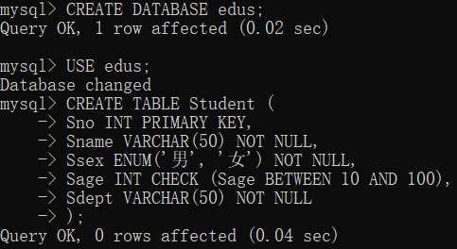
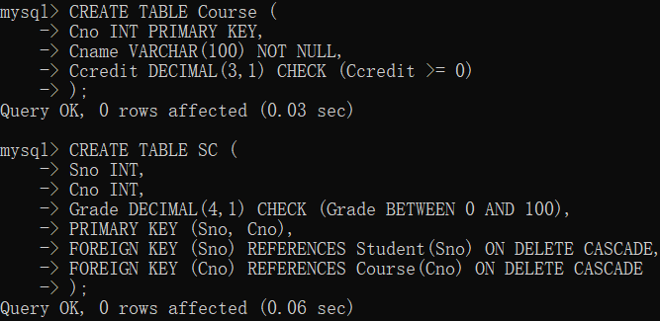

mysql> CREATE TABLE Department (
-> Dept_id INT PRIMARY KEY,
-> Dept_name VARCHAR(50) NOT NULL UNIQUE,
-> Dean_name VARCHAR(50),
-> Office_location VARCHAR(100)
-> );
Query OK, 0 rows affected (0.06 sec)

mysql> CREATE TABLE Class (
-> Class_id INT PRIMARY KEY,
-> Class_name VARCHAR(50) NOT NULL,
-> Class_type ENUM('本科', '研究生') NOT NULL,
-> Dept_id INT,
-> Head_teacher VARCHAR(50),
-> FOREIGN KEY (Dept_id) REFERENCES Department(Dept_id) ON DELETE SET NULL
-> );
Query OK, 0 rows affected (0.06 sec)

mysql> CREATE TABLE Office (
-> Office_id INT PRIMARY KEY,
-> Office_name VARCHAR(50) NOT NULL,
-> Dept_id INT,
-> Director VARCHAR(50),
-> FOREIGN KEY (Dept_id) REFERENCES Department(Dept_id) ON DELETE CASCADE
-> );
Query OK, 0 rows affected (0.06 sec)

mysql> CREATE TABLE Teacher (
-> Tno INT PRIMARY KEY,
-> Tname VARCHAR(50) NOT NULL,
-> Ttitle ENUM('教授', '副教授', '讲师', '助教') NOT NULL,
-> Office_id INT,
-> Research_area VARCHAR(100),
-> FOREIGN KEY (Office_id) REFERENCES Office(Office_id) ON DELETE SET NULL
-> );
Query OK, 0 rows affected (0.06 sec)

mysql> CREATE TABLE Course_Type (
-> Course_id INT PRIMARY KEY,
-> Course_level ENUM('本科', '研究生') NOT NULL,
-> FOREIGN KEY (Course_id) REFERENCES Course(Cno) ON DELETE CASCADE
-> );
Query OK, 0 rows affected (0.08 sec)

mysql> CREATE TABLE Student_Class (
-> Sno INT,
-> Class_id INT,
-> Enrollment_year YEAR,
-> PRIMARY KEY (Sno, Class_id),
-> FOREIGN KEY (Sno) REFERENCES Student(Sno) ON DELETE CASCADE,
-> FOREIGN KEY (Class_id) REFERENCES Class(Class_id) ON DELETE CASCADE
-> );
Query OK, 0 rows affected (0.07 sec)

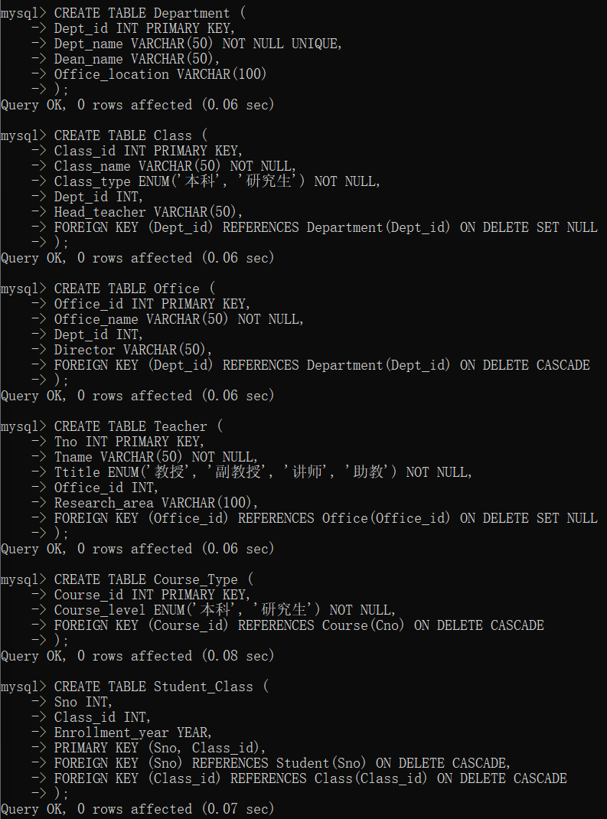

mysql> CREATE TABLE Supervision (
-> Supervisor_id INT,
-> Graduate_id INT,
-> Start_date DATE,
-> Research_topic VARCHAR(200),
-> PRIMARY KEY (Supervisor_id, Graduate_id),
-> FOREIGN KEY (Supervisor_id) REFERENCES Teacher(Tno) ON DELETE CASCADE,
-> FOREIGN KEY (Graduate_id) REFERENCES Student(Sno) ON DELETE CASCADE
-> );
Query OK, 0 rows affected (0.06 sec)

mysql> SHOW TABLES;
+----------------+
| Tables_in_edus |
+----------------+
| class |
| course |
| course_type |
| department |
| office |
| sc |
| student |
| student_class |
| supervision |
| teacher |
+----------------+
10 rows in set (0.00 sec)

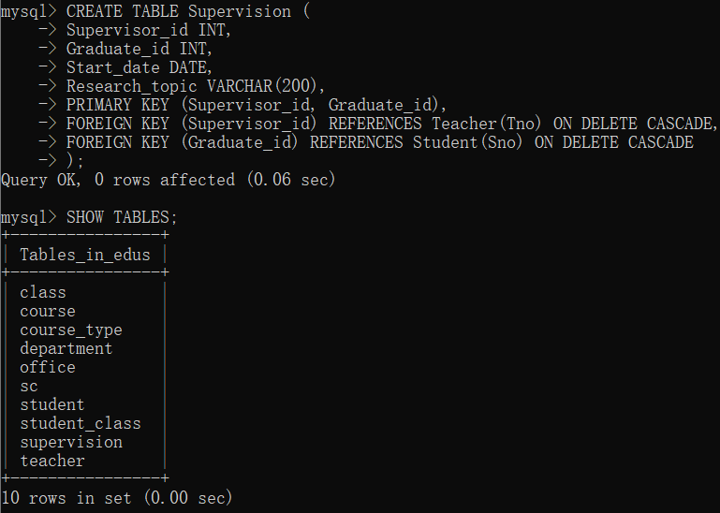

(2)输入数据，体验实体完整性、参照完整性、以及用户定义的完整性约束。

mysql> INSERT INTO Student (Sno, Sname, Ssex, Sage, Sdept) VALUES
-> (1001, '张强', '男', 20, '计算机科学'),
-> (1002, '李艳', '女', 19, '软件工程'),
-> (1003, '王刚', '男', 21, '数据科学'),
-> (1004, '孙芳', '女', 20, '计算机科学'),
-> (1005, '刘丽', '女', 22, '软件工程');
Query OK, 5 rows affected (0.01 sec)
Records: 5 Duplicates: 0 Warnings: 0

mysql> INSERT INTO Course (Cno, Cname, Ccredit) VALUES
-> (101, '程序设计基础', 3.0),
-> (102, '数据结构', 3.5),
-> (103, '数据库原理', 3.5),
-> (104, '操作系统', 3.5),
-> (201, '高等数学', 5.0),
-> (202, '线性代数', 3.0);
Query OK, 6 rows affected (0.02 sec)
Records: 6 Duplicates: 0 Warnings: 0

mysql> INSERT INTO SC (Sno, Cno, Grade) VALUES
-> (1001, 101, 85.5),
-> (1001, 201, 90.5),
-> (1001, 102, 76.5),
-> (1002, 101, 78.0),
-> (1002, 201, 82.0),
-> (1003, 101, 92.5),
-> (1003, 201, 88.0),
-> (1004, 103, 79.0),
-> (1005, 202, 91.0);
Query OK, 9 rows affected (0.01 sec)
Records: 9 Duplicates: 0 Warnings: 0

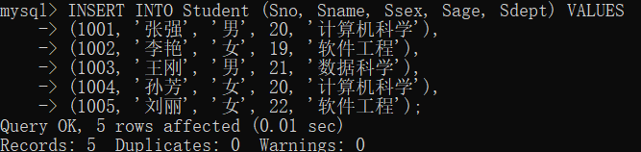
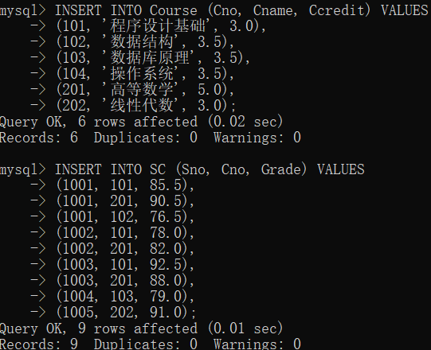

mysql> INSERT INTO Department (Dept_id, Dept_name, Dean_name, Office_location) VALUES
-> (1, '计算机科学学院', '张教授', '信息楼A座301'),
-> (2, '软件工程学院', '李教授', '信息楼B座201'),
-> (3, '数据科学学院', '王教授', '信息楼C座101');
Query OK, 3 rows affected (0.02 sec)
Records: 3 Duplicates: 0 Warnings: 0

mysql> INSERT INTO Class (Class_id, Class_name, Class_type, Dept_id, Head_teacher) VALUES
-> (101, '计算机科学2023级1班', '本科', 1, '赵老师'),
-> (102, '软件工程2023级1班', '本科', 2, '钱老师'),
-> (103, '数据科学2023级1班', '本科', 3, '孙老师'),
-> (201, '计算机科学研究生1班', '研究生', 1, '周老师');
Query OK, 4 rows affected (0.02 sec)
Records: 4 Duplicates: 0 Warnings: 0

mysql> INSERT INTO Office (Office_id, Office_name, Dept_id, Director) VALUES
-> (1, '人工智能教研室', 1, '吴教授'),
-> (2, '软件工程教研室', 2, '郑教授'),
-> (3, '大数据教研室', 3, '冯教授');
Query OK, 3 rows affected (0.02 sec)
Records: 3 Duplicates: 0 Warnings: 0

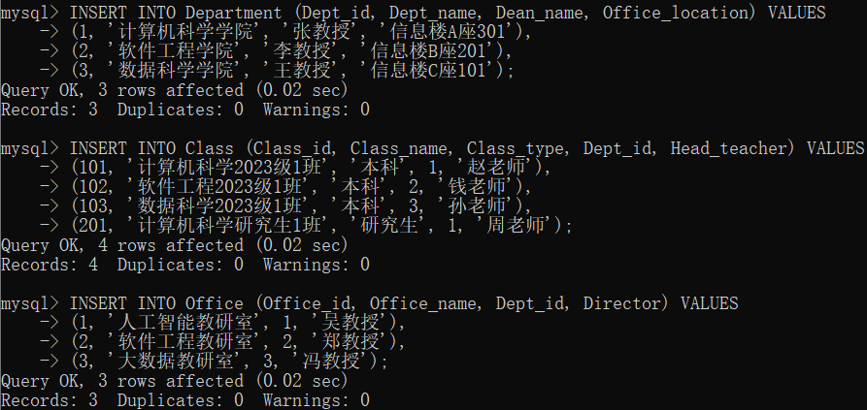

mysql> INSERT INTO Teacher (Tno, Tname, Ttitle, Office_id, Research_area) VALUES
-> (5001, '陈教授', '教授', 1, '机器学习与人工智能'),
-> (5002, '林副教授', '副教授', 1, '计算机视觉'),
-> (5003, '黄讲师', '讲师', 2, '软件测试'),
-> (5004, '刘教授', '教授', 3, '数据挖掘');
Query OK, 4 rows affected (0.02 sec)
Records: 4 Duplicates: 0 Warnings: 0

mysql> INSERT INTO Course_Type (Course_id, Course_level) VALUES
-> (101, '本科'),
-> (102, '本科'),
-> (103, '本科'),
-> (104, '本科'),
-> (201, '本科'),
-> (202, '本科');
Query OK, 6 rows affected (0.02 sec)
Records: 6 Duplicates: 0 Warnings: 0

mysql> INSERT INTO Student_Class (Sno, Class_id, Enrollment_year) VALUES
-> (1001, 101, 2023),
-> (1002, 102, 2023),
-> (1003, 103, 2023),
-> (1004, 101, 2023),
-> (1005, 102, 2023),
-> (1006, 201, 2023);
Query OK, 6 rows affected (0.02 sec)
Records: 6 Duplicates: 0 Warnings: 0

mysql> INSERT INTO Supervision (Supervisor_id, Graduate_id, Start_date, Research_topic) VALUES
-> (5001, 1006, '2023-09-01', '深度学习在图像识别中的应用研究');
Query OK, 1 row affected (0.02 sec)

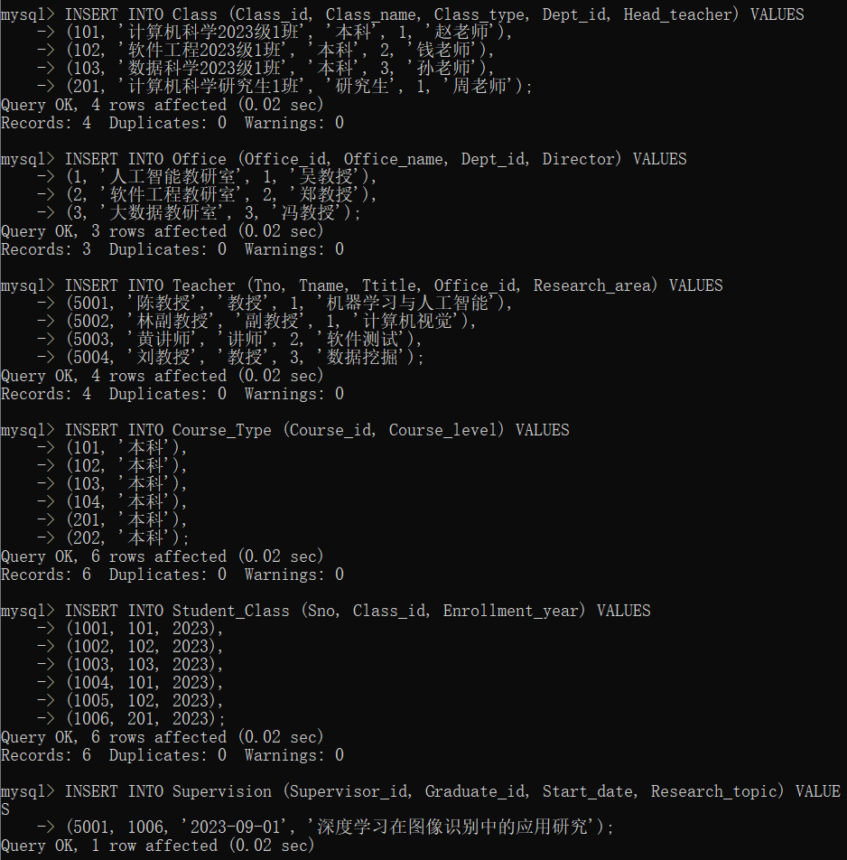

(3)实现简单的数据浏览以及数据增删改

浏览：
mysql> SELECT * FROM Student;
+------+-------+------+------+------------+
| Sno | Sname | Ssex | Sage | Sdept |
+------+-------+------+------+------------+
| 1001 | 张强 | 男 | 20 | 计算机科学 |
| 1002 | 李艳 | 女 | 19 | 软件工程 |
| 1003 | 王刚 | 男 | 21 | 数据科学 |
| 1004 | 孙芳 | 女 | 20 | 计算机科学 |
| 1005 | 刘丽 | 女 | 22 | 软件工程 |
+------+-------+------+------+------------+
5 rows in set (0.01 sec)

mysql> SELECT * FROM Course;
+-----+--------------+---------+
| Cno | Cname | Ccredit |
+-----+--------------+---------+
| 101 | 程序设计基础 | 3.0 |
| 102 | 数据结构 | 3.5 |
| 103 | 数据库原理 | 3.5 |
| 104 | 操作系统 | 3.5 |
| 201 | 高等数学 | 5.0 |
| 202 | 线性代数 | 3.0 |
+-----+--------------+---------+
6 rows in set (0.00 sec)

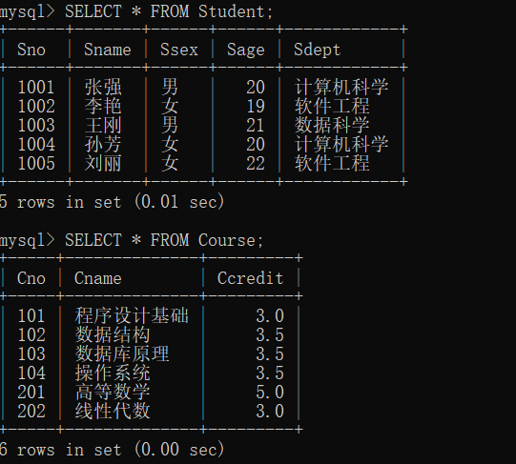

实体完整性与参照完整性：
mysql> INSERT INTO Student VALUES (1001, ' 赵六 ', ' 男 ', 20, ' 计算机科学 ');
ERROR 1265 (01000): Data truncated for column 'Ssex' at row 1
mysql> INSERT INTO Student (Sname, Ssex, Sage, Sdept) VALUES (' 钱七 ', ' 女 ', 21, ' 数据科 学 ');
ERROR 1265 (01000): Data truncated for column 'Ssex' at row 1
mysql> INSERT INTO Course VALUES (101, 'Python 编程 ', 4.0);
ERROR 1062 (23000): Duplicate entry '101' for key 'course.PRIMARY'
mysql> INSERT INTO Course (Cname, Ccredit) VALUES ('Java 编程 ', 4.0);
ERROR 1364 (HY000): Field 'Cno' doesn't have a default value
mysql> INSERT INTO SC VALUES (1006, 101, 80.0);
ERROR 1452 (23000): Cannot add or update a child row: a foreign key constraint fails (`edus`.`sc`, CONSTRAINT `sc_ibfk_1` FOREIGN KEY (`Sno`) REFERENCES `student` (`Sno`) ON DELETE CASCADE)
mysql> INSERT INTO SC VALUES (1001, 301, 75.0);
ERROR 1452 (23000): Cannot add or update a child row: a foreign key constraint fails (`edus`.`sc`, CONSTRAINT `sc_ibfk_2` FOREIGN KEY (`Cno`) REFERENCES `course` (`Cno`) ON DELETE CASCADE)

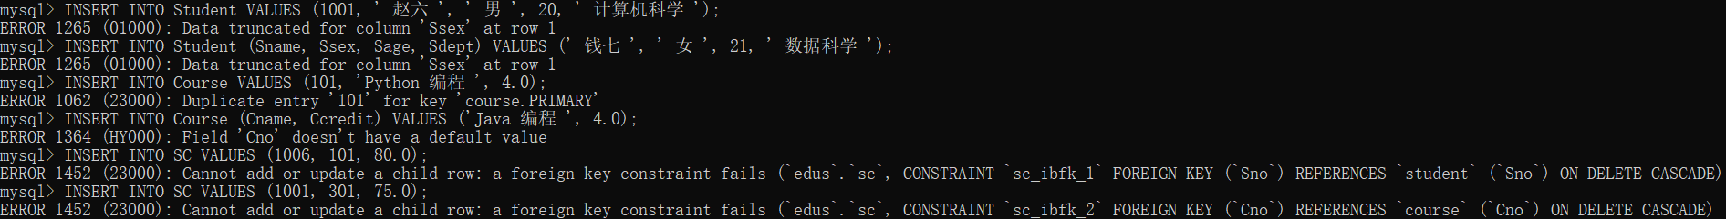

增删改：
mysql> INSERT INTO Student VALUES (1006, '郑十', '男', 20, '数据科学');
Query OK, 1 row affected (0.06 sec)

mysql> UPDATE Student SET Sage=20 WHERE Sno=1002;
Query OK, 1 row affected (0.01 sec)
Rows matched: 1 Changed: 1 Warnings: 0

mysql> DELETE FROM SC WHERE Sno=1001 AND Cno=102;
Query OK, 1 row affected (0.02 sec)

mysql> SELECT * FROM Student;
+------+-------+------+------+------------+
| Sno | Sname | Ssex | Sage | Sdept |
+------+-------+------+------+------------+
| 1001 | 张强 | 男 | 20 | 计算机科学 |
| 1002 | 李艳 | 女 | 20 | 软件工程 |
| 1003 | 王刚 | 男 | 21 | 数据科学 |
| 1004 | 孙芳 | 女 | 20 | 计算机科学 |
| 1005 | 刘丽 | 女 | 22 | 软件工程 |
| 1006 | 郑十 | 男 | 20 | 数据科学 |
+------+-------+------+------+------------+
6 rows in set (0.00 sec)

mysql> SELECT * FROM SC;
+------+-----+-------+
| Sno | Cno | Grade |
+------+-----+-------+
| 1001 | 101 | 85.5 |
| 1001 | 201 | 90.5 |
| 1002 | 101 | 78.0 |
| 1002 | 201 | 82.0 |
| 1003 | 101 | 92.5 |
| 1003 | 201 | 88.0 |
| 1004 | 103 | 79.0 |
| 1005 | 202 | 91.0 |
+------+-----+-------+
8 rows in set (0.00 sec)

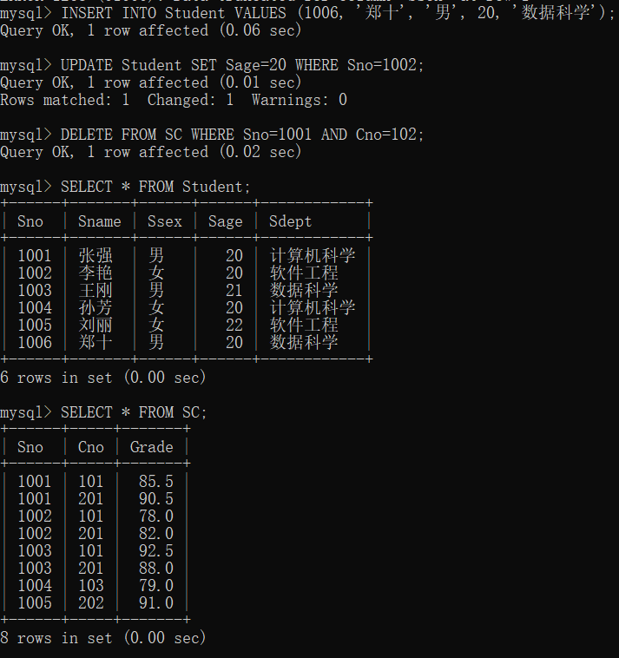

三、心得总结（写出自己在完成实验过程中遇到的问题、解决方法，以及体会、收获等）（10%）

刚开始写代码的时候，忘记了一些语法，从ppt中复习后重新开始构思。一开始数据库反复建立又反复删除，总是想做到完美但总是出现小的问题。后来不着急写代码，先把表的列都想好，约束也都想好，随后直接打出来，得到一个基本的数据库。

在此基础之上，参照课上的例题与知识，给出了测试实体完整性等的语句，完成了基本的操作。

后来经过老师提醒，发现建的表不够。于是又增加到十个表，也输入了数据。

