Programming for mobile devices

TrackIT App

Universitatea de Vest din Timisoara

Facultatea de Matematica si Informatica

Lupulescu Alexandru

Coordinate teacher: Liviu-Octavian Mafteiu-Scai

15.05.2021

Abstract

The application is an Android exclusive and

The tracker provides tools from which the users can visualize their weaknesses and improve their overall performance. It is crucial in fitness and strength training to track progress because it provides a way to visualize progressive overload. The principle of progressive overload suggests that the continual increase in the total workload during training sessions will stimulate muscle growth and strength gain.

Goal and userbase

The goal of the application is to serve the users with a simple way to track their progress towards their fitness/strength goals. The tracker provides tools from which the users can visualize their weaknesses and improve their overall performance.

The userbase consists of anyone who has an Android phone with a minimum version of 4.1 and wishes to track its strength workouts. The simplicity of the UI allows anyone with a minimum knowledge of using mobile devices to use it.

My contribution

The problem which the application is trying to solve is to encourage the users to track their training so they can focus on their workouts and progress at an optimal rate.

The app is not the first of its kind, there are many options of fitness trackers including:

* [Google FIt](https://play.google.com/store/apps/details?id=com.google.android.apps.fitness)
* [RepCount](https://play.google.com/store/apps/details?id=sp.repcount)
* [Gym Workout Tracker](https://play.google.com/store/apps/details?id=com.anthonyng.workoutapp)

The difference between my application and the mentioned apps are:

* my app focuses more on the users’ workouts
* it offers illustrations of over 300 exercies
* it focuses on one niche: strength training, which in return offers an unbloated experience

Functionality

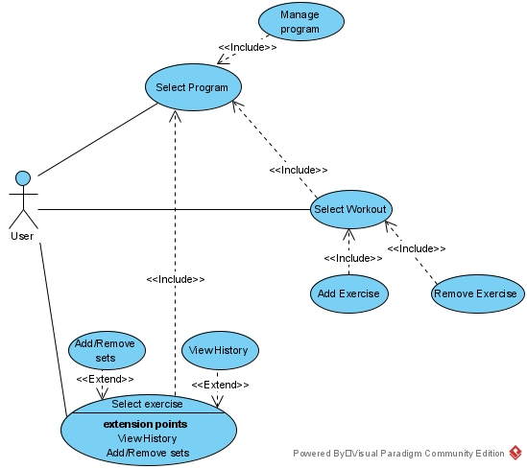

User guide

The app provides a prepopulated database with over 300 exercises from which you can choose from and incorporate in your workouts. As specified in the fragments description, you can add your own exercises, programs and workouts.

Program fragment

All programs will be shown here. A new program can be added from the + button on the top right corner. Accessing the workout programs can be done by tapping on the program.

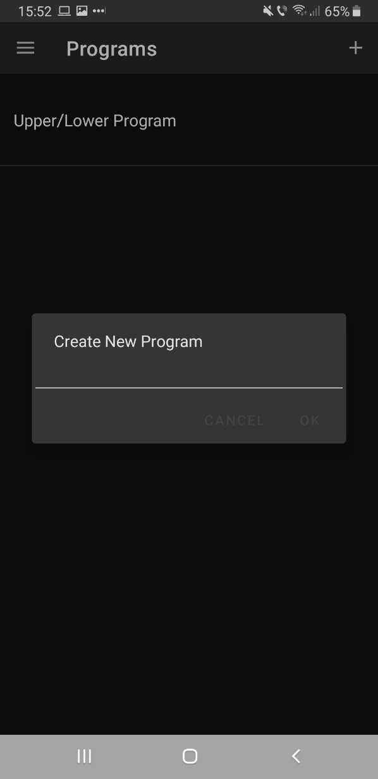

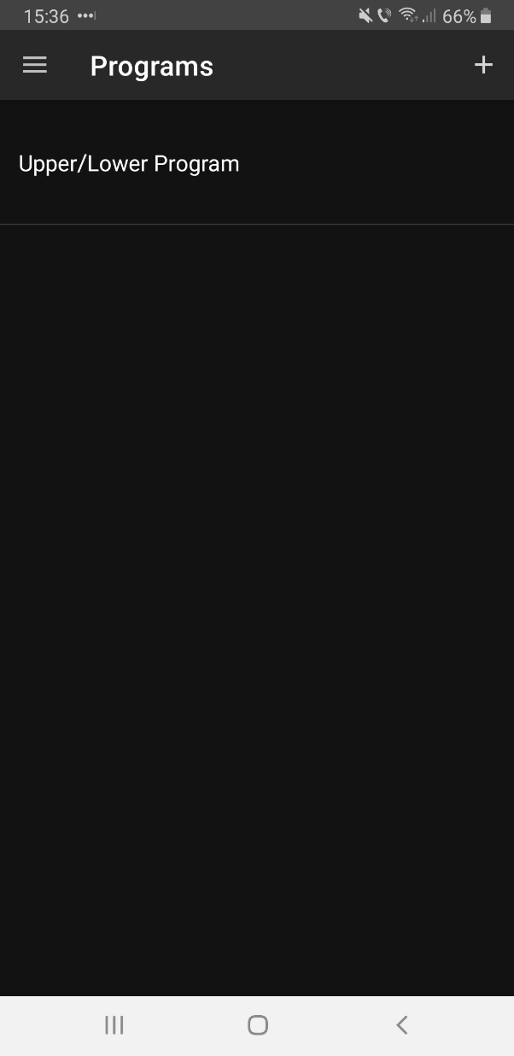

(main program fragment) (after pressing + button)

Workout programs fragment

All workout programs from the selected program will be shown here. A new workout program can be added by tapping on the + from the top right corner. To access the exercises from the workout, tap on the desired workout.

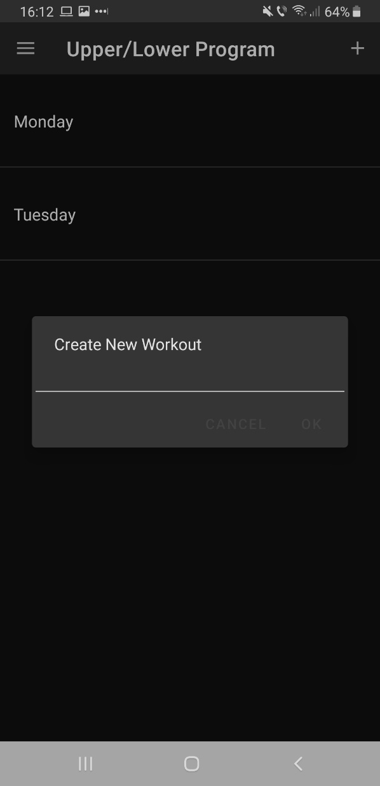

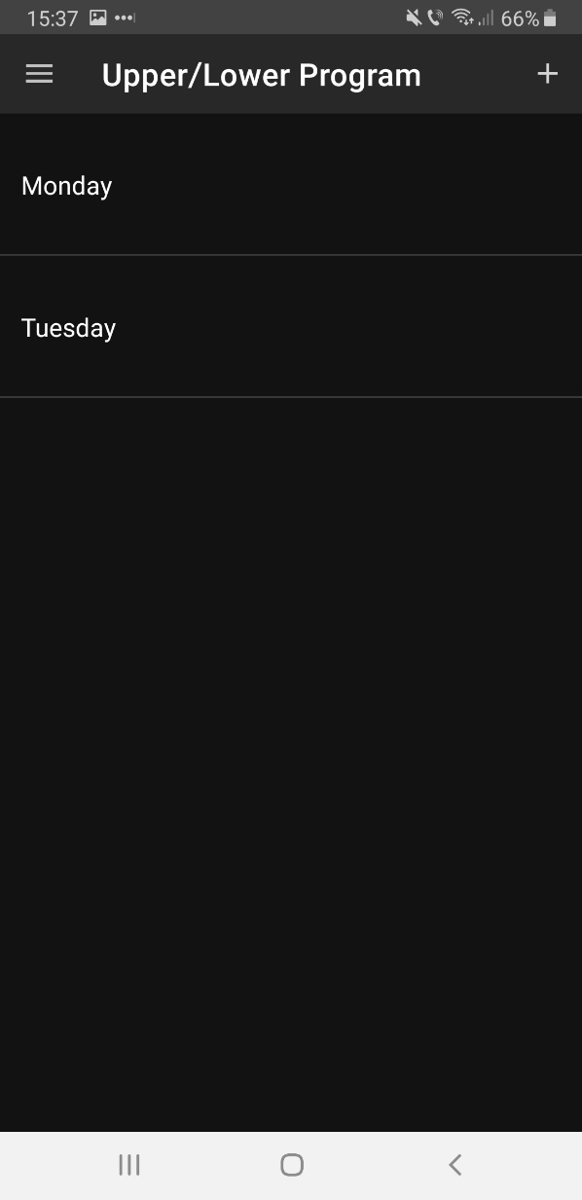

(after pressing on the +)

(main fragment)

Workout exercise fragment

All exercises from the clicked workout will be shown here and new exercises can be added to it from the + button.

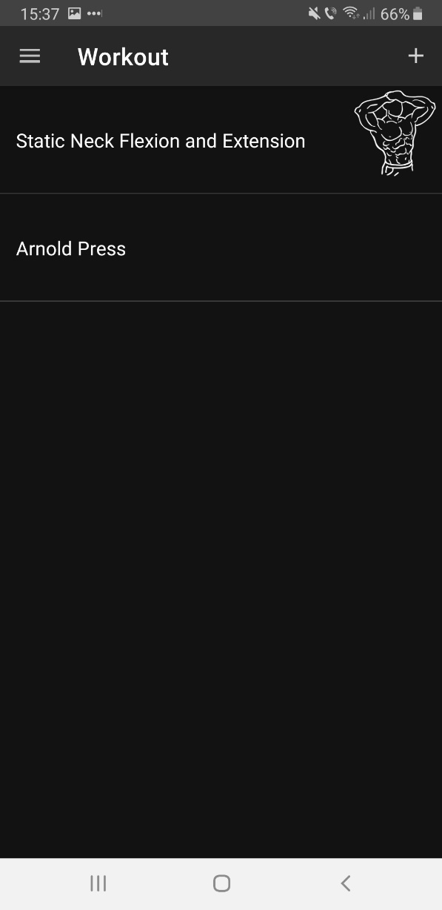

Add exercise to workout program fragment

This is what is shown after clicking on the + button from the Workout exercise fragment. You can add an exercise to the workout by sliding left on it.

The list can be filtered by name by clicking on the magnifying glass from the top right corner.

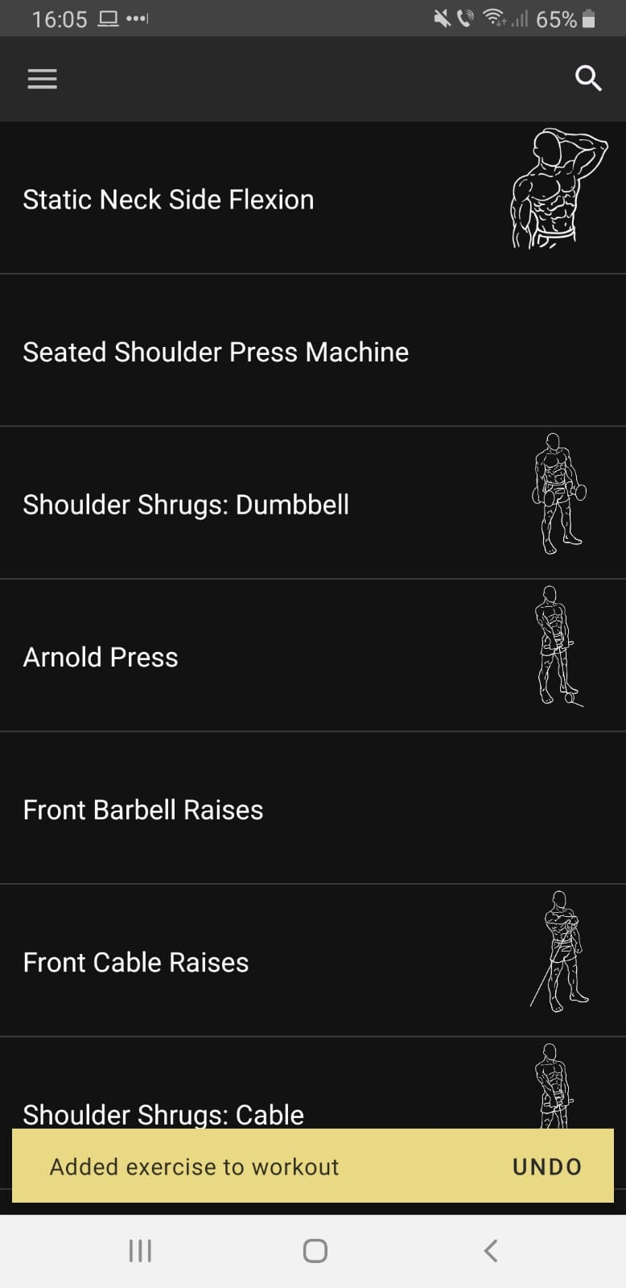

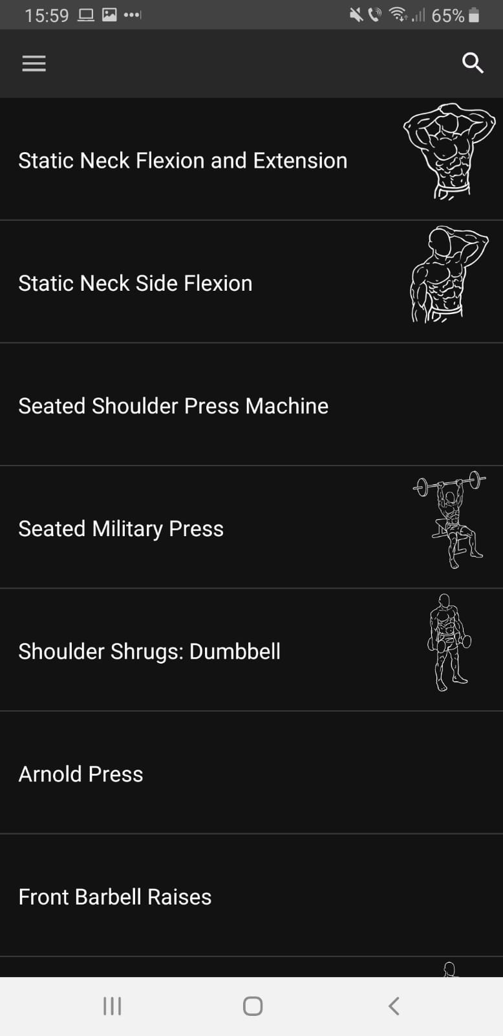

(main fragment)

(what is shown after adding and exercise, you can undo the action by tapping on undo)

Exercise track fragment

After tapping on an exercise from the workout exercise fragment, you will be provided with a view in which you can do the tracking on the selected exercise. Specify the reps and weight by tapping on the reps and weight dialogs and input the value. The minus and plus buttons can be used to input the reps/weight more easily. Press on “finish set” after you finished typing in the reps and weight.

Press on the “view history” button to access the sets from previous sessions.

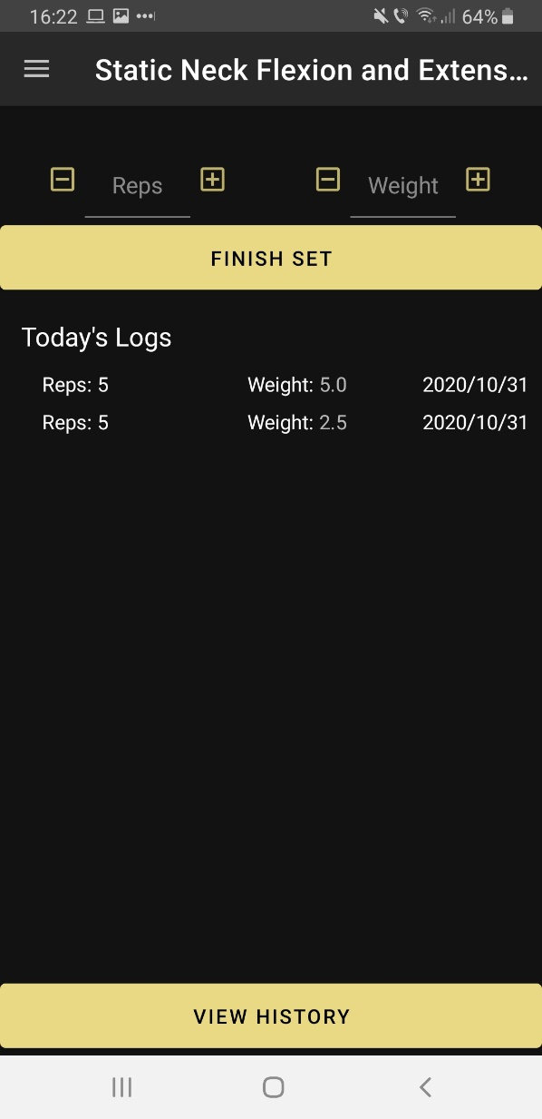

View exercise history fragment

All sets from previous sessions will be shown here.

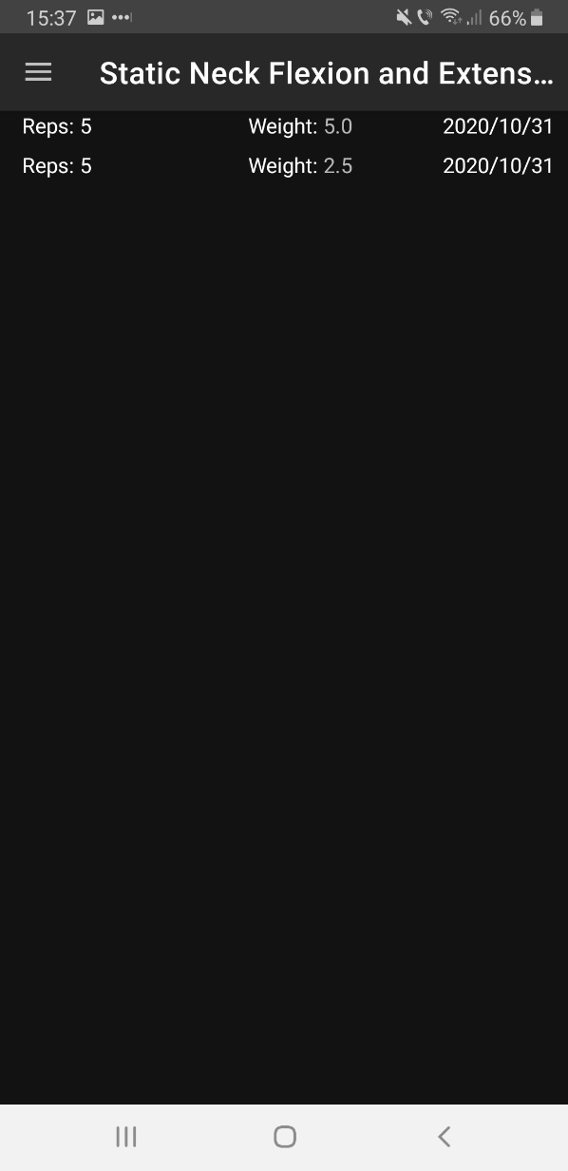

Sidebar menu

You can also access the sidebar menu by sliding right on any fragment.

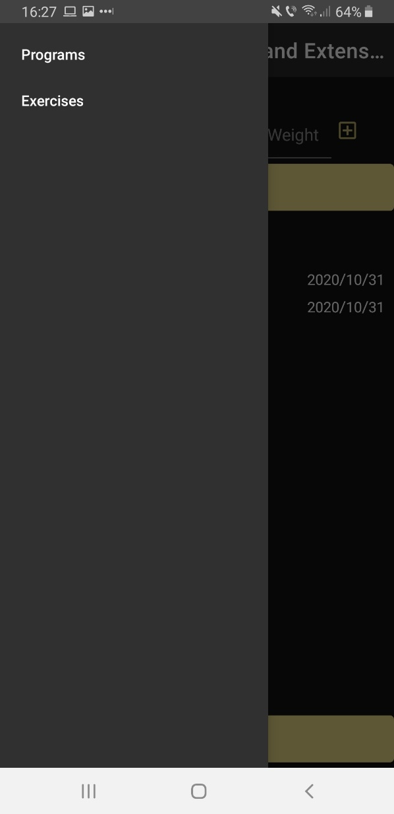

App’s structure (technical manual)

This section proposes to explain the design of the activities/fragments and the structure of the database.

The application uses [Room](https://developer.android.com/training/data-storage/room) to save data to the database.