
IndexedSearch Crawler for tt_news
Extension Key: indexedsearch_ttnews_crawler
Language: en
Version: 1.1.6
Keywords: ttnews, crawler, search, indexing
Copyright 2006-2014, Simon Schick, <simonsimcity@gmail.com>

This document is published under the Open Content License
available from http://www.opencontent.org/opl.shtml

The content of this document is related to TYPO3
- a GNU/GPL CMS/Framework available from www.typo3.org
Table of Contents
IndexedSearch Crawler for tt_news 1
Introduction 3
What does it do? 3
Screenshots 3
Users manual 4
Administration 5
Configuration 6
Tutorial 7
Known problems 8
To-Do list 9
ChangeLog 10

Introduction

What does it do?
It gives you the possibility to index tt_news entries using crawler and indexed_search.
The benefit of this extension, over choosing the build-in option of indexed_search (choosing “Database Records” as type and “News” as table to index) is, that you can filter the news, to be indexed, by categories.
For example if you have two main-categories, that are stored in one storage-folder and you have a single-view for each of them, this extension will fit your needs.

Screenshots
Here you see what the extension does:
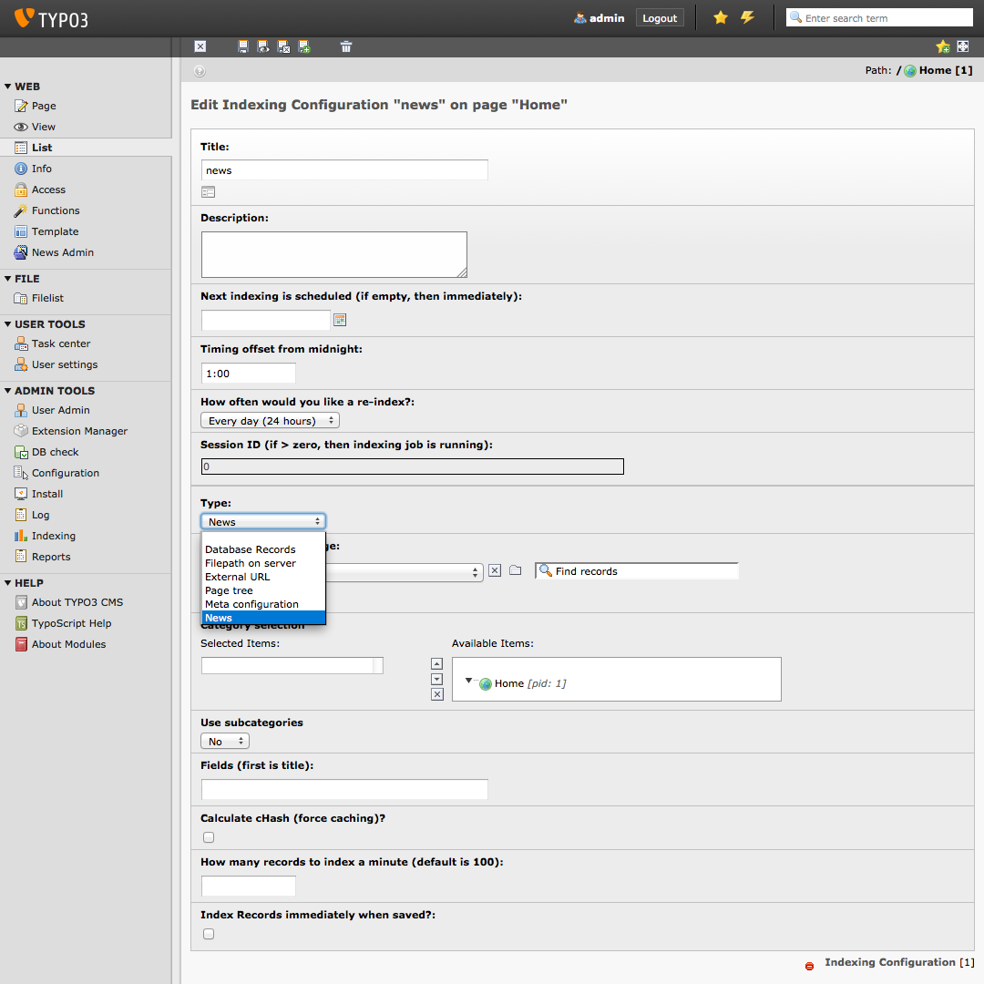
It adds a new type to the Indexing Configuration called “News” which let's you set several settings specially for news. The settings you don't see here are called “Alternative Source Page” and “Category selection”. All functionalities are described in the Administration section of this document.

Users manual
No user manual since you have to configure this extension once and let it do it's work.

Administration
You probably already read the documentation of indexed_search. Following that, you can create Indexing Configuration at pages where you have extended content that should be indexed.
In this case, we're indexing news. Please create an Indexing Configuration on every page you show the news on as SingleView. The pid of the Indexing Configuration Record will be used as id in the generated url for the news.
If you choose “News” in the type-field of an Indexing Configuration, the following additional fields will appear:
- Alternative Source Page
The pool where your news-entries are saved in. If you have multiple you should create one for each source page on this page.
- Include news without category
Choose this option if you have news that are related to no category and you want them to be indexed in this Indexing Configuration
→ This field is hidden if you enabled the option “requireCategories” in tt_news
- Category selection
Choose the categories you want to index here.
- Use subcategories
This feature has been added that you don't have to add every category to the record, you add in the system. You can just add it's parent-category and all child-categories can be taken as well.
- Fields
A comma-separated list of database-columns that will be pushed to the crawler. The content of the first column will be used as title. Prefered value: title, short, bodytext
The other fields (Calculate cHash, How many records to index in a minute, Index Records immediately when saved) have the same functionalities as the one at the type Database Records.

Configuration
Don't know what to write here … drop me a mail if you're missing something here and I will update the manual. I don't have special configuration or any TypoScript.

There's just one hook you can use:
$GLOBALS['TYPO3_CONF_VARS']['EXTCONF']['indexedsearch_ttnews_crawler']['indexSingleNewsRecord']
It is thought for manipulating a document before it get's send to the indexer. This is for example used by the extension indexedsearch_rendered_ttnews, which replaces the column “bodytext” by what is shown if you'd show the news-entry on your website.

Tutorial
First you have to think about where your news are stored (Alternative Source Pages) and where your news are displayed on the page.
I, for example, have a structure like this:
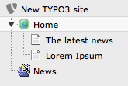
In addition, I also have three news-categories.
Two called “latest” and “TYPO3”. All news in here are displayed on the page “The latest news”, the LIST and the SINGLE view. But just the fact, that the SINGLE view is on this page, is of importance here.
The third category is called “lorem ipsum”. The news linked to this category are visible on the page “Lorem Ipsum”.
This said, I create an Indexing Configuration at the page “The latest news” and fill it with the following data:
Property: | Value: | Reason:
Title | News – Latest and TYPO3 | Because I like the name :) This is not used by any logic.
Type | News | To use this extension :)
Alternative Source Page | 3 | Id of the page where my news are stored (storage-folder called “News”)
Category selection | latest, TYPO3 | Selected the categories who'se single-view is on “The latest news”. No selection is not equal to all news!
Use subcategories | Yes | Include all news, linked to a subcategory of one of the categories chosen in “category selection”.
Fields | title,short,bodytext | A list of database-columns I want to have indexed. The first value is the title. In this case I want to have the news-title as title and the short- and bodytext as content of the element that can be found in the search.
Index Records immediately when saved? | Yes | I want my records to be added to the index when I save them. This lets new news-entries turn up in the search as soon as they're published. Same appeals when I update the content.  (Functionality provided by crawler)

After that, I create another Indexing Configuration at the page “Lorem Ipsum” having nearly the same configuration (attention to the category-selection):
Property: | Value: | Reason:
Title | News – Lorem Ipsum | See above ...
Type | News | See above ...
Alternative Source Page | 3 | See above ...
Category selection | lorem ipsum | Selected the categories who'se single-view is on “Lorem Ipsum”. No selection will not index any news!
Use subcategories | Yes | See above ...
Fields | title,short,bodytext | See above ...
Index Records immediately when saved? | Yes | See above ...

Known problems
Not that I know of...

To-Do list
- The crawler should get an information when a news-entry is deleted or hidden. Currently all news will be added, but never removed from the index.
- Add option to index all news, don't care about category-selection. This is only of benefit of you want to use an extension that extends this one, like indexedsearch_rendered_ttnews. If you don't use one of them, you could also use the type “Database selection” instead.

ChangeLog
Version: | Changes:
1.1.6 | Fixed incompatibility with indexedsearch_rendered_ttnews and rgnewsce
1.1.5 | Fixed bug where system crashed for incorrect initialized tt_news instance given to other plugins like indexedsearch_rendered_ttnews
1.1.4 | Raised compatibility to TYPO3 6.1.x (no code changes)
1.1.3 | Major performance increase by not re-generating the TypoScript on each call
1.1.2 | Raised compatibility to TYPO3 v4.5.0-6.0.x
1.1.1 | Fixed that having “use subcategories” checked will cause an MySQL error for every news-entry having no categories. (Thanks again to Paavo Schmid)
1.1.0 | Added feature that you can index news that have no category selected. (Thanks to Paavo Schmid)
1.0.1 | Added documentation and icon
1.0.0 | Wrote the code of the extension.

