# Website structure

Home

Academic Life

Phytoplankton

Research

Projects & Collaborations

List of Publications

Contact

Positions Available

I am marine microbial ecologist interested in understanding the structure of marine eukaryotic phytoplankton communities and how environmental factors shape their diversity. They are the core of globally important cycles such as carbon and oxygen and understand the factors that control and maintain their diversity and the structure of their communities, is fundamental to understand our planet. My work combined traditional culture isolation and laboratory studies along with cutting-edge DNA sequencing approaches to elucidate the patterns of marine eukaryotic phytoplankton communities across a wide range of environments.

# Academic Life

From the Federal university of Rio de Janeiro, I received a bachelor’s degree in Genetics and Molecular biology. Focused in pursue the academic career, I enrolled in the master program and in a blink of an eye I was doing a PhD in environmental Microbiology. During my PhD, I was awarded with a government scholarship that allowed me to spend an year at University of Michigan in Dr. James Tiedje laboratory. There, I had the opportunity to discover the potential of high throughput sequencing technologies to investigate the microbial diversity in different environments. When I graduated, I was fascinated by the microbial world and had just heard about an immense diversity of organisms and viruses at the sea. It was the moment to shift my career towards to marine ecosystems. I first started as a junior postdoctoral research fellow at the Oceanographic Institute at the University of São Paulo (Brazil) time I participated in two international marine microbial ecology courses (ECODIM – Chile and CMORE – Hawaii). By 2012 I moved to France, where I worked for the 5 years at the Station Biologique in Roscoff, France, focusing on oceanic microalgae, connecting large scale molecular biology data sets from the marine environment with classical methods such as isolation and cultivation of marine phytoplankton. I left Roscoff in late 2017, to take my new position at the Nanyang Technological University where I am currently working and pursuing new wonders of the phytoplankton world ([*Curriculum Vitae*]( https://www.researchgate.net/profile/Adriana_Lopes_Dos_Santos)].

# Phytoplankton

# Photosynthesis, the biological process of transforming solar energy into biomass, has forged our planet as we know it. The machinery of photosynthesis absorbs and uses solar energy to separate the water into its component parts, oxygen and hydrogen, and the chemical energy to convert the CO2 (carbon dioxide) sequestrated out of the atmosphere into sugars (biomass). This biological process is called primary productivity and it is performed by organisms called photosynthesizers, such as plants.

# The products of photosynthesis, water and sugar, are essential to all forms of life we know, and so is oxygen to most of the living beings on planet. Ocean and the land share, almost equally, the primary production of the Earth. Due to our terrestrial nature as human beings, it is very easy to spot how dependent we are of the plants, of our crops to live, but in the ocean, who is feeding all the animals, who is sustaining the trophic web?

# In the Oceans, microscopic photosynthesizes cells from the sunlit ocean layer, called phytoplankton, feed the entire open ocean ecosystem (marine food web) and produce half of the oxygen we consume. Phytoplankton is a functional group of single cell organisms including cyanobacteria and eukaryotes that can perform oxygenic photosynthesis. The eukaryotic compartment of phytoplankton harbors a great diverse of organisms that are distributed widely across several branches of eukaryotic tree of life.

# My research is focused on understanding and characterizing these organisms. Specially the smallest ones (average size 2 - 3 µm = 1000x smaller than a pin head) fascinate me as life can be so efficient and elegant at such small scales.

# How diverse these cells are? How are they distributed in the oceans? How each group of phytoplankton contribute to the primary productivity in the ocean? How do they respond to limiting growth factors, such as nutrient and light? These are questions I have addressed during the last years and want to continue addressing in the future by combining different methodologies such as classical cultivation and isolation methods and cutting-edge DNA sequencing technologies, such as metabarcoding and metatranscriptomics.

# If you are interested in learning more about marine phytoplankton and the work we are developing, please explore this site and feel free to drop an [email](adriana.lopes@ntu.edu.sg) with any questions.

![](/img/phytopk.jpg)(Schematic tree representing the distribution of phytoplanktonic taxa across eukaryote lineages)

## Research

I believe an interdisciplinary, open and collaborative science can only bring solid knowledge and a better understanding of the world we live and share with the microbes.

### Diversity and oceanic distribution of marine phytoplankton

Changes in marine plankton communities driven by environmental variability impact the marine food web

and global biogeochemical cycles of carbon and other elements. To predict and assess these community

shifts and their consequences, ecologists are increasingly investigating how the functional traits of plankton

determine their relative ﬁtness along environmental and biological gradients

Changes in marine plankton communities driven by environmental variability ultimately impact the marine food web and global biogeochemical cycles (pathway by which a chemical substance moves through biotic and abiotic compartments of Earth). To predict and assess community shifts and their consequences, we first need to determine the composition of these communities and how they change along environmental and biological gradients, for example latitude or temperature.

With the advent of molecular biology methods such as high throughput sequencing of gene markers (metabarcoding) and an increasing number of sequence datasets, access to the global scale distribution of your favorite “bug” became more feasible. Basically, after acquiring sequence data either in the lab or through public databases, all you need is to determine which sequence belongs to which bug, pretty much like sorting the sequences into boxes where each box represents different individuals. The challenge here is to determine the individual units (like deciding the size of the box) and their close relatives, so you don’t end up sorting the sequences into the wrong compartment.

One common language we all use in biology to define the limits between individuals is the one provided by taxonomy, where the individuals are categorized into species, the different species into genera, etc. Tthe combination of taxonomy and metabarcoding method brings fascinating insights into marine phytoplankton distribution and ecology.

Below you can see examples of how we combined taxonomic knowledge with metabarcoding data to unveil the distribution of phytoplankton groups.

***Bolidophyceae, the sister group of diatoms***

![](/img/Bolido1.png)

*A. xxx B. xxx*

Late in the 1990’s, naked flagellated cells (previously called Bolidomonas, A) were isolated and described as belonging to the class Bolidophyceae. The silicified Parmales group (B) was discovered and observed in marine waters back in the 1970’s but their taxonomic affiliation was an enigma until the isolation of one Parmales strain in 2011 when by DNA sequence identity Bolidophyceae and Parmales were thought to be sister classes or even organisms within the same class. In our study ([Ichinomiya and Lopes dos Santos et al., 2016](files/papers/Ichinomiya_2016.pdf)), we acquired sequence data from strains of both groups to analyze the evolutionary relationships among several silicified and flagellated cells isolated from different oceanic regions. We were able to confirm that the silica covered cells belong to the same Class (Bolidophyceae) than the naked flagellated cells, suggesting that Bolidophyceae may have a life cycle with motile flagellated and non-motile silicified stages. Our data allowed to determine the distribution of the major Bolidophyceae taxa across the world oceans using metabarcoding data set obtained in the frame of the Tara Oceans expedition. We observed that silicified cells are mostly found in cold-water while the naked flagellate have temperate and tropical distributions.

Many questions about Bolidophyceae remain open, so in collaboration with [Akira Kuwata]( https://www.researchgate.net/profile/Akira_Kuwata) we plan to continue exploring the diversity of this groups and the ecological factors that determine its growth and differentiation into flagellate and silicified cells.

***Chloropicophyceae also known as Prasinophytes clade VII***

Chloropicophyceae is a group of pico (2 – 3 µm) planktonic green algae that were known previously as prasinophytes clade VII ([Lopes dos Santos et al., 2017](files/papers/ Lopes_2017b.pdf)).

Since the isolation of the first strain in 1965, numerous rRNA sequences belonging to this group have been retrieved from the marine environment and many strains isolated. We gathered the sequence data available from strains and environmental samples to analyze the diversity of these tiny little green balls. First, by using different gene markers, we demonstrated that this group is composed of at least 10 different clades: A1 to A7 and B1 to B3 ([Lopes dos Santos et al., 2017](files/papers/Lopes_2017a.pdf)) which today is represented by at least one described species. By using metabarcoding data from Tara Oceans and Ocean Sampling Day projects we were able to show that this group is one of the dominant Chlorophyta (green algae) group in oceanic waters, especially in areas where nutrients concentrations are moderately low.

Currently, in collaboration with [Claude Lemieux] (https://www.researchgate.net/profile/Claude_Lemieux2), from Laval University, we are gathering information from Chloroplast and Mitochondrial genomes of Chloropicophyceae species to access the relationship among them and their environmental adaptation.

## Projects & Collaborations

### Green Edge

Climate change has triggered fundamental modifications in the Arctic Ocean (AO). The decrease in the extent of the ice pack during summer has led to a 20% increase in pan-Arctic primary production (PP) over the last decade. Phytoplankton blooms now occur earlier in several parts of the AO. In other parts, the structure of the phytoplankton community is shifting toward smaller species, typical of more oligotrophic conditions (poor in nutrients) and some species found in warmer waters now migrate into the Arctic Ocean.

Phytoplankton grow in the top tens of meters of both ice-free and ice-covered waters. The phytoplankton spring bloom (PSB) that develops at the ice-edge accounts for >50% of annual primary production in the AO and is generally associated with both large energy transfer to higher trophic levels and export of carbon to the bottom. The Arctic PSB develops in the seasonally-covered ice zone (SIZ), the extent of which is expected to increase significantly during the next years, possibly over the whole AO as early as in 2030. How the PSB will evolve in this context is currently unknown. Furthermore, the culture, health and economic capacity building of Northern human populations are closely associated with marine resources supported by the PSB.

From mid-March to mid-July of 2015 and 2016, during the [GreenEdge expedition] ( <http://greenedge-expeditions.com/>), we followed the development of the PSB from a fixed ice camp near Qikiqtarjuaq (Nunavut), using a range of methods. Currently we* are analyzing the phytoplankton DNA and RNA composition to understand the diversity dynamics of the bloom.

* [Daniel Vaulot]( <http://daniel-vaulot.fr/>), [Catherine Gerikas]( <https://www.researchgate.net/profile/Catherine_Ribeiro>), [Dominique Marie]( <https://www.researchgate.net/profile/Dominique_Marie>), Margot Tragin, [Ian Probert]( <https://www.researchgate.net/profile/Ian_Probert>), [Priscillia Gourvil]( <https://www.researchgate.net/profile/Priscillia_Gourvil>)

### Marine microorganisms: Cultivation methods for improving their biotechnological applications.

Macumba was a European collaborative project (4 years) involving 11 different countries. Microorganisms, including those found in marine environments, form an almost untapped resource of biotechnological potential. However, its use is hindered by the low success rate of isolation of novel microorganisms and often by poor growth efficiency. The vast majority of marine microorganisms has not been cultivated and is often considered as unculturable. MaCuMBA aimed improving the isolation rate and growth efficiency of marine microorganisms from conventional and extreme habitats, by applying innovative methods, and the use of automated high throughput procedures. The approaches included the co-cultivation of interdependent microorganisms as well as gradient cultures and other methods mimicking the natural environment, and the exploitation of cell-to-cell communication.

* [MACUMBA web site](<http://www.macumbaproject.eu/>)

In order to add a publication to a project you have to go the file of publication (in the publication folder) and add the project as shown below. You can add several projects separated by commas.

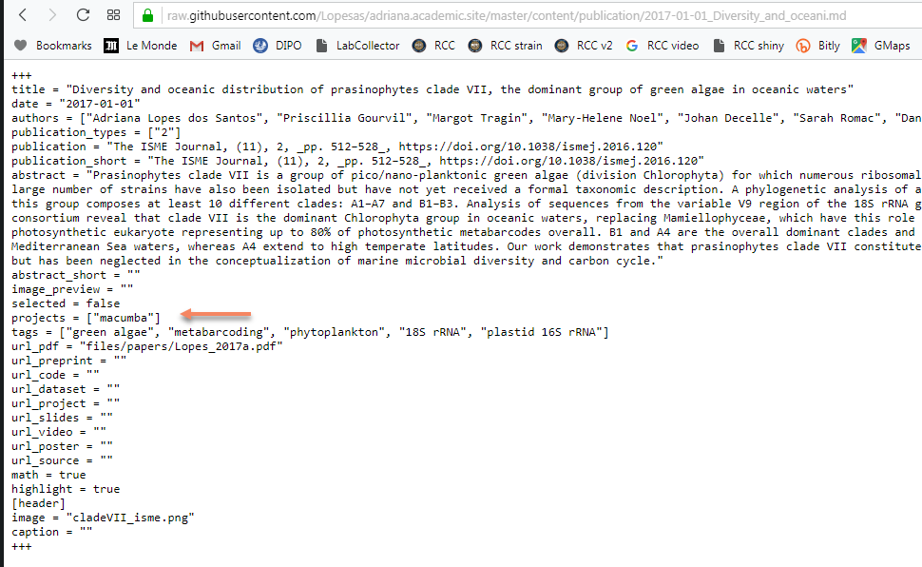

### PiSCOSouth

The South part of the Pacific Ocean is an under-sampled oceanic region. It harbors mesotrophic (moderately low nutrient concentration) and oligotrophic (low nutrient concentration) areas in which primary production is dominated by very small eukaryotic cells, with less than 2-3 μm (pico-phytoplankton). Despite their ecological importance, many of these organisms are still uncultured and their morphology and physiology remains unknown. If offshore tropical waters become more oligotrophic in response to global change as predicted, a shift in the size class dominance may take place within the phytoplankton, with an increased dominance of smaller photosynthetic eukaryotes. Understanding the contributions of the different groups of pico – phytoplankton to the carbon cycle, their ecology and physiology is fundamental for choosing the appropriate parameters to model primary production in the future oceans.

**P**icophytoplankton **S**tudy of **C**arbon rates in **O**ligotrophic waters of the **South** Pacific Ocean aims at obtaining detailed information on the diversity and production of eukaryotic picophytoplankton in the South Pacific. We will combine a range of state of the art techniques including metabarcoding of marker genes, C14 productivity measurements of flow cytometry sorted populations, electron microscopy coupled with *in situ* probe hybridization and high throughput culture isolation using flow cytometry sorting.

Who is involved in PiSCOSouth?

[Andres Gutierrez]( <https://www.researchgate.net/profile/Andres_Gutierrez22>), [Dominique Marie]( <https://www.researchgate.net/profile/Dominique_Marie>), [Daniel Vaulot]( <http://daniel-vaulot.fr/>),

, [Nicole Trefault](<https://www.researchgate.net/profile/Nicole_Trefault>), [Osvaldo Ulloa]( <https://www.researchgate.net/profile/Osvaldo_Ulloa>), [Peter Van Dasson]( <https://www.researchgate.net/profile/Peter_Von_Dassow2>), Antonia Cristi Martinez and [Susana Rodriguez]( https://www.researchgate.net/profile/Susana_Rodriguez_Maconi)

## Positions Available

### Ph.D. student in Earth Science with focus in Marine Ecology

We are looking for a curious and driven Ph.D. student to join our team! The student will be at the forefront of a project research that aims to unveil the dynamics and contribution of small (pico) oceanic eukaryotic phytoplankton to the carbon cycle. We will combine classical primary productivity experiments with phytoplankton population sorting and metabarcoding (metaB) of marker gene to access group specific contribution to carbon fixation.

In order track the variation of phytoplankton communities’ abundances and their metabolism *in situ*, we will perform high-resolution sampling through their natural diel-cycle in different water masses and apply meta transcriptomic (metaT) data analysis to examine the pathways that lead to nutrient acquisition and growth of key picoplanktonic species.

The project will involve field and laboratory studies.

Lab experience and/or computing skills will be considered favorably. Geeks with love for microbes are welcome!

#### The Asian School of Environment

The Asian School of the Environment (ASE) is part of the Nanyang technological University (NTU). Nanyang Technological University is a young and research-driven university, ranked 12th globally by the QS World University Rankings.

The ASE is an interdisciplinary School research focusing on Asian environmental challenges. The ASE integrates earth and environmental life science, ecology, engineering and technology, human ecology, humanities, and the social sciences to address key issues of the environment and sustainability. The Ph.D is designed to be completed with 4 years of study.

#### Criteria for admission in the PhD program

The minimum requirement for admission is a Bachelor’s degree with 2nd Class Honors Upper.

All applicants are required to submit their GRE or GATE test scores which must be within 5 years or less from the date of application. Special arrangements can be made for selected applicants to sit for Technical Proficiency Test (TPT) in place of GRE.

International applicants for whom English is not their first language are required to submit their TOEFL/IELTS test scores as well. Test dates must be within 2 years or less from the date of your application. Special arrangements can be made for selected applicants to sit for NTU’s English Proficiency Test (EPT) in place of TOEFL/IELTS.

Bachelor (and if it is case, Master) degrees that are not English should be submitted with the English Official translation.

#### Deadline for application

31st January 2019 to start in August 2019 intake.

**You will have to build an application which will take quite a bit of time, so please contact me as soon as possible if you are interested.**

#### Benefits

The student will be provided with a graduate research assistantship that includes a stipend for living expenses, academic fees, tuition and health insurance.

#### Contact

If you are interested, please send inquiries to adriana.lopes@ntu.edu.sg. Include your CV and a statement of research experience and interests. We can talk and work on your application.

### Undergrad projects

Thinking about to do a lab internship or which project to conduct during last year project? Join us! Please contact adriana.lopes@ntu.edu.sg to learn more about projects available.