Wordpress

Installation Manual

9352B

Group 4

BALLESTEROS, KIEFFER MICHAEL

GARCIA, EPHRAIM JOHN KEYNNETH

IGNACIO, HAZEL

LOPEZ, NEIL CLARENCE

MANUEL, YVONNE

SALAZAR, VAN YEZA

April 10, 2018

1. sudo apt-get upgrade

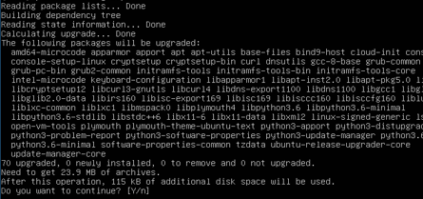

1. sudo apt-get install nginx

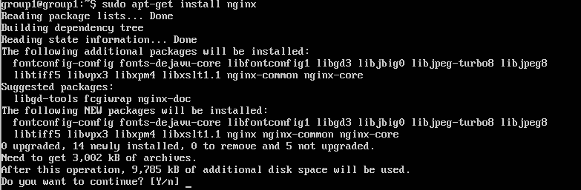

1. sudo apt-get install mysql-client mysql-server

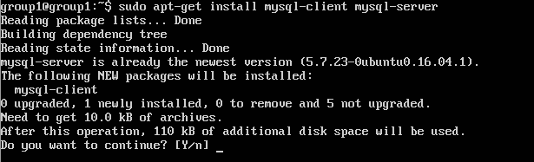

1. sudo mysql_secure_installation

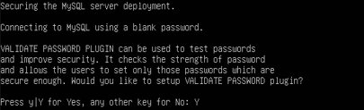

1. sudo mysql –u root –p

Run the command below:

CREATE DATABASE group1 ;

SET GLOBAL validate_password_policy=LOW;

CREATE USER ‘group1_user@’localhost’ IDENTIFIED BY ‘group12018’;

GRANT ALL ON group1.* TO ‘group1_user ‘ @’localhost’;

FLUSH PRIVILEGES;

EXIT;

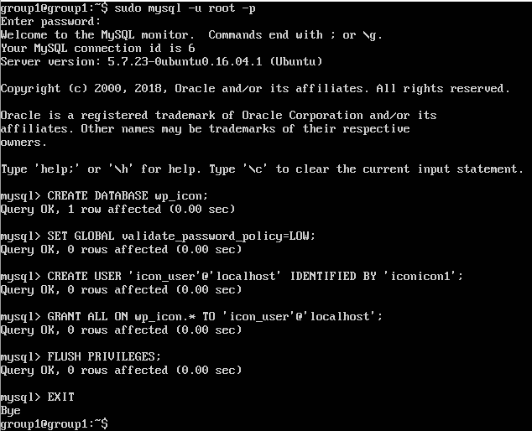

1. sudo wget <https://wordpress.org/latest.tar.gz>

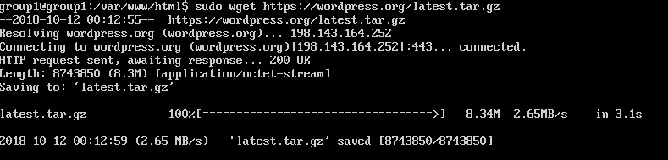

1. sudo tar –zxvf latest.tar.gz –strip-components=1



1. sudo chown –R www-data:www-data /var/www/html



1. sudo chmod –R /var/www/html/



1. sudo vim samcis.com

**ENABLE CONFIGURATION FILES**

11.sudo ln -s /etc/nginx/sites-available/samcis.com /etc/nginx/sites-enabled/

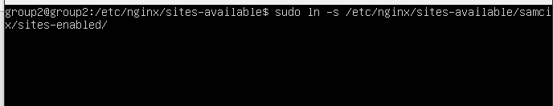

**TEST NGINX IF IT’S OKAY**

12. sudo nginx -t

13. sudo systemctl restart nginx

**CONFIGURING WORDPRESS**

14. sudo mv wp-config-sample.php wp-config.php

1. sudo vim wp-config.php

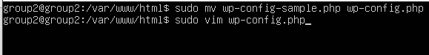

Open web browser and input your domain or the ubuntu IP Address