Github Link:

<https://github.com/Lopezkneiv/csd-340>

Local Directory: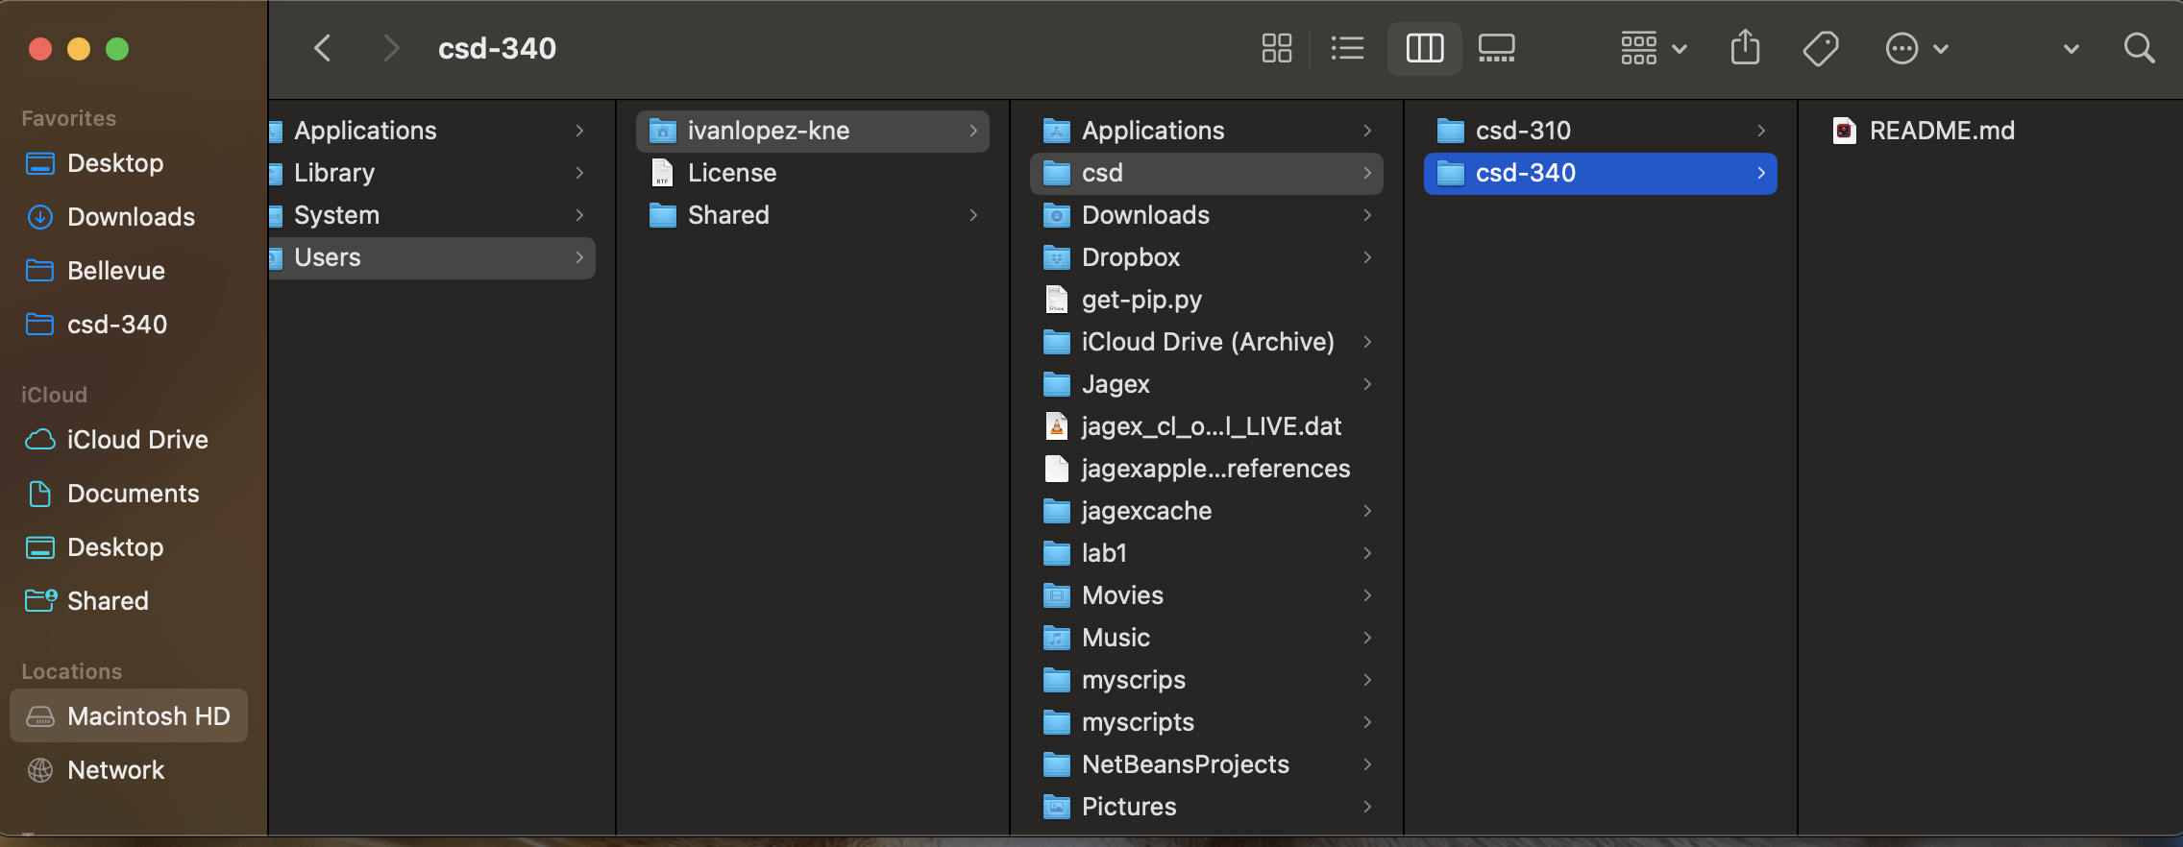

README Output: