Ivan Lopez-Kne

August 13, 2023

Assignment 1.3

Starter code, with errors: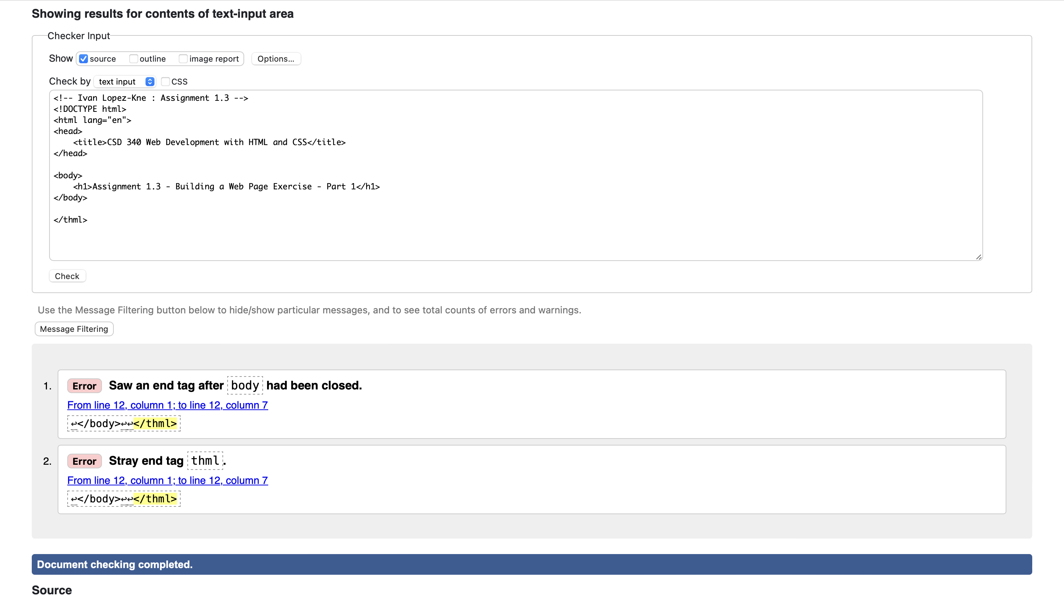

Starter code, errors removed: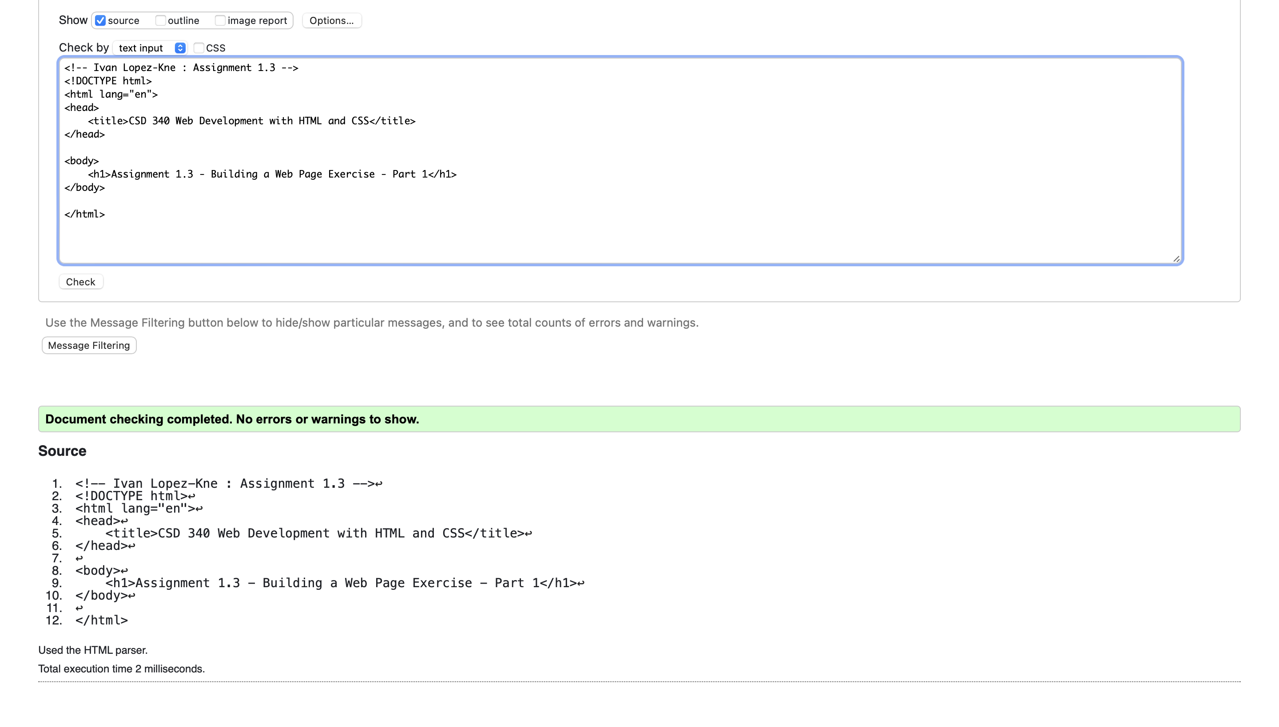

Start code, updated per assignment: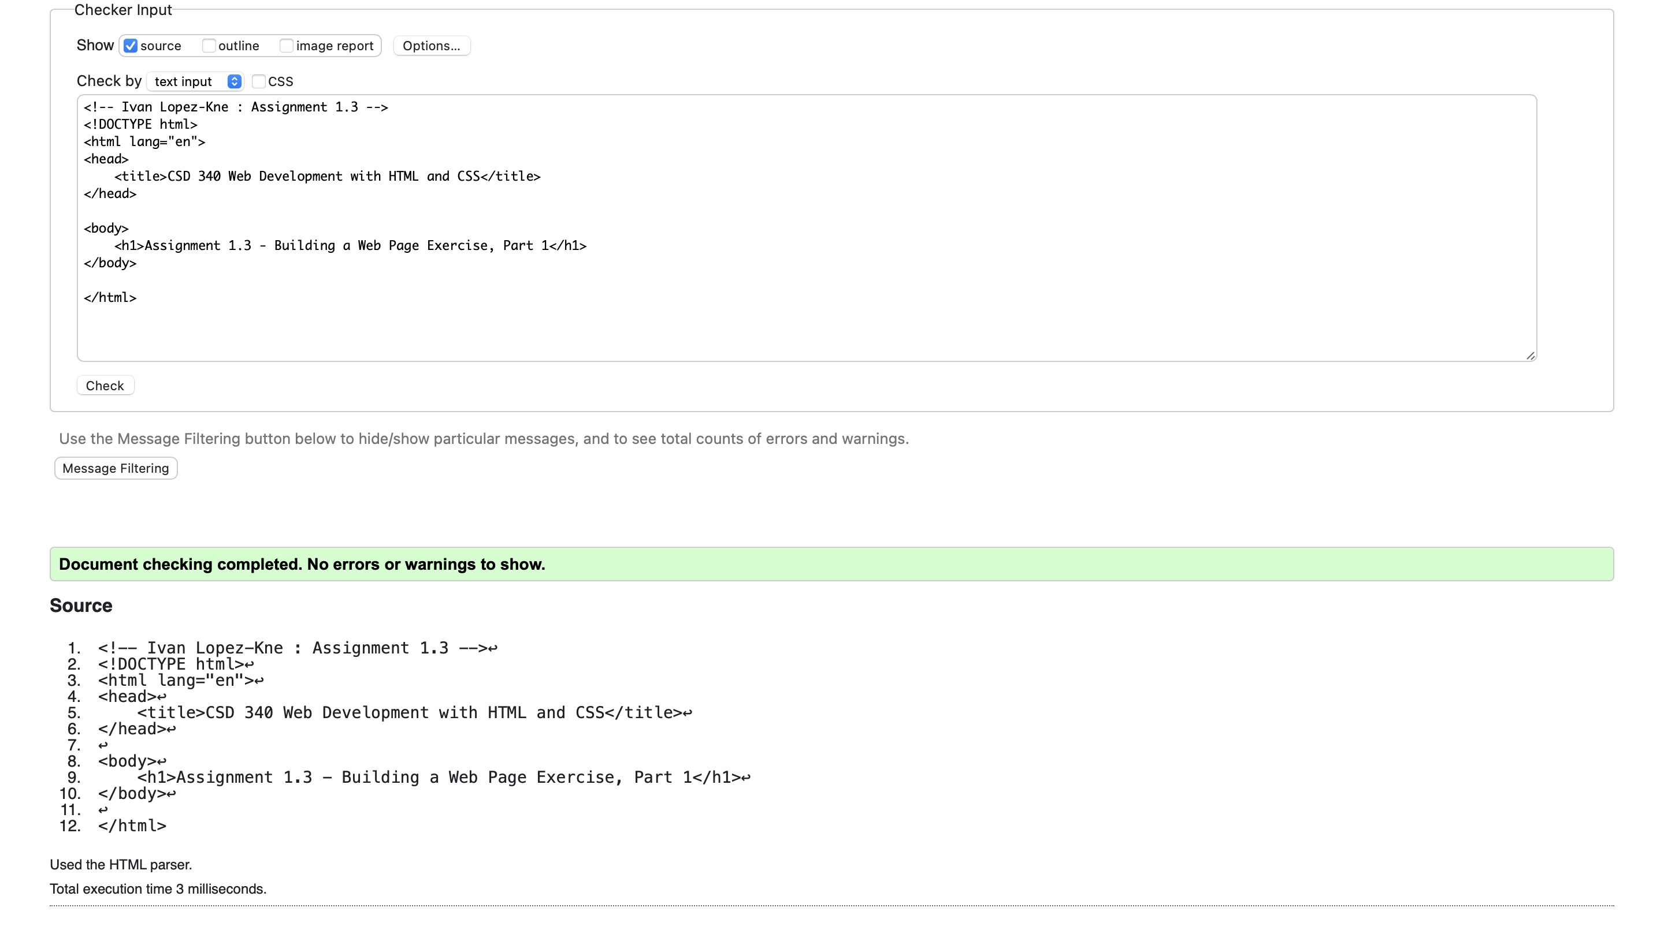

Final output in Safari: