Ivan Lopez-Kne

Assignment 3.2

August 18, 2023

Github Pages: <https://lopezkneiv.github.io/csd-340/>

HTML Validation: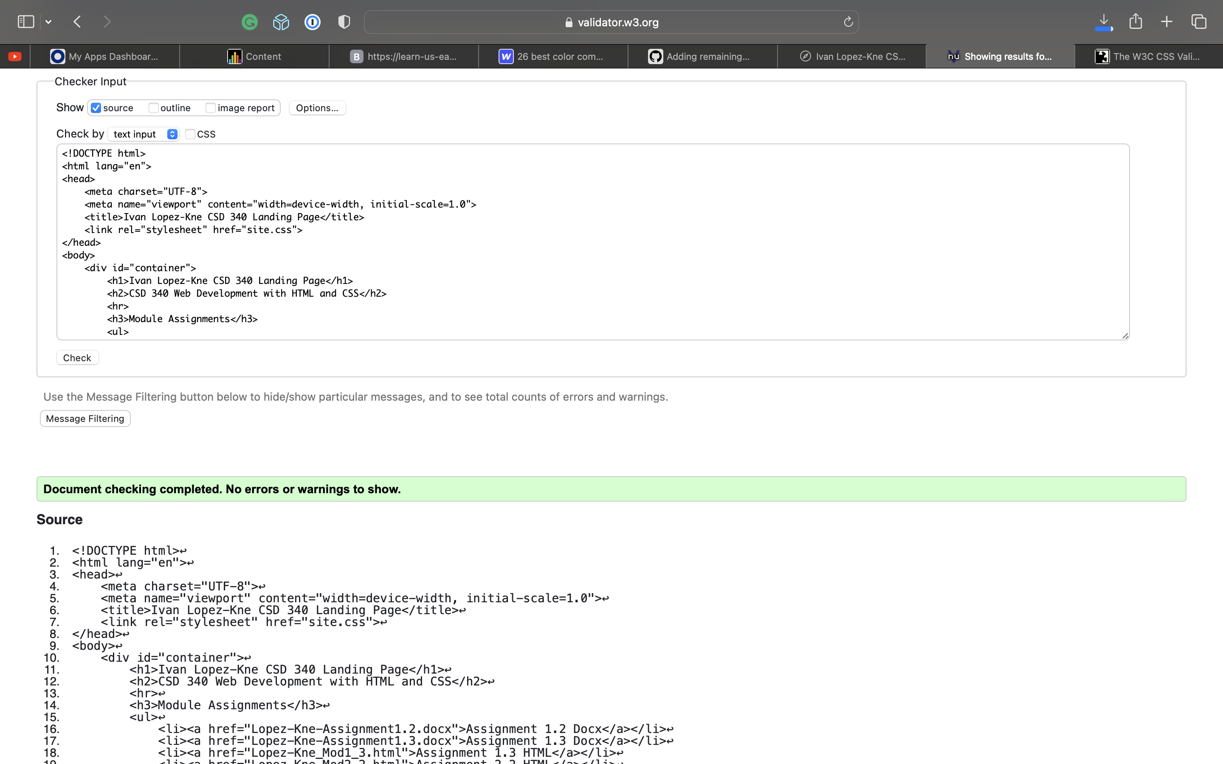

CSS Vali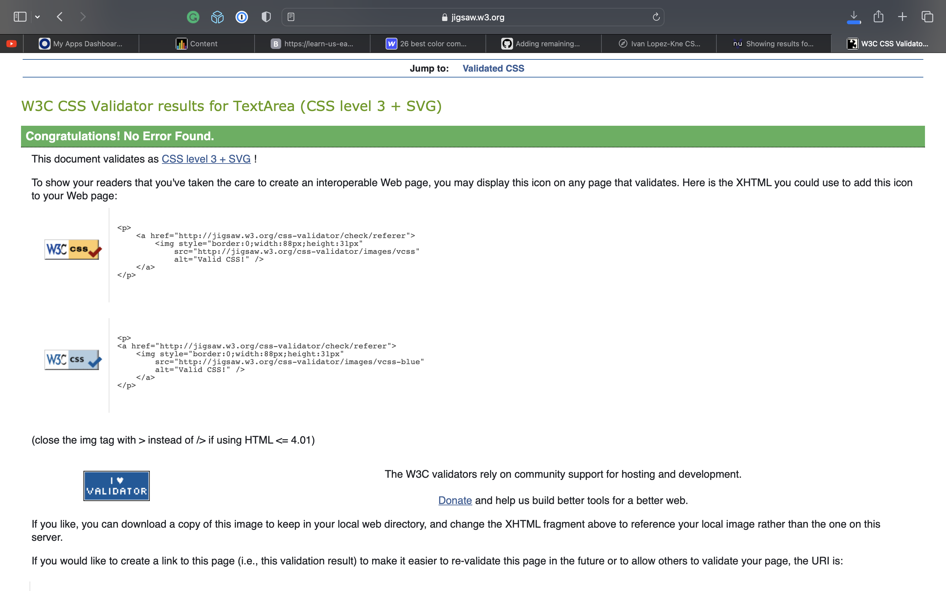dation: