Ivan Lopez-Kne

Assignment 3.3

Github Repository: https://github.com/Lopezkneiv/csd-340

Landing Page: <https://lopezkneiv.github.io/csd-340/>

HTML Validation: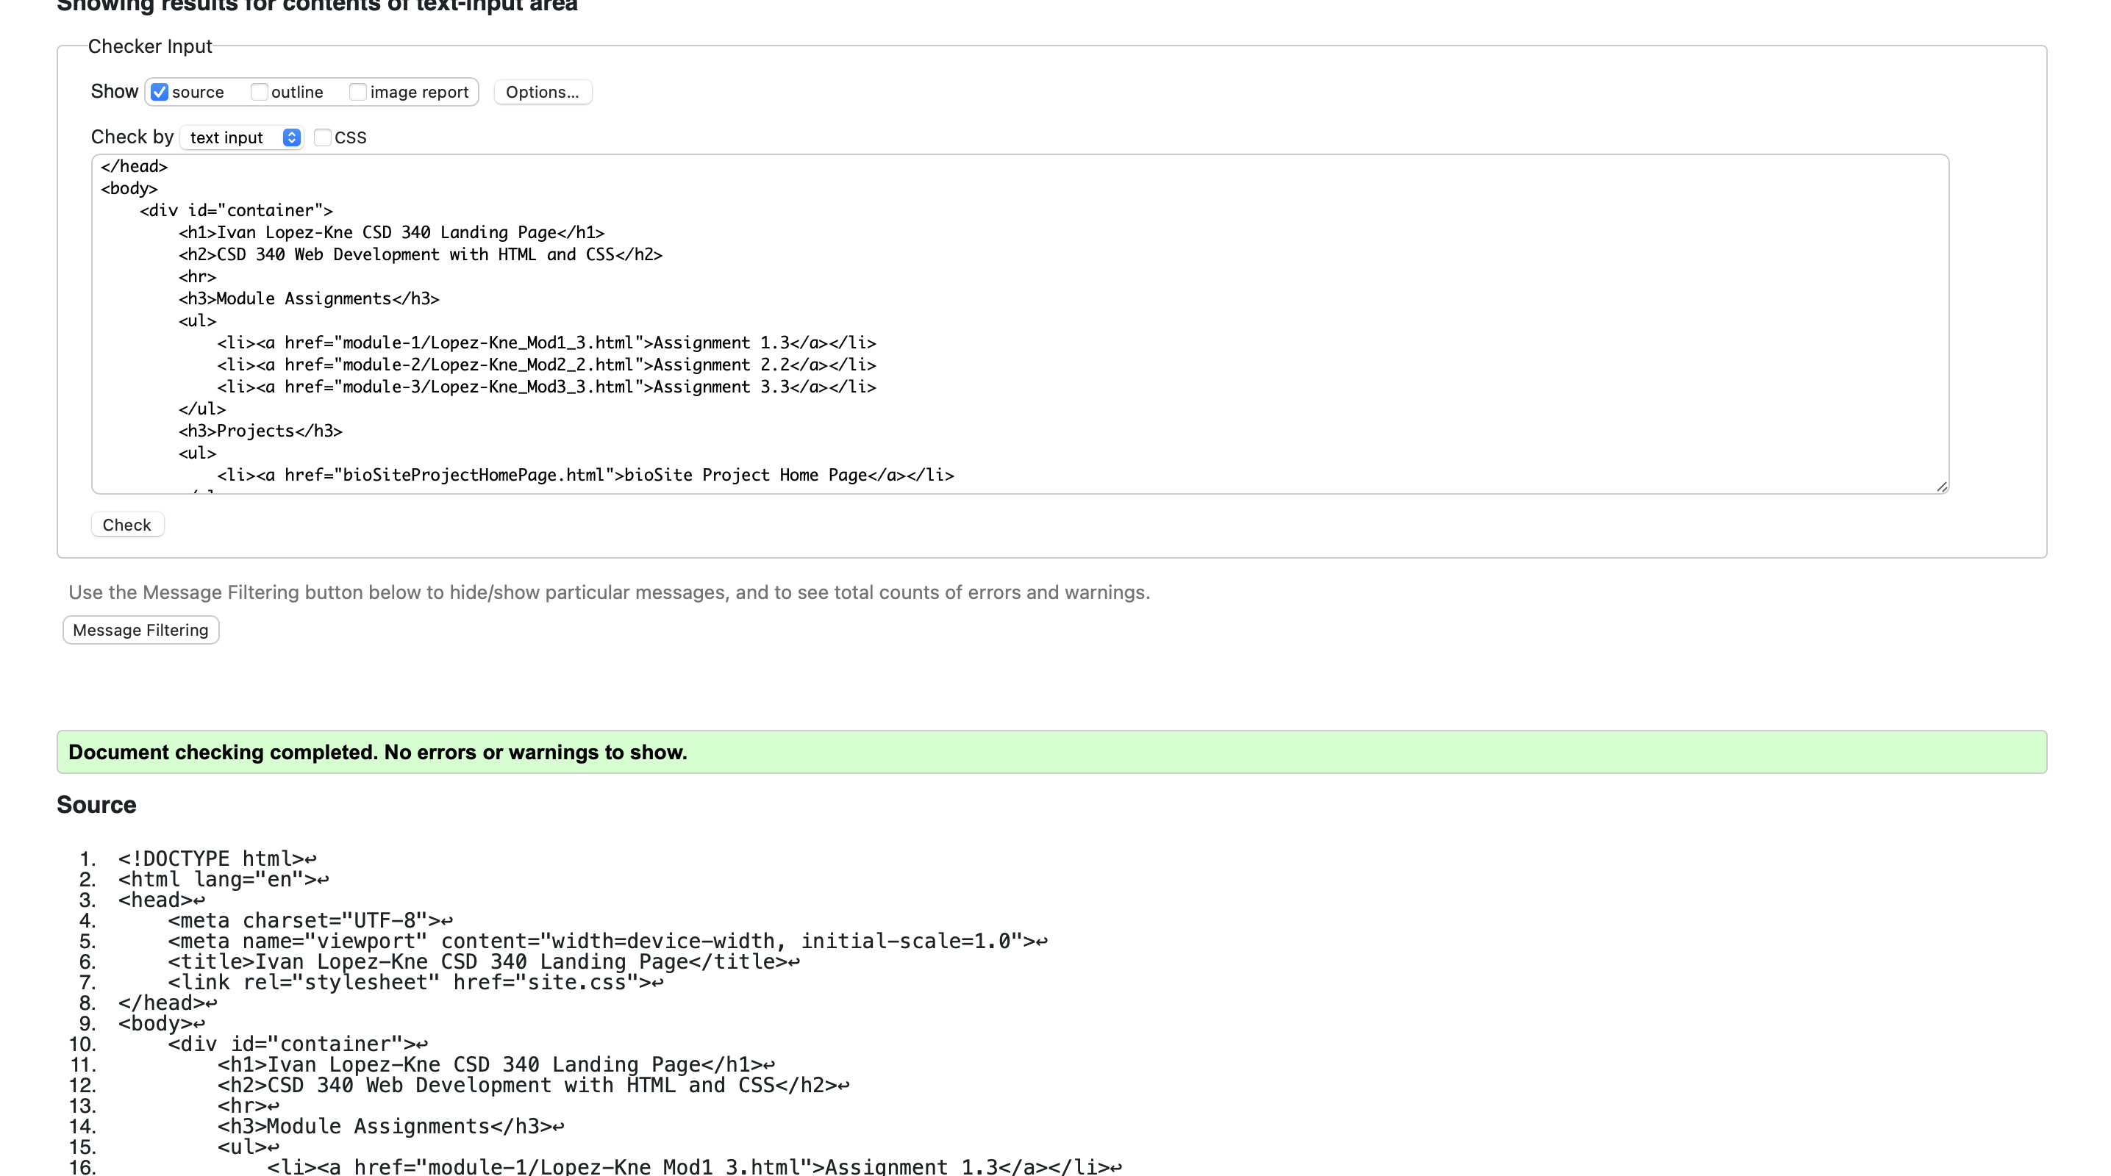

CSS Validation: