Ivan Lopez-Kne

Assignment 1.2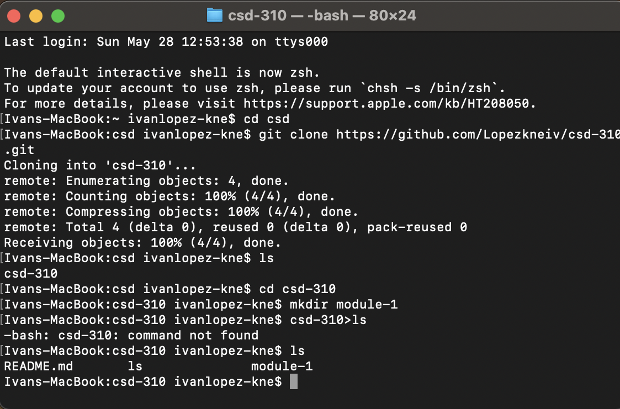

https://github.com/Lopezkneiv/csd-310/tree/main/module-1